Avilés, Asturias, Spain
Avilés pairs a beautifully preserved medieval centre — arcaded streets, Gothic palaces, and a Romanesque quarter — with a striking Oscar Niemeyer cultural campus right at the water's edge. Asturian cider flows freely, and Oviedo is barely half an hour away.
⚓ Docked (commercial port) · 🕒 Typical call: 7-9 hrs · 💶 Euro (€) · 🗣️ Spanish
✍️ MY DAY IN PORT (FILL IN)
Ship / Date
In port | arrive ______ · all aboard ______
Booked excursion
Notes / meeting point
GETTING ASHORE
- Docking: Ships berth at the Port of Avilés commercial quay; old town is a 10-15 min walk across the estuary bridge
- Walk to centre: ~10-15 min on foot to Plaza de España via the estuary footbridge; Niemeyer Centre is right next to the pier
- Best For: Medieval architecture, Asturian gastronomy, day trips to Oviedo, coastal scenery
- Don't Miss: A glass of sidra natural poured from on high in a sidrería on Calle Galiana
GETTING AROUND
- 🚕 Taxi: ~€5-10 local hops; ~€25-40 to Oviedo/Asturias Airport — Taxis are the simplest choice for Salinas beach, Oviedo, Gijón, or a short hop if you do not want to walk. Local fares a
TOP THINGS TO DO
- Avilés Old Quarter Walking Tour — Wander the arcaded lanes of Calle Galiana and Calle Rivero, passing the 14th-century Valdecarzana Palace, the Church of San…
- Centro Niemeyer — Oscar Niemeyer's last major project is a sweeping white cultural complex on the waterfront — dome, auditorium, tower with…
- Day Trip to Oviedo — The Asturian capital is 30 minutes by taxi or bus.
- Salinas Beach — A broad Atlantic surf beach about 5 km west of Avilés, lined with seafood restaurants.
- Asturian Cider & Tapas Tour — Asturias is Spain's cider capital.
BEST WALKS
- Old Town Highlights Loop: 1.5 km · 35 min · Easy · All on pedestrian streets — Start at the Centro Niemeyer on the waterfront, cross to the old town and enter via Calle de la…
- Estuary Waterfront Stroll: 2 km · 30 min · Easy · Flat promenade — Follow the Avilés estuary promenade from the port past the Niemeyer Centre, continuing along the…
WEATHER · DAYLIGHT · MONEY
Month | High °F | Low °F | Rainy days
May | 63 | 52 | 13
Jul | 71 | 62 | 10
Sep | 71 | 59 | 12
Daylight: May 6:59AM–9:41PM · Jul 6:56AM–10:02PM · Sep 8:03AM–8:33PM
cruiseports.org/aviles · Confirm terminal & all-aboard time with your ship

Avilés, Asturias, Spain — Port Map
Red = walkable sights · Amber = excursions farther out · P = cruise terminal
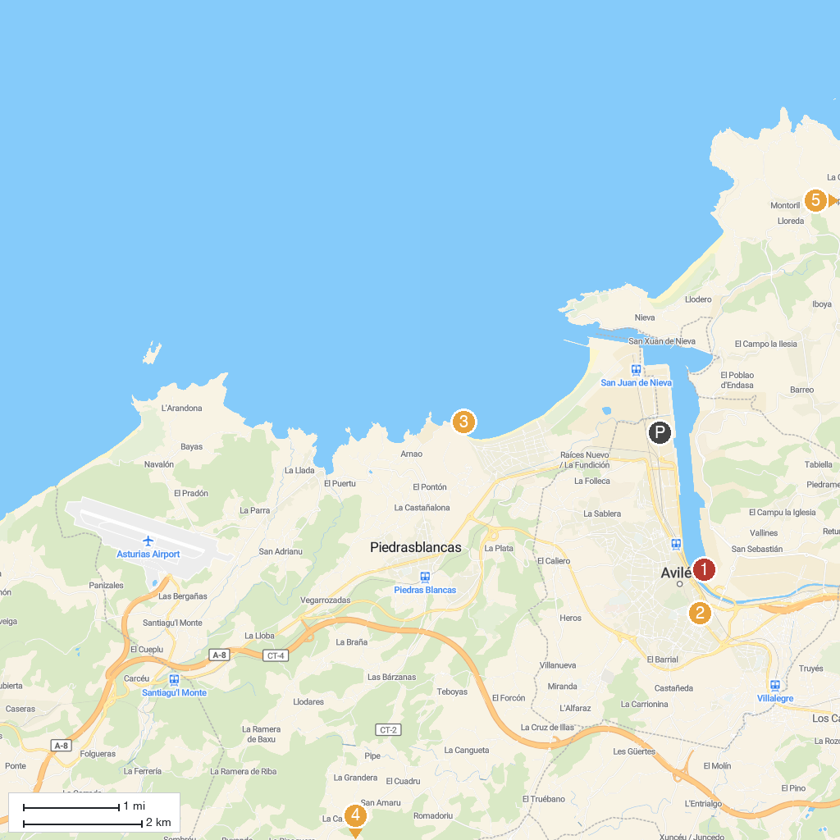
MAP KEY
1. Oscar Niemeyer International Cultural Centre | 5. Área recreativa La Degollada
2. Centro Municipal de Arte y Exposiciones (CMAE) | 6. El Rincón de Las Aves
3. Philippe Cousteau Anchor Museum | 7. Museo Marítimo de Asturias
4. Grotto Arbedales | 8. Mirador de Monteagudo
P. Cruise port / terminal
Map © MapTiler © OpenStreetMap contributors · cruiseports.org

