Ayia Napa, Famagusta District, Cyprus
Turquoise coves, dramatic sea caves, and a 16th-century monastery: Ayia Napa delivers a classic Eastern Mediterranean shore day with a lively, sun-bleached edge.
⚓ Docked (marina) or tender for large ships · 🕒 Typical call: 6-8 hrs · 💶 Currency: Euro (€) · 🗣️ Language: Greek (English widely spoken)
✍️ MY DAY IN PORT (FILL IN)
Ship / Date
In port | arrive ______ · all aboard ______
Booked excursion
Notes / meeting point
GETTING ASHORE
- Docking: Small ships berth at Ayia Napa Marina; larger vessels anchor offshore and tender to the marina quayside
- Walk to center: ~5 min from marina to Ayia Napa town center
- Best For: Beaches, sea caves, coastal hiking, boat trips
- Don't Miss: Cape Greco National Park and a boat trip to the sea caves
GETTING AROUND
- 🚕 Taxi: €5–10 — Taxis are available around the marina and town center. Short hops within Ayia Napa are inexpensive; pre-book for longer
- 📱 Rideshare: ✅ Bolt
TOP THINGS TO DO
- Cape Greco National Park — Hike or drive the dramatic headland southeast of town: sea arches, the Kamara tou Koraka (Lovers' Bridge), sea caves, and…
- Coastal Boat Trip — Sea Caves & Blue Lagoon — Half-day cruises depart the marina to the Ayia Napa sea caves, Cape Greco, Konnos Bay, and sometimes Famagusta's ghost-town…
- Nissi Beach — Ayia Napa's most famous beach: powdery white sand, a tidal sandbar linking to Nissi Island, and vivid turquoise shallows.
- Ayia Napa Monastery & Town Center — The 16th-century Venetian monastery sits at the heart of town — one of the best-preserved on Cyprus.
- Famagusta Ghost Town Day Trip — Varosha, the abandoned resort district of Famagusta, was partially reopened to visitors in 2020.
BEST WALKS
- Marina to Monastery & Town Square: 1.5 km · 20 min · Easy — From the marina, walk into town along the main pedestrian strip to Ayia Napa Monastery and the…
- Coastal Path toward Cape Greco: 3-5 km one-way · 1-2 hrs · Easy-moderate — Head southeast along the coastal path from the marina past Makronissos Beach toward the sea caves…
WEATHER · DAYLIGHT · MONEY
Month | High °F | Low °F | Rainy days
May | 79 | 65 | 3
Jul | 90 | 76 | 0
Sep | 87 | 74 | 1
Daylight: May 5:40AM–7:40PM · Jul 5:41AM–7:58PM · Sep 6:27AM–6:50PM
cruiseports.org/ayia-napa · Confirm terminal & all-aboard time with your ship

Ayia Napa, Famagusta District, Cyprus — Port Map
Red = walkable sights · Amber = excursions farther out · P = cruise terminal
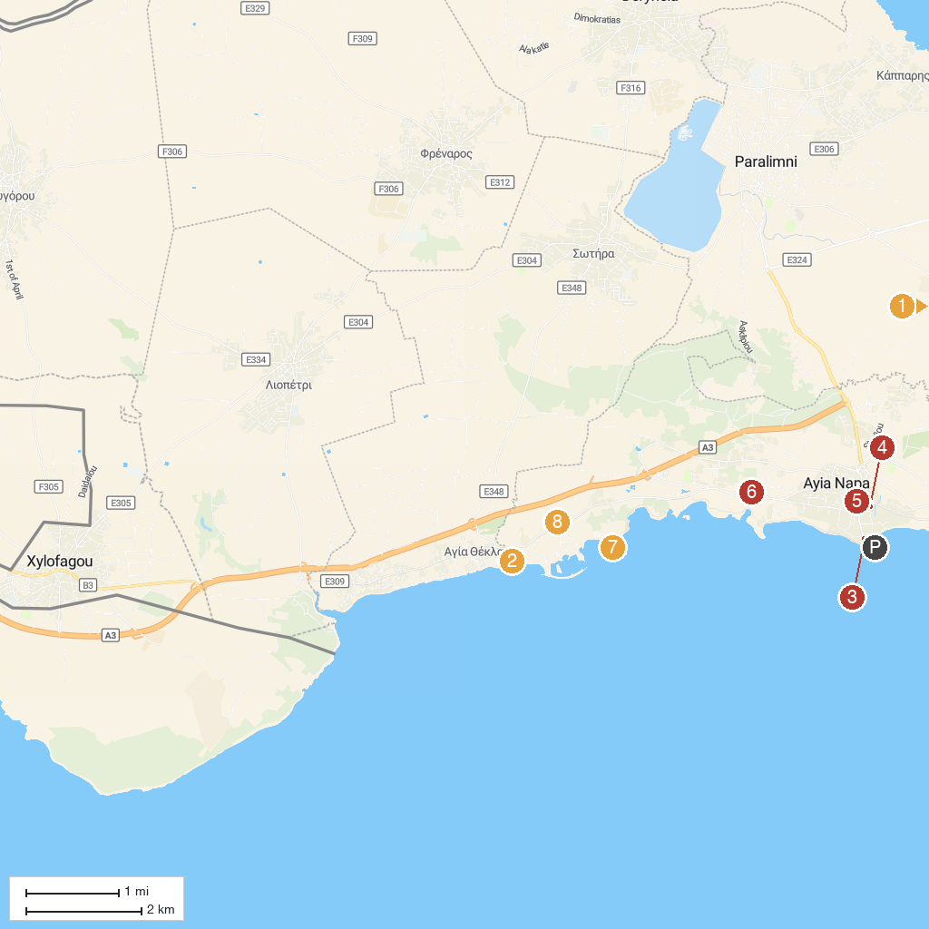
MAP KEY
1. Profitis Elias church | 5. Ayia Napa Monument
2. Ayia Thekla Beach | 6. Σκανδιναβική Εκκλησία
3. Dolfin's Luna Park (Ayia Napa Harbour) | 7. Makronissos Archaeological Site
4. Thalassa | 8. WaterWorld Themed Waterpark Ayia Napa
P. Cruise port / terminal
Map © MapTiler © OpenStreetMap contributors · cruiseports.org

