Ayr, South Ayrshire, Scotland
Scotland's poet country meets dramatic clifftop castles. Ayr packs Burns heritage, championship golf, and one of Ayrshire's finest coastlines into a very walkable town — with Culzean Castle a quick drive away.
⚓ Tender port · 🕒 Typical call: 7-9 hrs · 💷 GBP (£) · 🗣️ English · 🎯 Heritage & outdoors
✍️ MY DAY IN PORT (FILL IN)
Ship / Date
In port | arrive ______ · all aboard ______
Booked excursion
Notes / meeting point
GETTING ASHORE
- Docking: Tender to north side of River Ayr; town centre is a short walk
- Walk to centre: 5 min from tender pier to High Street
- Best For: Robert Burns fans, castle lovers, golfers, beach walkers
- Don't Miss: Culzean Castle & Country Park (20 min south by taxi)
GETTING AROUND
- 🚕 Taxi: £5–£10 — Multiple local taxi firms (Streamline Taxis, Ayrshire Transport) offer 24-hour service. Pre-booking is advised for cruis
- 📱 Rideshare: ✅ Uber
TOP THINGS TO DO
- Robert Burns Birthplace Museum, Alloway — Scotland's national bard was born in Alloway in 1759.
- Culzean Castle & Country Park — Robert Adam's masterpiece perches on Ayrshire cliffs above the Firth of Clyde.
- Ayr Beach & Esplanade Walk — Ayr's long sandy beach stretches south from the harbour with views across to the Isle of Arran and the volcanic plug of Ailsa…
- Golf on Ayrshire's Championship Links — Ayrshire is Scotland's golf heartland.
- Ayr Town Centre & Auld Brig — Ayr's compact High Street has good independent shops and cafes.
BEST WALKS
- Ayr Harbour to Auld Brig & Town Centre: 1.5 km · 20 min · Easy · Flat — From the tender landing walk into the town centre along the riverbank to the Auld Brig (1491), then…
- Ayr Beach Esplanade & Greenan Castle: 5 km · 75 min · Easy · Coastal path — Head south from the harbour along the beach and esplanade to the cliffside ruin of Greenan Castle…
WEATHER · DAYLIGHT · MONEY
Month | High °F | Low °F | Rainy days
May | 59 | 44 | 11
Jul | 65 | 53 | 11
Sep | 62 | 50 | 10
Daylight: May 5:08AM–9:22PM · Jul 4:57AM–9:50PM · Sep 6:51AM–7:34PM
Representative sunrise/sunset — 2025, 15th of each month; local civil time including DST (Europe/London). Source: Astral; not a forecast or climate average.
cruiseports.org/ayr · Confirm terminal & all-aboard time with your ship

Ayr, South Ayrshire, Scotland — Port Map
Red = walkable sights · Amber = excursions farther out · P = cruise terminal
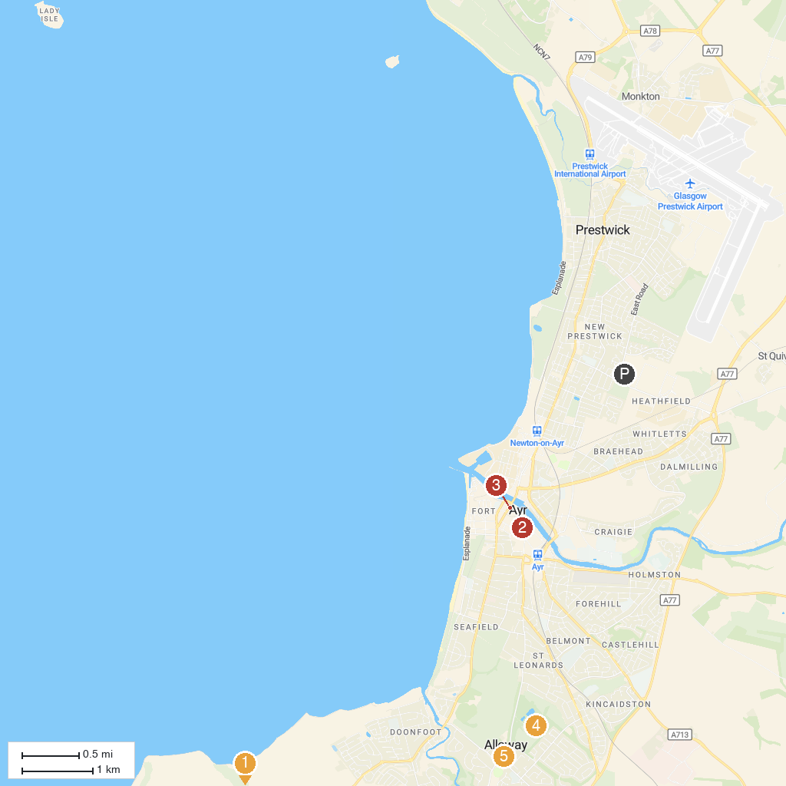
MAP KEY
1. Dunure Castle | 5. Rozelle Estate
2. Heads Of Ayr Farm Park | 6. Burns Cottage - Robert Burns Birthplace Museum (National Trust for Scotland)
3. The Wallace Tower | 7. Electric Brae
4. Ayr Town Hall | 8. Maybole Castle
P. Cruise port / terminal
Map © MapTiler © OpenStreetMap contributors · cruiseports.org

