Bad Breisig, Rhineland-Palatinate, Germany
A compact Rhine spa town where warm mineral springs meet a riverside promenade — and castle-studded hills start just beyond the quay.
⚓ Docked (river quay) · 🕒 Typical call: 6-8 hrs · 💶 Currency: Euro (€) · 🗣️ Language: German · 🌿 Spa & nature focus
✍️ MY DAY IN PORT (FILL IN)
Ship / Date
In port | arrive ______ · all aboard ______
Booked excursion
Notes / meeting point
GETTING ASHORE
- Docking: River quay on the Rhine; ships dock directly — no tender required
- Walk to center: 2-5 min on foot along the Rhine promenade
- Best For: Thermal baths, castle hikes, Rhine cycling, family day trips
- Don't Miss: Römer-Thermen thermal pools and Schloss Rheineck above town
GETTING AROUND
- 🚕 Taxi: Metered (call for quote) — Local taxis serve the area 24/7. City Taxi Bad Breisig (+49 2633 9110) and Rhein Taxi 24 (+49 2633 9991) can be booked d
TOP THINGS TO DO
- Römer-Thermen Thermal Baths — Bad Breisig's signature attraction: warm mineral water drawn from 600 m deep fills indoor and outdoor pools (28–34°C), a sauna…
- Schloss Rheineck — A hilltop castle with 12th-century origins (rebuilt in Romanesque-revival style in the 1830s) towering above Bad Breisig with…
- Andernach Cold-Water Geyser — The world's highest cold-water geyser erupts periodically near Andernach, about 12 km south.
- Maria Laach Abbey — One of Germany's finest Romanesque churches, this Benedictine abbey sits on the shore of the Laacher See crater lake about 17 km…
- Brohltal Narrow-Gauge Railway (Vulkan-Expreß) — A narrow-gauge railway operating since 1901 (steam and diesel) climbs nearly 400 m from the Rhine valley into the volcanic Eifel…
BEST WALKS
- Rhine Promenade & Spa Park Stroll: 1.5 km · Easy · 30-40 min — Walk the pedestrianised Rhine promenade from the dock, passing the spa gardens (Kurpark) and the…
- Schloss Rheineck Hill Walk: 3 km round trip · Moderate · 60-80 min — From the promenade, follow signed footpaths up through vineyards and woodland toward Schloss…
WEATHER · DAYLIGHT · MONEY
Month | High °F | Low °F | Rainy days
May | 65 | 49 | 13
Jul | 76 | 60 | 12
Sep | 69 | 54 | 9
Daylight: May 5:43AM–9:12PM · Jul 5:36AM–9:36PM · Sep 7:06AM–7:44PM
cruiseports.org/bad-breisig · Confirm terminal & all-aboard time with your ship

Bad Breisig, Rhineland-Palatinate, Germany — Port Map
Red = walkable sights · Amber = excursions farther out · P = cruise terminal
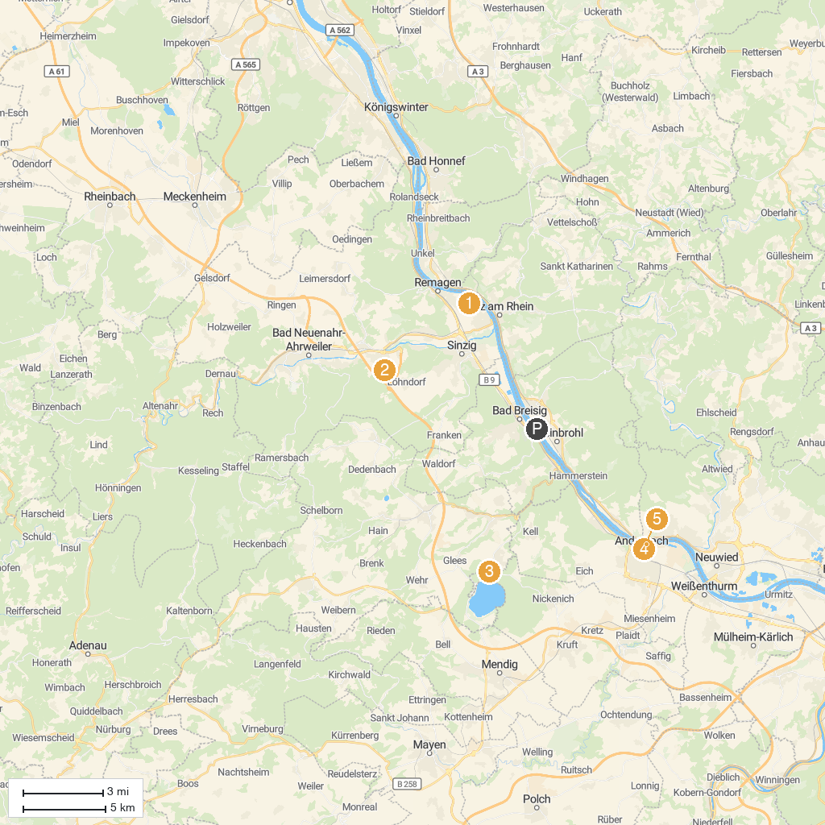
MAP KEY
1. Maria Laach Abbey | 5. Lydiaturm
2. Forest Adventure Treeclimbing Park Bad Neuenahr | 6. Schlossgarten
3. Friedenskapelle „Schwarze Madonna“ | 7. Lenné Park
4. Sitzbank XXL | 8. Andernach Bollwerk
P. Cruise port / terminal
Map © MapTiler © OpenStreetMap contributors · cruiseports.org

