Bad Essen, Lower Saxony, Germany
A gentle spa town on the Mittelland Canal, Bad Essen rewards slow walkers with half-timbered squares, moated castles, and a rare set of 150-million-year-old dinosaur footprints just outside town.
⚓ Docked (canal quay) · 🕒 Typical call: 6–8 hrs · 💶 Currency: Euro (€) · 🗣️ Language: German · 🛁 Health-resort town
✍️ MY DAY IN PORT (FILL IN)
Ship / Date
In port | arrive ______ · all aboard ______
Booked excursion
Notes / meeting point
GETTING ASHORE
- Docking: River ships tie up at the MYC Mittelland marina on the Mittelland Canal, ~1.5 km from the historic town center.
- Walk to center: ~20-minute flat walk or short taxi from the canal quay to the market square.
- Best For: Half-timbered architecture, castle day-trips, spa culture, canal cycling, and dinosaur tracks.
- Don't Miss: The 150-million-year-old dinosaur tracks at Barkhausen (a district of Bad Essen) and the moated Schloss Hünnefeld.
GETTING AROUND
- 🚕 Taxi: €10–€20 — Local taxis are available near the dock. Short rides within Bad Essen to the spa area or town center are affordable; far
TOP THINGS TO DO
- Historic Old Town Walk — Stroll the market square and surrounding streets to admire well-preserved half-timbered buildings that place Bad Essen on the…
- Schloss Hünnefeld — A moated castle first documented in 1146, with a late-Renaissance manor house (built c.1600–1614) and a round dovecote added in…
- Dinosaur Tracks at Barkhausen — One of Germany's most unusual day-trip attractions: 150-million-year-old sauropod and theropod footprints preserved in a former…
- Schloss Ippenburg Garden Exhibition — A neo-Gothic aristocratic estate (the current house built 1862–1867 on older foundations) celebrated for its gardens, open to…
- SolePark & Brine Pools — Bad Essen's spa heritage is on full display in the SolePark, where salty brine trickles over blackthorn hedges to freshen the air.
BEST WALKS
- Marina to Market Square: 1.5 km · ~20 min · Flat — Walk from the MYC Mittelland marina along the canal path, then turn south toward the town center.
- Old Town Timber-Frame Loop: 2 km · ~30 min · Flat — From the market square, follow the signed German Timber-Frame Road route through the historic core.
WEATHER · DAYLIGHT · MONEY
Month | High °F | Low °F | Rainy days
May | 64 | 47 | 11
Jul | 74 | 58 | 13
Sep | 67 | 53 | 9
Daylight: May 5:31AM–9:15PM · Jul 5:23AM–9:41PM · Sep 7:01AM–7:41PM
cruiseports.org/bad-essen · Confirm terminal & all-aboard time with your ship

Bad Essen, Lower Saxony, Germany — Port Map
Red = walkable sights · Amber = excursions farther out · P = cruise terminal
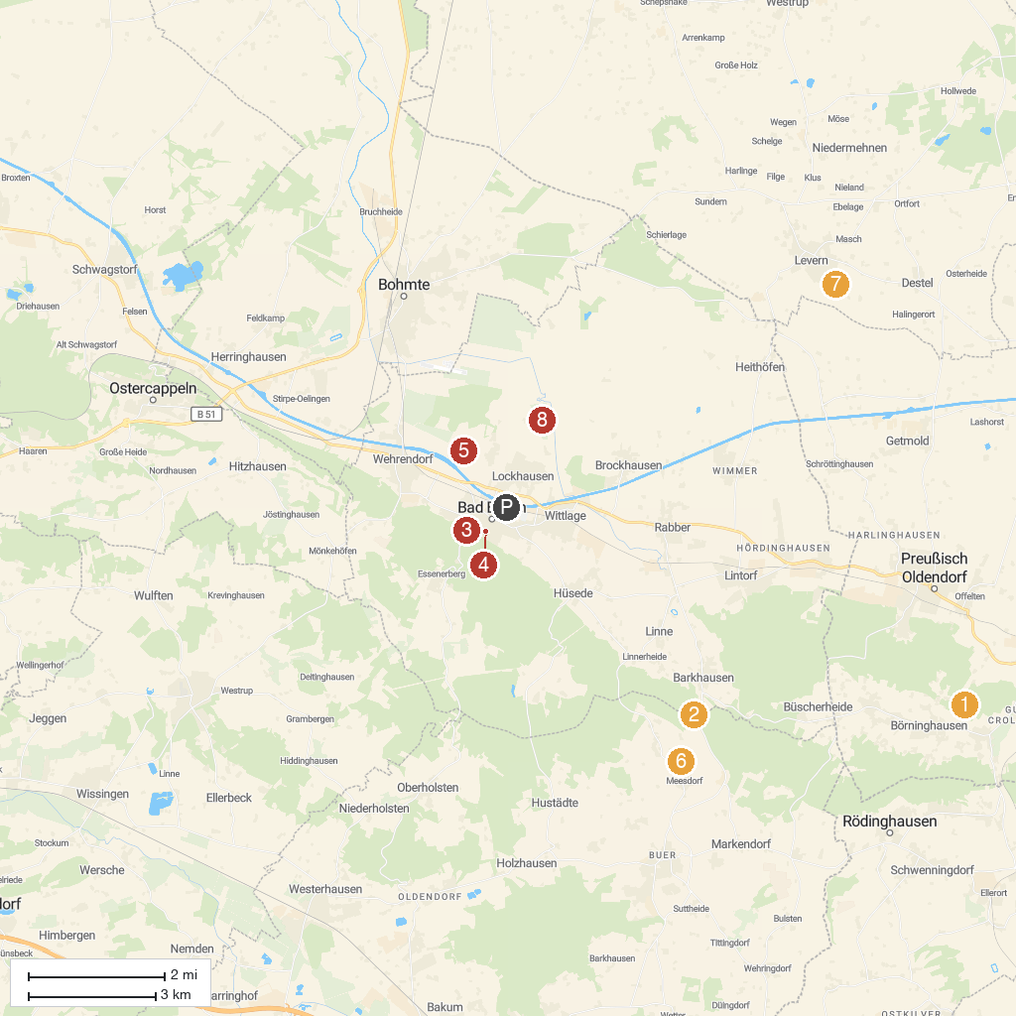
MAP KEY
1. Limberg Castle | 5. Schloss Hünnefeld
2. Saurierfährten Barkhausen | 6. Obere Hunte
3. Water Mill Bad Essen | 7. Windmühle Levern
4. SoleArena | 8. Schloss Ippenburg - 7ha geöffneter Garten mit Schlosscafè
P. Cruise port / terminal
Map © MapTiler © OpenStreetMap contributors · cruiseports.org

