Baddeck, Nova Scotia, Canada
A quiet Cape Breton village on the shores of a UNESCO-biosphere lake, Baddeck punches above its size with world-class history, eagle-dotted waters, and the Cabot Trail at its doorstep.
⚓ Docked (public wharf) · 🕒 Typical call: 6-8 hrs · 💵 Canadian Dollar (CAD) · 🗣️ English / Gaelic heritage
✍️ MY DAY IN PORT (FILL IN)
Ship / Date
In port | arrive ______ · all aboard ______
Booked excursion
Notes / meeting point
GETTING ASHORE
- Docking: Ships berth at Baddeck public wharf, steps from the waterfront
- Walk to center: 2 min — village shops and waterfront are immediately adjacent
- Best For: History buffs, scenic lake tours, Cabot Trail day trips
- Don't Miss: Alexander Graham Bell National Historic Site
GETTING AROUND
- 🚕 Taxi: Metered (short rides minimal) — Traditional taxis and the local Giv'er app (ridegiver.app/cape_breton) connect you with licensed Cape Breton drivers. Fa
- 📱 Rideshare: ❌ not available
TOP THINGS TO DO
- Alexander Graham Bell National Historic Site — The world's largest collection of Bell artifacts is right here in the village — a short walk from the wharf.
- Bras d'Or Lake Boat Tour — Board the WinStar double-decker tour boat from the Baddeck wharf for a narrated cruise across the UNESCO Biosphere Reserve lake.
- Cabot Trail Scenic Drive — Baddeck is the traditional gateway to the Cabot Trail, consistently ranked among North America's most scenic drives.
- Kidston Island Ferry & Beach — A short passenger ferry from the Baddeck wharf drops you on Kidston Island with a sandy beach, walking trails, and a historic…
- Cape Breton Lobster Supper — Nova Scotia lobster suppers are a regional institution.
BEST WALKS
- Waterfront & Village Loop: 1.5 km · 25-30 min · Easy — Start at the Baddeck public wharf and walk along the waterfront boardwalk toward the Bell Museum on…
- Baddeck to Bell Estate Viewpoint: 1 km · 15 min · Easy — From the Bell Museum grounds, follow the lakeside path to the viewpoint overlooking Bras d'Or Lake…
WEATHER · DAYLIGHT · MONEY
Month | High °F | Low °F | Rainy days
May | 54 | 39 | 13
Jul | 72 | 59 | 14
Sep | 66 | 54 | 11
Daylight: May 5:30AM–8:28PM · Jul 5:27AM–8:50PM · Sep 6:41AM–7:13PM
cruiseports.org/baddeck-ns · Confirm terminal & all-aboard time with your ship

Baddeck, Nova Scotia, Canada — Port Map
Red = walkable sights · Amber = excursions farther out · P = cruise terminal
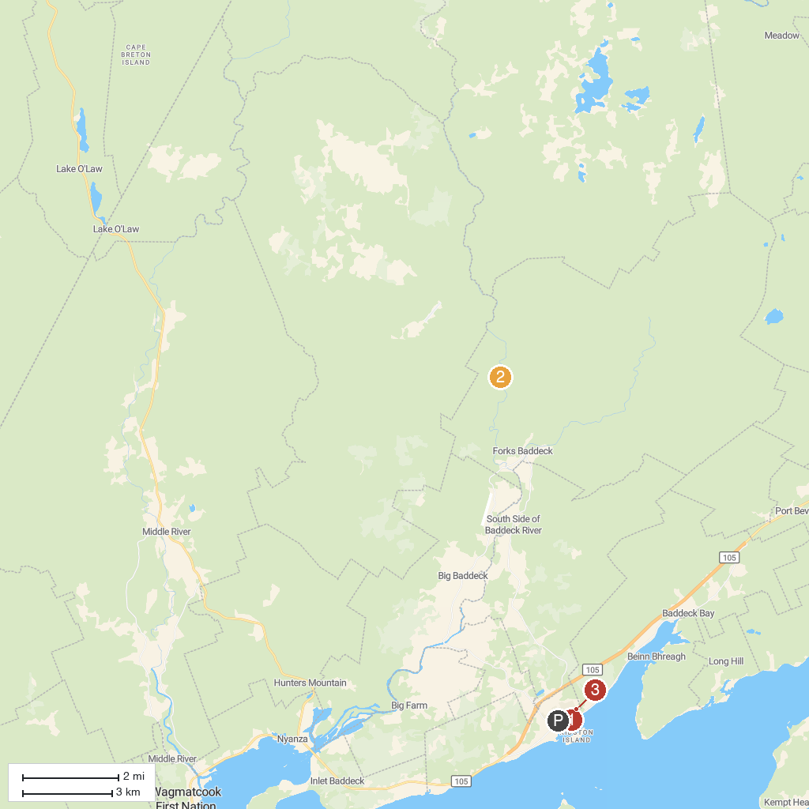
MAP KEY
1. WinStar Cruises | 3. Alexander Graham Bell National Historic Site
2. Uisge Bàn Falls Provincial Park
P. Cruise port / terminal
Map © MapTiler © OpenStreetMap contributors · cruiseports.org

