Baden-Baden, Baden-Württemberg, Germany
Europe's grand spa capital sits at the edge of the Black Forest — elegant thermal baths, a storied casino, and flower-lined promenades await just a short transfer from the Rhine.
⚓ Tender/transfer port (dock at Rastatt, ~16 km) · 🕒 Typical call: 6-8 hrs · 💶 Euro (EUR) · 🗣️ German
✍️ MY DAY IN PORT (FILL IN)
Ship / Date
In port | arrive ______ · all aboard ______
Booked excursion
Notes / meeting point
GETTING ASHORE
- Docking: No berth at Baden-Baden itself; ships dock at Rastatt (~16 km), Kehl-Strasbourg, or Karlsruhe and bus passengers in
- Walk to centre: Not walkable from dock — shuttle or taxi required
- Best For: Thermal spa day, casino visit, Lichtentaler Allee stroll, Black Forest excursion
- Don't Miss: Friedrichsbad Roman-Irish bath ritual or Caracalla Spa thermal pools
GETTING AROUND
- 🚕 Taxi: about €35-€50 one-way — Useful if you are not taking the cruise coach or need to return independently. Baden-Baden is inland from the Rhine, so
- 📱 Rideshare: ✅ Uber
- 🚌 Hop-on hop-off: ✅
TOP THINGS TO DO
- Friedrichsbad Roman-Irish Spa — Step into the 19th-century marble halls of Friedrichsbad for a 17-stage Roman-Irish bathing ritual — hot rooms, steam baths…
- Caracalla Spa Thermal Pools — The modern alternative to Friedrichsbad: 5,000 sq m of thermal pools (indoor and outdoor), whirlpools, current channels, and…
- Casino Baden-Baden & Kurhaus Tour — Called 'the most beautiful casino in the world' by Marlene Dietrich, the Belle Époque Casino Baden-Baden inside the Kurhaus is…
- Lichtentaler Allee & Rose Garden — A 2.3 km promenade along the River Oos lined with centuries-old trees, sculpted gardens, and elegant villas.
- Black Forest Day Excursion — Most cruise lines offer a half-day into the Black Forest — pine-covered hillsides, traditional farmhouses, and panoramic…
BEST WALKS
- Old Town to Kurhaus Loop: 2.5 km · 45 min · Easy — Start at Leopoldsplatz, walk through the old town lanes to the Trinkhalle (Pump Room), continue to…
- Friedrichsbad to Hohenbaden Castle: 3 km · 1-1.5 hrs · Moderate (uphill) — From Friedrichsbad, head uphill through residential streets to the romantic ruins of Hohenbaden…
WEATHER · DAYLIGHT · MONEY
Month | High °F | Low °F | Rainy days
May | 66 | 51 | 14
Jul | 78 | 62 | 12
Sep | 70 | 56 | 10
Daylight: May 5:45AM–9:01PM · Jul 5:40AM–9:25PM · Sep 7:04AM–7:39PM
cruiseports.org/baden-baden · Confirm terminal & all-aboard time with your ship

Baden-Baden, Baden-Württemberg, Germany — Port Map
Red = walkable sights · Amber = excursions farther out · P = cruise terminal
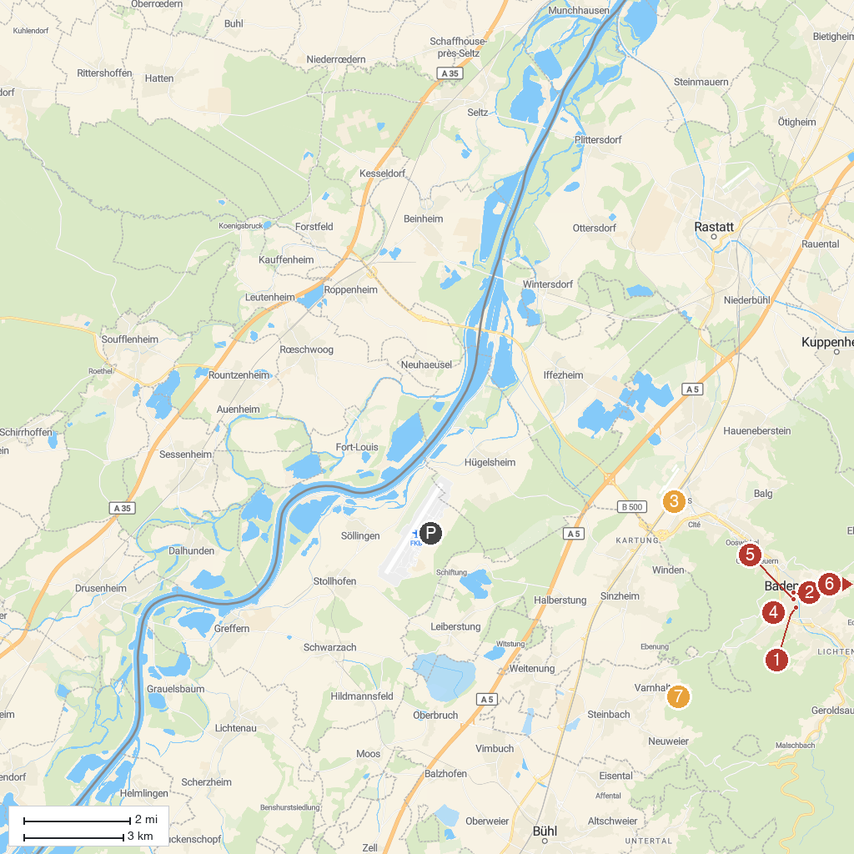
MAP KEY
1. Museum Frieder Burda | 5. The Baden-Baden Casino
2. Faberge Museum | 6. Trinkhalle
3. Frida Kahlo Ausstellung | 7. Dahliengarten Baden-Baden
4. Rose Society Garden (New Rose Garden) | 8. Mini Black Forest Village Varnhalt
P. Cruise port / terminal
Map © MapTiler © OpenStreetMap contributors · cruiseports.org

