Baffin Island, Nunavut, Canada
Canada's largest island and one of the Arctic's most dramatic stages — sheer granite fjords, drifting icebergs, beluga whales, and ancient Inuit homeland await beyond the floe edge.
⚓ Tender/Zodiac only · 🕒 Typical call: 5-8 hrs per community · 💵 Canadian Dollar (CAD) · 🗣️ Inuktitut & English · 🧊 Expedition ships only
✍️ MY DAY IN PORT (FILL IN)
Ship / Date
In port | arrive ______ · all aboard ______
Booked excursion
Notes / meeting point
GETTING ASHORE
- Docking: No cruise piers — all landings via Zodiac inflatable boats
- Communities visited: Iqaluit, Pond Inlet, Pangnirtung, Qikiqtarjuaq
- Best for: Wildlife (narwhal, polar bear, walrus), fjord scenery, Inuit culture
- Season: July–September (ice-free coastal access)
GETTING AROUND
- 🚕 Taxi: ~C flat rate — Iqaluit has local taxi service (Caribou Tuktu Cabs) with a flat rate of approximately C per ride within the city. No app
- 📱 Rideshare: ❌ not available
TOP THINGS TO DO
- Sam Ford Fjord Zodiac Cruise — Glide beneath near-vertical granite walls rising over 1,200 m from sea level in one of the world's great fjords.
- Narwhal and Beluga Watch — Baffin Bay's North Water Polynya supports one of the Arctic's richest marine ecosystems.
- Pangnirtung Inuit Art Visit — Pangnirtung is world-famous for its Inuit tapestries and printmaking.
- Auyuittuq National Park Hike — Hike into the Akshayuk Pass — a dramatic glaciated valley flanked by the peaks of Mount Thor (highest vertical cliff on Earth)…
- Pond Inlet Community & Sirmilik National Park — Pond Inlet (Mittimatalik) is called the Jewel of the North for good reason: tidewater glaciers, narwhal-rich waters, and a warm…
BEST WALKS
- Pangnirtung Village Stroll: Easy · 1-2 hrs · flat gravel roads — Walk from the Zodiac landing at the Pangnirtung wharf through the hamlet to the Uqqurmiut Centre…
- Pond Inlet Hamlet Walk: Easy · 1 hr · flat — From the small boat landing, walk through Mittimatalik along the shoreline road with views across…
WEATHER · DAYLIGHT · MONEY
Month | High °F | Low °F | Rainy days
May | 31 | 22 | 8
Jul | 54 | 43 | 12
Sep | 41 | 33 | 10
Daylight: May 3:23AM–9:40PM · Sep 5:58AM–6:57PM
cruiseports.org/baffin-island · Confirm terminal & all-aboard time with your ship

Baffin Island, Nunavut, Canada — Port Map
Red = walkable sights · Amber = excursions farther out · P = cruise terminal
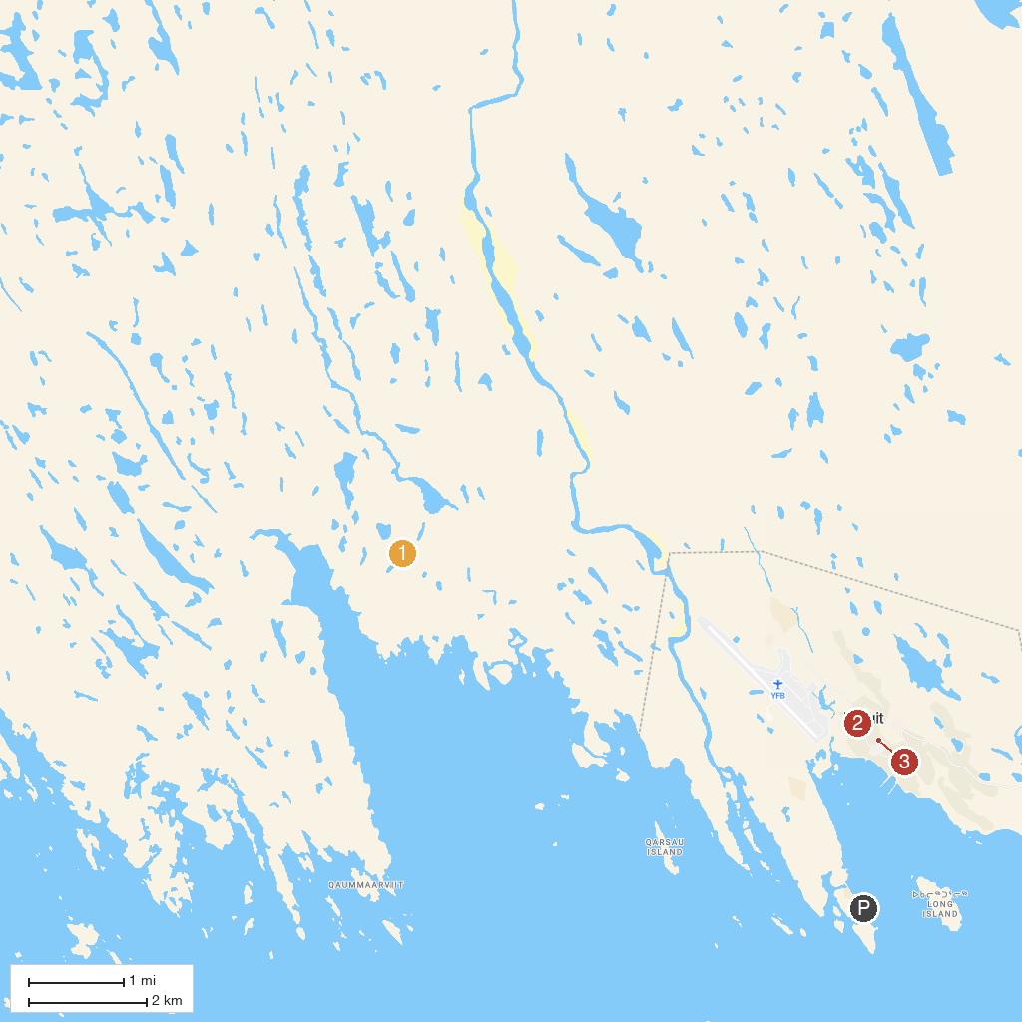
MAP KEY
1. Sylvia Grinnell Territorial Park | 3. St. Jude's Cathedral, Iqaluit
2. Legislative Building of Nunavut
P. Cruise port / terminal
Map © MapTiler © OpenStreetMap contributors · cruiseports.org

