Bagan, Mandalay Region, Myanmar
An ancient plain studded with more than 2,000 brick temples and pagodas built between the 9th and 13th centuries. Arriving by river at dawn, with mist drifting over the spires, is one of Southeast Asia's great travel moments.
⚓ River jetty — small craft dock · 🕒 Typical call: full day or overnight · 💵 Myanmar Kyat (MMK); USD accepted · 🗣️ Burmese; English at tour operations · 🏛️ UNESCO World Heritage Site
✍️ MY DAY IN PORT (FILL IN)
Ship / Date
In port | arrive ______ · all aboard ______
Booked excursion
Notes / meeting point
GETTING ASHORE
- Docking: River jetties near Nyaung-U; river cruise ships dock or moor along the Ayeyarwady riverbank
- Walk to center: Nyaung-U town ~10 min walk; Old Bagan archaeological zone requires transport (e-bike, horse cart, taxi)
- Best For: Temple explorers, history buffs, photographers, hot air balloon experiences
- Don't Miss: Ananda Temple, sunrise over the plains, a hot air balloon flight, lacquerware workshops in Myinkaba
GETTING AROUND
- 🚕 Taxi: $7–$20 USD — Taxis meet ships at Nyaung-U jetty. No meters — agree on price before departing. 20–30 min to Old or New Bagan.
TOP THINGS TO DO
- Bagan Temple Plain by E-Bike — Rent an electric bike and self-navigate the dusty tracks between Ananda Temple, Thatbyinnyu, Sulamani, and Dhammayangyi at your…
- Hot Air Balloon over Bagan — Rise at dawn for a 45-minute balloon flight over 2,000+ temples glowing in morning light.
- Ananda Temple & Shwezigon Pagoda — Visit Ananda Temple — Bagan's most elegant Mon-style pagoda with four giant standing Buddhas — then Shwezigon, believed to…
- Myinkaba Lacquerware Village — Walk through Myinkaba village to watch artisans apply layer upon layer of lacquer — a traditional craft passed down for centuries.
- Day Trip to Mount Popa — Drive ~50 km southeast to Mount Popa, a sacred dormant volcano, where the Taung Kalat monastery perches atop a volcanic plug…
BEST WALKS
- Nyaung-U Market Stroll: Easy · ~1 hr · Flat — From the Nyaung-U jetty, walk into Nyaung-U town to the local market.
- Old Bagan Temple Walk: Easy · 2-3 hrs · Mostly flat sandy tracks — From Old Bagan village, walk or take a short tuk-tuk to Ananda Temple, then continue on foot to…
WEATHER · DAYLIGHT · MONEY
Month | High °F | Low °F | Rainy days
May | 99 | 81 | 9
Jul | 92 | 80 | 19
Sep | 90 | 78 | 20
Daylight: May 5:32AM–6:41PM · Jul 5:37AM–6:55PM · Sep 5:57AM–6:13PM
cruiseports.org/bagan · Confirm terminal & all-aboard time with your ship

Bagan, Mandalay Region, Myanmar — Port Map
Red = walkable sights · Amber = excursions farther out · P = cruise terminal
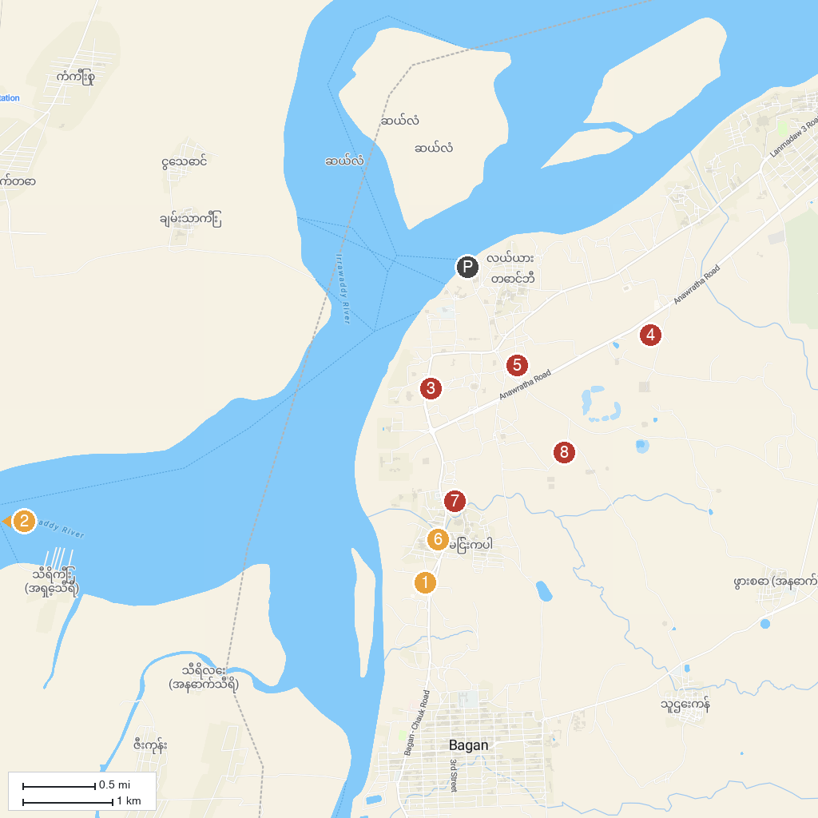
MAP KEY
1. Apalyadana Temple | 5. Ananda Temple
2. Tant Kyi Swel Taw | 6. Manuha Temple
3. Meemalaung Kyaung | 7. Gu Byauk Gyi Myin Kabar
4. Bulethi Pagoda | 8. Dhammayangyi Temple
P. Cruise port / terminal
Map © MapTiler © OpenStreetMap contributors · cruiseports.org

