Baltra Island, Galápagos, Ecuador
The gateway to the Galápagos, Baltra Island is where most cruises begin and end — a flat, arid outpost with a storied WWII history, a solar-powered 'green' airport, and land iguanas wandering the tarmac.
⚓ Tender / Zodiac transfer · 🕒 Embark / Debark port · 💵 US Dollar (USD) · 🗣️ Spanish
✍️ MY DAY IN PORT (FILL IN)
Ship / Date
In port | arrive ______ · all aboard ______
Booked excursion
Notes / meeting point
GETTING ASHORE
- Docking: Tender / zodiac transfer — ships anchor in Aeolian Bay or Itabaca Channel
- Also Known As: South Seymour Island
- Best For: Galápagos cruise embarkation, land iguana spotting near the airport
- Don't Miss: North Seymour Island excursion — blue-footed boobies, frigatebirds, sea lions
GETTING AROUND
- 🚕 Taxi: $25–$30/taxi (up to 4 passengers) — White pickup trucks at the Santa Cruz ferry landing take up to 4 people to Puerto Ayora in ~45 minutes. Split the flat f
- 📱 Rideshare: ❌ not available
TOP THINGS TO DO
- North Seymour Island Walk — A short panga ride brings you to North Seymour, just north of Baltra and one of the Galápagos' best seabird colonies.
- Mosquera Islet Sea Lion Colony — This tiny sandy islet between Baltra and North Seymour hosts a large sea lion colony.
- Snorkeling the Itabaca Channel — The nutrient-rich waters of the Itabaca Channel attract marine iguanas feeding on algae, green sea turtles, rays, and the…
- WWII Military History of Baltra — During WWII, the US Army Air Force used Baltra as a strategic Pacific base to protect the Panama Canal.
- Daphne Major Panga Ride — The twin tuff cones of Daphne Major and Minor rise dramatically from the sea near Baltra.
BEST WALKS
- Dock to Airport Road: 1.5 km | Flat | 20 min — A simple walk from the Muelle de Baltra dock along the paved road toward Seymour Airport.
WEATHER · DAYLIGHT · MONEY
Month | High °F | Low °F | Rainy days
May | 83 | 76 | 7
Jul | 80 | 72 | 1
Sep | 79 | 70 | 0
Daylight: May 5:54AM–6:00PM · Jul 6:04AM–6:09PM · Sep 5:53AM–5:59PM
cruiseports.org/baltra-island · Confirm terminal & all-aboard time with your ship

Baltra Island, Galápagos, Ecuador — Port Map
Red = walkable sights · Amber = excursions farther out · P = cruise terminal
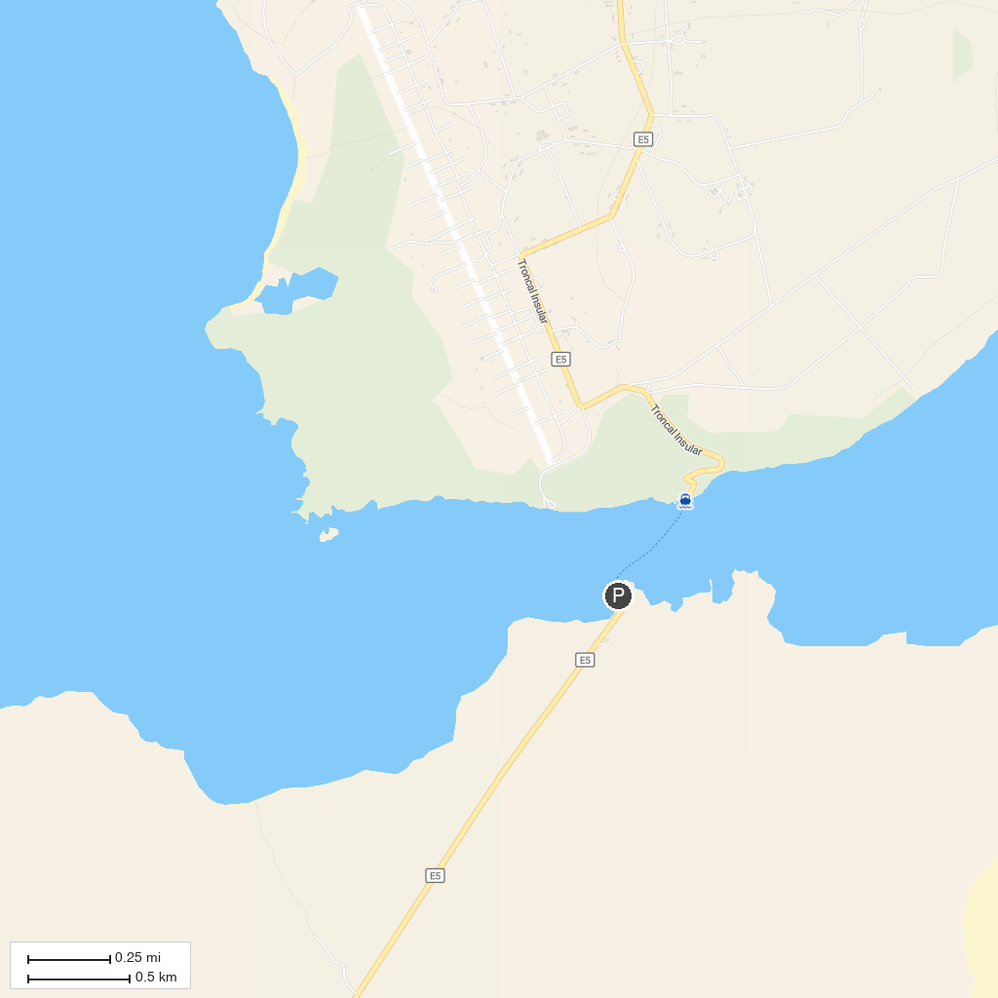
MAP KEY
1. Parque Nacional Galápagos | 3. Rancho Primicias - Giant Tortoise Reserve
2. Lava Tunnel
P. Cruise port / terminal
Map © MapTiler © OpenStreetMap contributors · cruiseports.org

