Bamberg, Bavaria, Germany
Bamberg's seven hills, medieval spires, and legendary smoked beer make it one of the most rewarding stops on a Main or Danube river cruise — and almost everything is walkable from the dock.
⚓ Docked (river pier) · 🕒 Typical call: 6-8 hrs · 💶 Euro (€) · 🗣️ German
✍️ MY DAY IN PORT (FILL IN)
Ship / Date
In port | arrive ______ · all aboard ______
Booked excursion
Notes / meeting point
GETTING ASHORE
- Docking: River pier along Regnitz River near Am Kranen or Markusbrücke — central location
- Walk to center: 5-15 min on foot to Old Town Hall; Cathedral Hill is a short uphill climb
- Best For: Medieval architecture, UNESCO sightseeing, brewery culture, photography
- Don't Miss: Schlenkerla Rauchbier (smoked beer) straight from the tap at the source
GETTING AROUND
- 🚕 Taxi: €5–€15 (short city trips) — Metered taxis available with base fare €4.90 and €2.20–€3.00/km. Since most ships dock near the center, taxi rides withi
- 🚌 Hop-on hop-off: ✅
TOP THINGS TO DO
- UNESCO Old Town Walking Tour — Explore the Altes Rathaus on its island, Little Venice's fishermen's houses along the Regnitz, and the vast Domplatz with its…
- Bamberg Cathedral & Neue Residenz — The 13th-century Romanesque-Gothic Dom houses the Bamberger Reiter equestrian statue and the tomb of Emperor Henry II.
- Rauchbier Brewery Tour — Bamberg is the world capital of smoked beer (Rauchbier).
- Franconian Switzerland Day Trip — Bus excursions head into the Fränkische Schweiz (Franconian Switzerland) region — rolling hills, sandstone cliffs, medieval…
- Alte Hofhaltung & Historical Museum — Adjacent to the cathedral, this 15th-century half-timbered courtyard complex was the bishop's medieval residence and now houses…
BEST WALKS
- Old Town Highlights Loop: 2.5 km · 60-90 min · Easy (some cobblestones) — From the dock at Am Kranen, cross Obere Brücke to the Altes Rathaus island for photos, then walk…
- Riverside & Michelsberg Walk: 3 km · 75 min · Moderate (one hill) — Head north from the dock along the Regnitz to Luisenhain Park, then climb to Michelsberg Monastery…
WEATHER · DAYLIGHT · MONEY
Month | High °F | Low °F | Rainy days
May | 66 | 48 | 11
Jul | 77 | 59 | 11
Sep | 69 | 52 | 9
Daylight: May 5:31AM–8:55PM · Jul 5:24AM–9:19PM · Sep 6:52AM–7:29PM
Representative sunrise/sunset — 2025, 15th of each month; local civil time including DST (Europe/Berlin). Source: Astral; not a forecast or climate average.
cruiseports.org/bamberg · Confirm terminal & all-aboard time with your ship

Bamberg, Bavaria, Germany — Port Map
Red = walkable sights · Amber = excursions farther out · P = cruise terminal
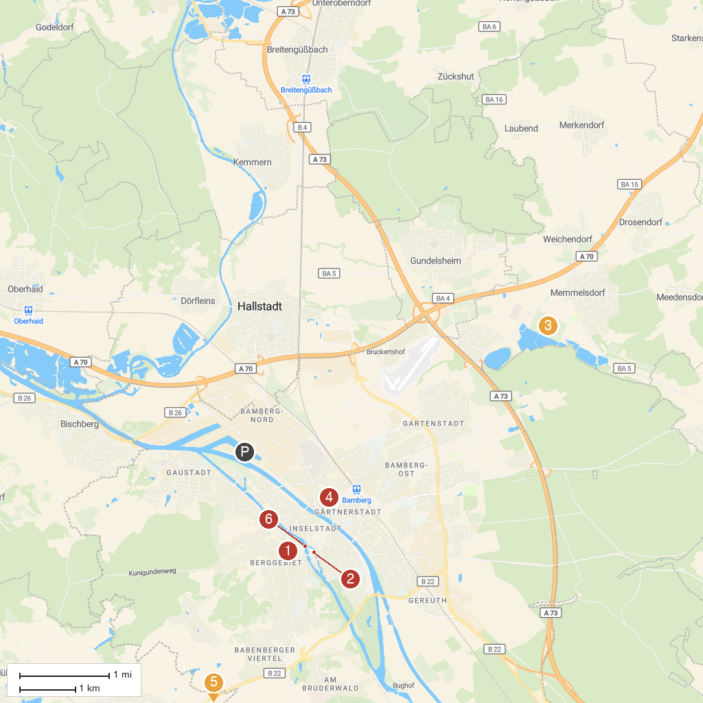
MAP KEY
1. Bamberg Cathedral | 4. Gärtner- und Häckermuseum
2. BAMBERG Tourismus | 5. Bauernmuseum Bamberger Land
3. Seehof Palace | 6. Altes Rathaus
P. Cruise port / terminal
Map © MapTiler © OpenStreetMap contributors · cruiseports.org

