Bandar Seri Begawan, Brunei
The Sultan's gilded capital rises from the jungle on Borneo's north coast — expect opulent mosques, a living stilt city on the river, and proboscis monkeys in the mangroves at dusk.
⚓ Docked at Muara Port · 🕒 Typical call: 8–10 hrs · 💵 Brunei Dollar (BND = SGD) · 🗣️ Malay & English spoken
✍️ MY DAY IN PORT (FILL IN)
Ship / Date
In port | arrive ______ · all aboard ______
Booked excursion
Notes / meeting point
GETTING ASHORE
- Docking: Muara Port, 28 km northeast of city — 30–40 min by taxi or shuttle
- Walk to Center: Not walkable; taxis ~BND 20–25 or ship shuttle
- Best For: Mosques, Kampong Ayer water village, wildlife river cruises
- Don't Miss: Sultan Omar Ali Saifuddien Mosque & proboscis monkey river safari
GETTING AROUND
- 🚕 Taxi: BND 40–50 (~USD 30–37) — Taxis wait at the pier but charge flat negotiated rates — significantly more expensive than Dart. Cash only; credit card
- 📱 Rideshare: ✅ Dart
TOP THINGS TO DO
- Sultan Omar Ali Saifuddien Mosque — Brunei's most photographed landmark: Italian marble, a 52-metre golden dome, and a ceremonial stone boat moored in the…
- Kampong Ayer Water Village Tour — Home to roughly 10,000 residents, this centuries-old stilt village on the Brunei River is the world's largest still-inhabited…
- Royal Regalia Museum — The Sultan's coronation chariot, bejewelled regalia, and gifts from world leaders fill this free museum.
- Proboscis Monkey River Safari — Boat through the Brunei River mangroves at dusk to spot the bulbous-nosed proboscis monkeys — endemic to Borneo — leaping through…
- Ulu Temburong National Park — Brunei's pristine rainforest reserve features a treetop canopy walk, suspension bridges, and jungle rivers.
BEST WALKS
- City Centre Heritage Loop: 2 km · Easy · 1–1.5 hrs — A flat riverside stroll linking BSB's major landmarks.
- Jame' Asr Mosque & Gadong Stroll: Easy · Best by taxi to mosque, then walk Gadong — Take a taxi 4 km north to the Jame' Asr Hassanil Bolkiah Mosque — Brunei's largest, with 29 golden…
WEATHER · DAYLIGHT · MONEY
Month | High °F | Low °F | Rainy days
May | 87 | 77 | 25
Jul | 86 | 76 | 22
Sep | 86 | 75 | 23
Daylight: May 6:06AM–6:26PM · Jul 6:15AM–6:37PM · Sep 6:11AM–6:19PM
cruiseports.org/bandar-seri-begawan · Confirm terminal & all-aboard time with your ship

Bandar Seri Begawan, Brunei — Port Map
Red = walkable sights · Amber = excursions farther out · P = cruise terminal
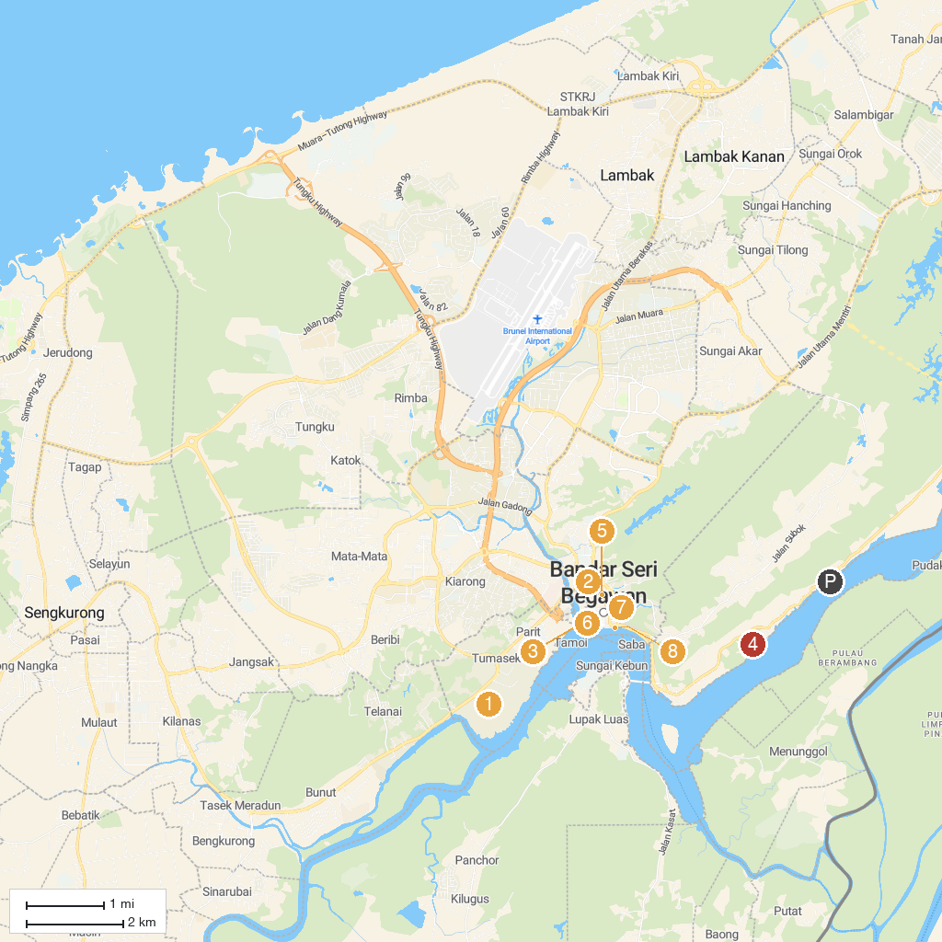
MAP KEY
1. Istana Nurul Iman | 5. Royal Regalia Museum
2. Church of Our Lady of Assumption Catholic Church | 6. BIBD Frame Brunei Darussalam
3. Omar Ali Saifuddien Mosque | 7. Kianggeh Market
4. Malay Technology Museum | 8. Brunei Waterfront
P. Cruise port / terminal
Map © MapTiler © OpenStreetMap contributors · cruiseports.org

