Bandel, West Bengal, India
A quiet bend in the Hooghly holds centuries of history — Portuguese basilicas, Mughal shrines, and terracotta temples crowd a riverbank most travellers speed past.
⚓ River mooring (ghat) · 🕒 Typical call: 5–7 hrs · 💵 Indian Rupee (INR) · 🗣️ Bengali / Hindi · 🌡️ Best Oct–Feb
✍️ MY DAY IN PORT (FILL IN)
Ship / Date
In port | arrive ______ · all aboard ______
Booked excursion
Notes / meeting point
GETTING ASHORE
- Docking: River mooring at Bandel Ghat; small vessels tie up directly, larger ships may anchor and tender
- Walk to centre: Bandel Church is ~500 m from the ghat; town market ~5 min walk
- Best For: Colonial history, Indo-Portuguese architecture, river scenery
- Don't Miss: The ship's mast relic inside the Basilica of the Holy Rosary
GETTING AROUND
- 🚕 Taxi: ₹50–₹150 — Taxis are available near Bandel station for trips to local landmarks. Rates start around ₹9–₹10/km; confirm fare with dr
- 📱 Rideshare: ✅ Uber, Ola
TOP THINGS TO DO
- Basilica of the Holy Rosary — One of the oldest churches in India, the Basilica was founded by Portuguese Augustinians in 1599 and rebuilt in 1660.
- Hooghly Imambara — A short ride downriver in Chinsurah, this grand Shia Muslim shrine features a clock tower whose twin towers — about 150 ft (46 m)…
- Bansberia Temples — Hangseshwari & Ananta Basudeb — In nearby Bansberia, the Hangseshwari Temple is a riot of 13 slender spires dedicated to the goddess Hangseshwari, while the…
- Hooghly River Boat Ride — Local wooden boats leave from Bandel Ghat for leisurely river rides past riverside ghats, temple spires, and colonial bungalows.
- Chandannagar Day Visit — The former French enclave of Chandannagar, about 7 km south, preserves a Strand promenade, the Institut de Chandernagore, and…
BEST WALKS
- Ghat to Basilica Walk: 0.5 km · 10 min · Flat — Follow the main road north from Bandel Ghat to reach the Basilica of the Holy Rosary.
- Riverside Stroll: 1 km · 20 min · Flat — A leisurely walk along the riverbank from the ghat northward reveals fishing boats, dhobi ghats…
WEATHER · DAYLIGHT · MONEY
Month | High °F | Low °F | Rainy days
May | 96 | 75 | 10
Jul | 83 | 74 | 27
Sep | 83 | 72 | 25
Daylight: May 5:21AM–6:25PM · Jul 5:26AM–6:38PM · Sep 5:44AM–5:59PM
cruiseports.org/bandel · Confirm terminal & all-aboard time with your ship

Bandel, West Bengal, India — Port Map
Red = walkable sights · Amber = excursions farther out · P = cruise terminal
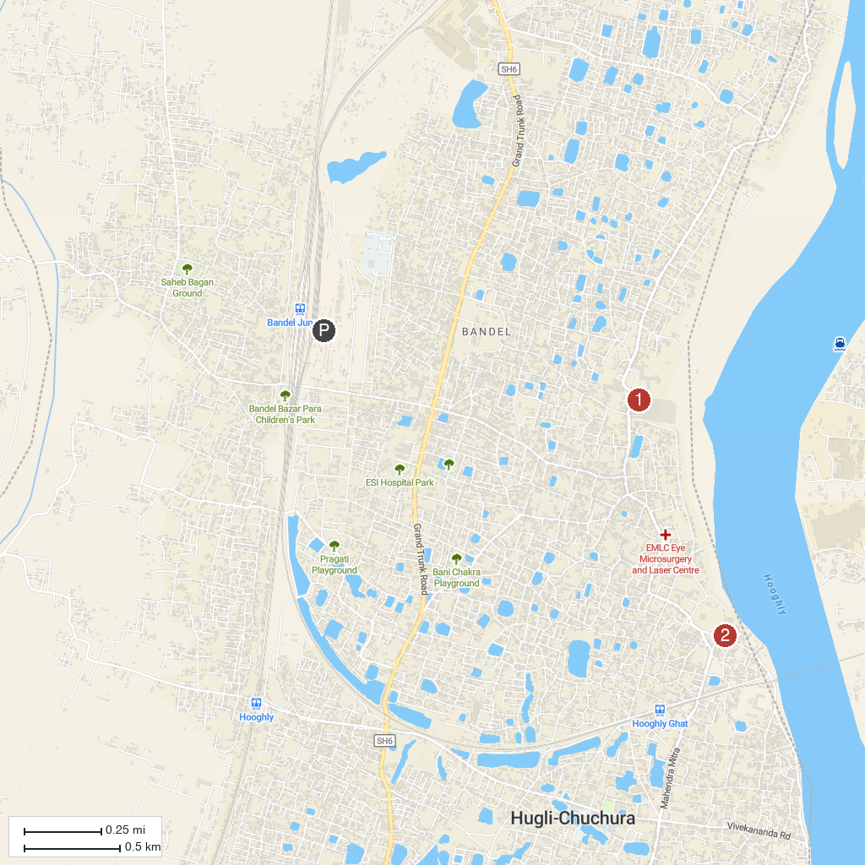
MAP KEY
1. Basilica of the Holy Rosary (Bandel Church) | 2. Hooghly Imambara
P. Cruise port / terminal
Map © MapTiler © OpenStreetMap contributors · cruiseports.org

