Bangor, Maine, USA
Bangor sits where the Penobscot River widens into a working waterfront — a compact New England city famous as Stephen King's home base, with a walkable downtown, quirky landmarks, and Acadia National Park just an hour east.
⚓ Docked (Bangor Landing pier) · 🕒 Typical call: 6-8 hrs · 💵 USD · 🗣️ English · 🌲 Small-ship river port
✍️ MY DAY IN PORT (FILL IN)
Ship / Date
In port | arrive ______ · all aboard ______
Booked excursion
Notes / meeting point
GETTING ASHORE
- Docking: Direct dock at Bangor Landing on the Penobscot River — no tender required
- Walk to center: 5-10 min stroll from the pier to downtown shops and restaurants
- Best For: Stephen King fans, history buffs, nature walks, Acadia day-trippers
- Don't Miss: The 31-ft Paul Bunyan statue and a walk past Stephen King's West Broadway home
GETTING AROUND
- 🚕 Taxi: $5–$15 — Local cab companies including City Cab and A King's Way Cab serve the area. Fares within downtown and nearby neighborhoo
- 📱 Rideshare: ✅ Uber, Lyft
TOP THINGS TO DO
- Stephen King's Bangor Tour — Bangor is King's real-life home and the inspiration for the fictional town of Derry.
- Fort Knox & Penobscot Narrows Observatory — One of Maine's best-preserved Civil War-era granite forts sits 25 miles south on the Penobscot River.
- Acadia National Park Day-Trip — Bar Harbor and Acadia are an hour east and the classic Maine cruise day-trip.
- Cole Land Transportation Museum — More than 200 antique vehicles — trucks, cars, military equipment, and snowplows — fill this well-curated Bangor museum.
- Orono Bog Boardwalk — A 1-mile accessible loop boardwalk through a living peat bog just outside the city — pitcher plants, sundews, and rare sphagnum…
BEST WALKS
- Waterfront to Paul Bunyan Statue: 1.5 miles | ~30 min | Easy | Flat — Walk north along the Penobscot River waterfront path from Bangor Landing, then cut up Main Street…
- Downtown Historic District Stroll: 1 mile loop | ~25 min | Easy | Flat — Circle through Bangor's handsome 19th-century downtown: the Bangor Opera House (Art Deco façade)…
WEATHER · DAYLIGHT · MONEY
Month | High °F | Low °F | Rainy days
May | 64 | 45 | 10
Jul | 79 | 62 | 11
Sep | 71 | 55 | 8
Daylight: May 5:06AM–7:57PM · Jul 5:04AM–8:17PM · Sep 6:14AM–6:45PM
cruiseports.org/bangor-me · Confirm terminal & all-aboard time with your ship

Bangor, Maine, USA — Port Map
Red = walkable sights · Amber = excursions farther out · P = cruise terminal
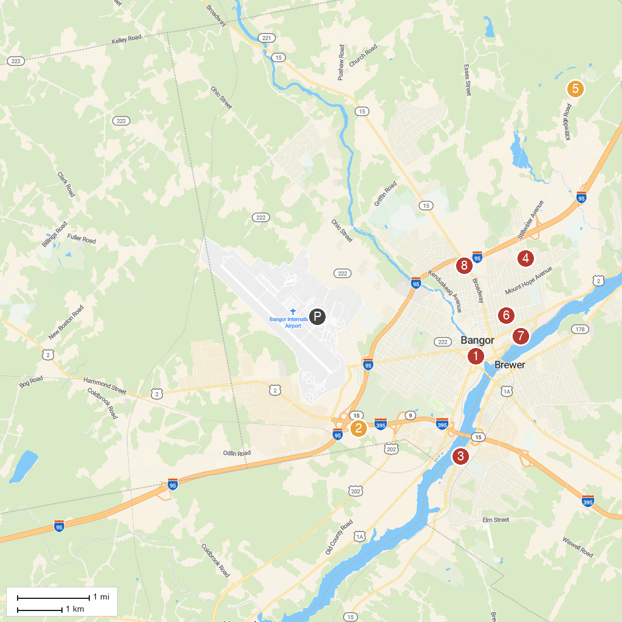
MAP KEY
1. Maine Discovery Museum | 5. Northeast Penjajawoc Preserve
2. Cole Land Transportation Museum | 6. Chapin Park
3. Fisherman’s Park | 7. Williams Park
4. Stillwater Park Playground | 8. International Cryptozoology Museum
P. Cruise port / terminal
Map © MapTiler © OpenStreetMap contributors · cruiseports.org

