Banjul, Gambia
Banjul, The Gambia
Banjul, The Gambia · Banjul, The Gambia · Banjul, The Gambia · Banjul, The Gambia
✍️ MY DAY IN PORT (FILL IN)
Ship / Date
In port | arrive ______ · all aboard ______
Booked excursion
Notes / meeting point
GETTING ASHORE
- Docking: Docked
- Currency: Gambian Dalasi (GMD)
- Language: English
- Climate: Tropical
GETTING AROUND
- 🚕 Taxi: 50–150 GMD — Licensed tourist taxis wait outside the port gate. No meters — negotiate the fare before you get in. City center (Albert
TOP THINGS TO DO
- Albert Market & Colonial Walk — A guided walk through the bustling Royal Albert Market and the colonial-era architecture of the city center.
- Gambia River Boat Trip — A boat trip along the Gambia River, offering views of local villages and excellent birdwatching opportunities.
- Kunta Kinteh Island & Juffureh — A full-day Roots tour to the UNESCO-listed Kunta Kinteh Island and the village of Juffureh, birthplace of Kunta Kinteh.
- Kachikally Crocodile Pool — Visit the sacred crocodile pool in nearby Bakau, home to dozens of West African crocodiles, plus a small museum and nature trail.
BEST WALKS
- Local Seafood: Freshly caught fish and shellfish from the Atlantic — Try the local seafood, especially the grilled fish, at the waterfront eateries.
- Domoda: Traditional Gambian peanut stew — A must-try dish, rich and savory, often served with rice.
- Wonjo: Local Gambian beverage — A refreshing drink made from hibiscus flowers, often served chilled.
WEATHER · DAYLIGHT · MONEY
Month | High °F | Low °F | Rainy days
May | 83 | 72 | 0
Jul | 85 | 78 | 15
Sep | 85 | 78 | 20
Daylight: May 6:40AM–7:25PM · Jul 6:47AM–7:37PM · Sep 6:55AM–7:07PM
cruiseports.org/banjul · Confirm terminal & all-aboard time with your ship

Banjul, Gambia — Port Map
Red = walkable sights · Amber = excursions farther out · P = cruise terminal
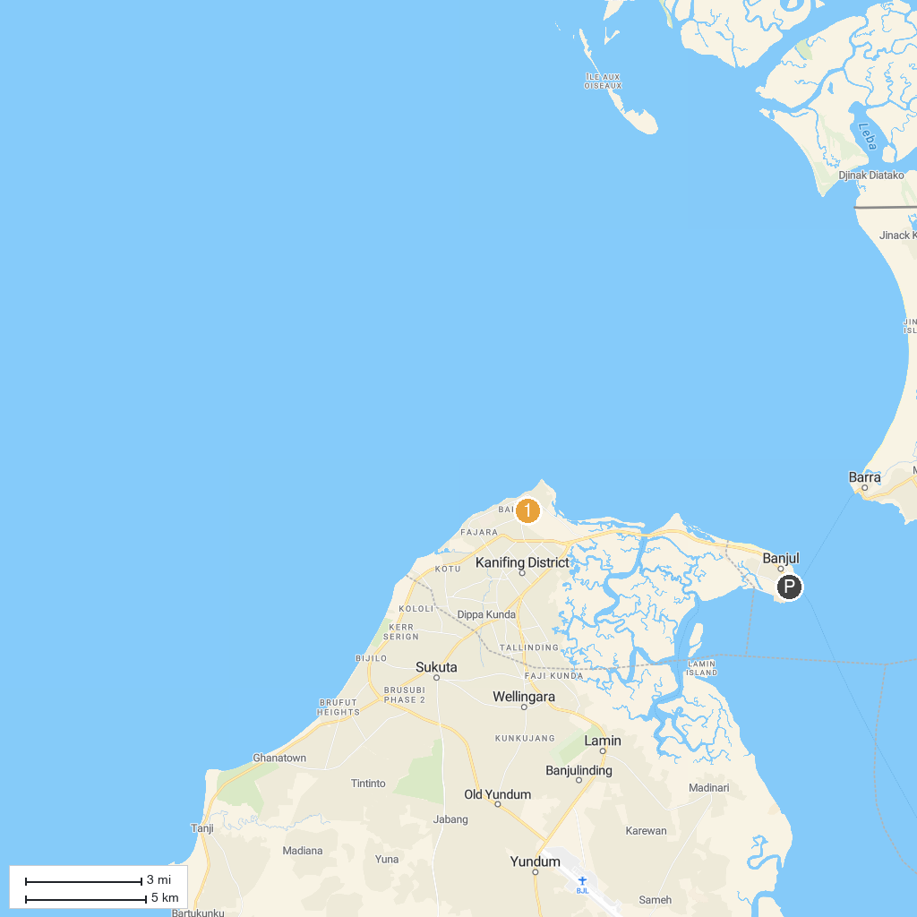
MAP KEY
1. Kachikally Crocodile Pool | 2. GAMBINO WATERSPORTS
P. Cruise port / terminal
Map © MapTiler © OpenStreetMap contributors · cruiseports.org

