Bar, Montenegro
Montenegro's main seaport punches above its weight — ancient ruins on a cliff, one of the world's oldest olive trees, and easy day-trips to Kotor and Lake Skadar all within reach.
⚓ Docked (Port of Adria) · 🕒 Typical call: 7-9 hrs · 💶 Currency: Euro (€) · 🗣️ Language: Montenegrin / English in tourist areas
✍️ MY DAY IN PORT (FILL IN)
Ship / Date
In port | arrive ______ · all aboard ______
Booked excursion
Notes / meeting point
GETTING ASHORE
- Docking: Ships berth directly at Port of Adria; shuttle to city waterfront (~1.5 km)
- Walk to center: Not walkable from berth — free port shuttle drops at King Nikola's Palace
- Best For: History buffs, Lake Skadar birdwatching, Adriatic coast day-trips
- Don't Miss: Stari Bar ruins and the 2,200-year-old Old Olive Tree nearby
GETTING AROUND
- 🚕 Taxi: €4–€12 — Taxis are available at the shuttle drop-off point in the city center. A ride to Stari Bar (Old Bar, ~4 km away) typicall
- 📱 Rideshare: ❌ not available
TOP THINGS TO DO
- Stari Bar — Ancient Ruined Town — Perched on a cliff 4 km from modern Bar, the abandoned medieval city of Stari Bar is Montenegro's most dramatic ruin.
- Lake Skadar National Park — The largest lake in the Balkans sits 35 minutes from Bar by car or train.
- King Nikola's Palace & Waterfront — Walking distance from the shuttle drop-off, this late-19th-century royal palace (now a museum) offers a look at Montenegrin court…
- Budva Old Town — Montenegro's most photogenic medieval town sits about 40 km north of Bar (1 hr by taxi/tour).
- Ulcinj — Ancient Pirate Town — Just 30 km south, Ulcinj was a notorious pirate stronghold and later an Ottoman garrison.
BEST WALKS
- Bar Waterfront Promenade: 1.5 km one-way · Flat · 20-30 min — From the shuttle drop-off at King Nikola's Palace, walk south along the palm-lined promenade past…
- Stari Bar Ruins Walk: Self-guided within ruins · Easy-Moderate · 1-2 hrs — Once you taxi to Stari Bar (€5–8), explore the 16-hectare ruined town on your own.
WEATHER · DAYLIGHT · MONEY
Month | High °F | Low °F | Rainy days
May | 71 | 57 | 8
Jul | 84 | 68 | 4
Sep | 78 | 62 | 7
Daylight: May 5:23AM–7:57PM · Jul 5:21AM–8:17PM · Sep 6:23AM–6:52PM
Representative sunrise/sunset — 2025, 15th of each month; local civil time including DST (Europe/Podgorica). Source: Astral; not a forecast or climate average.
cruiseports.org/bar-montenegro · Confirm terminal & all-aboard time with your ship

Bar, Montenegro — Port Map
Red = walkable sights · Amber = excursions farther out · P = cruise terminal
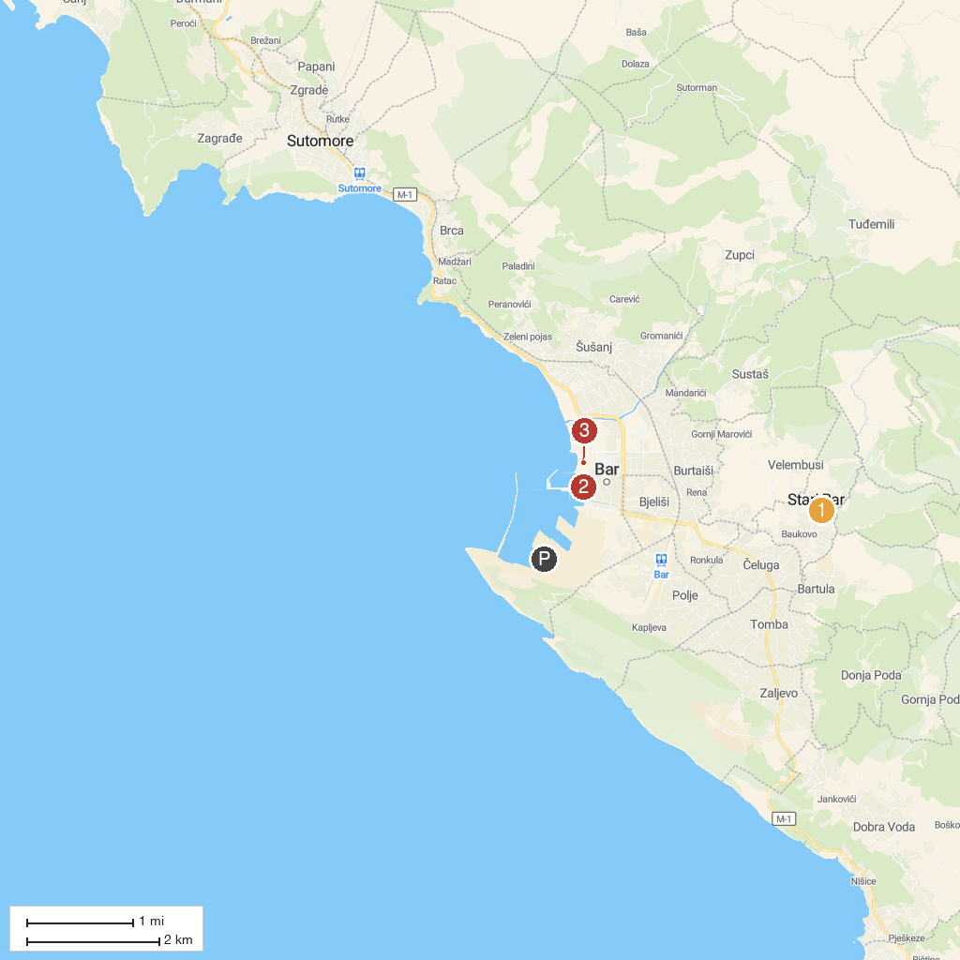
MAP KEY
1. Utvrđeni grad Stari Bar | 3. King Nikola's Palace
2. I Love Bar
P. Cruise port / terminal
Map © MapTiler © OpenStreetMap contributors · cruiseports.org

