Baranof Island, Southeast Alaska, USA
No roads, no tourist infrastructure—just natural hot springs, rushing waterfalls, and the raw quiet of the Alaskan rainforest. Baranof Island's Warm Springs Bay is expedition cruising at its most rewarding.
⚓ Anchor/tender only · 🕒 Typical call: 4–6 hrs · 💵 USD · 🗣️ English · 🧭 Small ships only
✍️ MY DAY IN PORT (FILL IN)
Ship / Date
In port | arrive ______ · all aboard ______
Booked excursion
Notes / meeting point
GETTING ASHORE
- Docking: Anchor & tender — no pier for large ships; small dock at Warm Springs Bay
- Walk to center: No town center; hot springs bathhouse ~0.2 mi from dock
- Best For: Hot springs soaking, waterfall hikes, wildlife, total immersion in wilderness
- Don't Miss: Baranof Hot Springs outdoor pools and the waterfall trail above the bay
GETTING AROUND
- 🚕 Taxi: $20–$30+ to downtown — Local taxis (Baranof Taxi & Tours, Tidal Taxi) operate at city-regulated rates. The terminal is 5-6 miles north of downt
TOP THINGS TO DO
- Baranof Hot Springs Soak — The star attraction: natural mineral hot springs drain into outdoor rock-lined soaking pools overlooking the bay.
- Waterfall & Rainforest Trail — A short but steep trail above the bathhouse leads past Baranof Lake outlet cascades to sweeping views of the bay.
- Kayaking the Bay — The calm, protected waters of Warm Springs Bay are ideal for sea kayaking.
- Floatplane Scenic Flight from Sitka — Some itineraries position Baranof Island as a day trip from Sitka by floatplane, offering aerial views of the island's fjords…
BEST WALKS
- Dock to Hot Springs Boardwalk: 0.2 mi | Easy | 5 min — A flat boardwalk stroll from the public dock past the Warm Springs Bay shoreline to the Baranof Hot…
- Waterfall Trail: 0.5 mi round-trip | Moderate | 30–45 min — From the hot springs bathhouse, follow the trail uphill through old-growth rainforest to the…
cruiseports.org/baranof-island · Confirm terminal & all-aboard time with your ship

Baranof Island, Southeast Alaska, USA — Port Map
Red = walkable sights · Amber = excursions farther out · P = cruise terminal
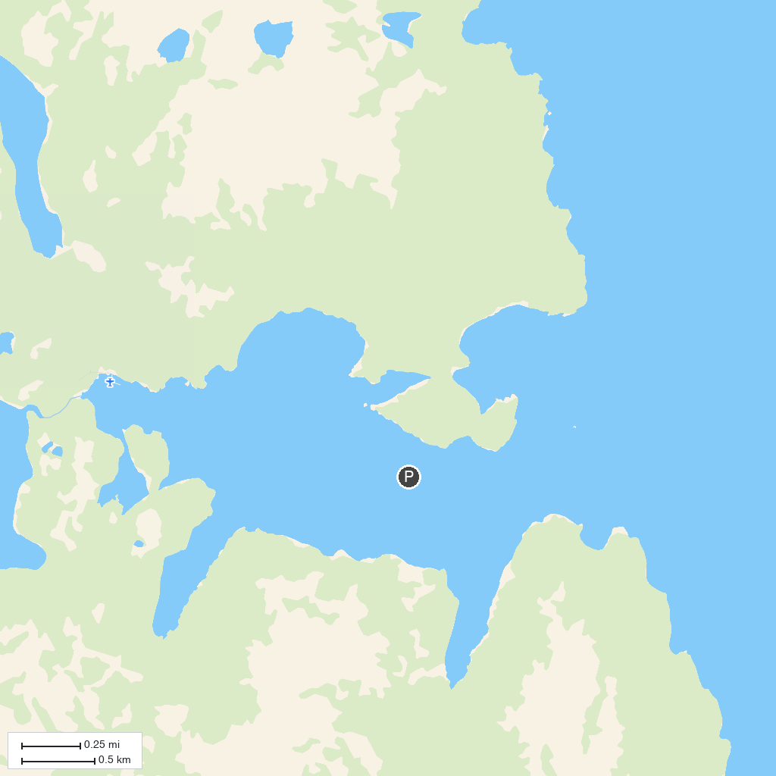
MAP KEY
1. Fortress of the Bear | 3. Whale Park
2. Herring Cove Trail
P. Cruise port / terminal
Map © MapTiler © OpenStreetMap contributors · cruiseports.org

