Barbuda Island, Antigua and Barbuda
One of the Caribbean's last unspoiled islands, Barbuda greets cruise visitors with rose-tinted sand, a vast frigatebird colony in Codrington Lagoon, and a blissful lack of crowds.
⚓ Tender port (no pier) · 🕒 Typical call: 6-8 hrs · 💵 USD & XCD accepted · 🗣️ English · 🏖️ Beach-day destination
✍️ MY DAY IN PORT (FILL IN)
Ship / Date
In port | arrive ______ · all aboard ______
Booked excursion
Notes / meeting point
GETTING ASHORE
- Docking: Tender only — ships anchor offshore; boats land at Codrington waterfront
- Walk to town: Codrington village is steps from the tender landing; beaches require a taxi or tour
- Best For: Pristine pink-sand beaches, frigatebird watching, snorkeling
- Don't Miss: Codrington Lagoon frigatebird colony — one of the largest in the Western Hemisphere
GETTING AROUND
- 🚕 Taxi: Negotiated; agree before riding — Barbuda taxis are informal and limited, especially on cruise-call days. Expect flat rates rather than meters, carry cash
TOP THINGS TO DO
- Codrington Lagoon Frigatebird Sanctuary — Explore the mangrove-lined Codrington Lagoon by small boat to witness one of the largest magnificent frigatebird colonies in the…
- Pink Sand Beach at Low Bay — Low Bay's powdery sand takes on a rosy blush from crushed coral and shell fragments — one of the finest pink-sand beaches in the…
- Snorkeling the Barbuda Reefs — The island's western and southern reefs offer vibrant coral and abundant marine life in gin-clear water.
- Martello Tower & Highland House — Barbuda's Martello Tower is a 19th-century British lookout tower on the south coast.
- Two Foot Bay & Indian Cave — On Barbuda's northeast coast, Indian Cave shelters Amerindian petroglyphs estimated at several hundred years old, set within a…
BEST WALKS
- Codrington Village Stroll: ~0.5 mi | Easy | 20–30 min — From the waterfront landing, walk along the main street through Codrington to see the small market…
WEATHER · DAYLIGHT · MONEY
Month | High °F | Low °F | Rainy days
May | 83 | 77 | 14
Jul | 85 | 79 | 17
Sep | 85 | 79 | 20
Daylight: May 5:35AM–6:32PM · Jul 5:41AM–6:45PM · Sep 5:55AM–6:08PM
cruiseports.org/barbuda-island · Confirm terminal & all-aboard time with your ship

Barbuda Island, Antigua and Barbuda — Port Map
Red = walkable sights · Amber = excursions farther out · P = cruise terminal
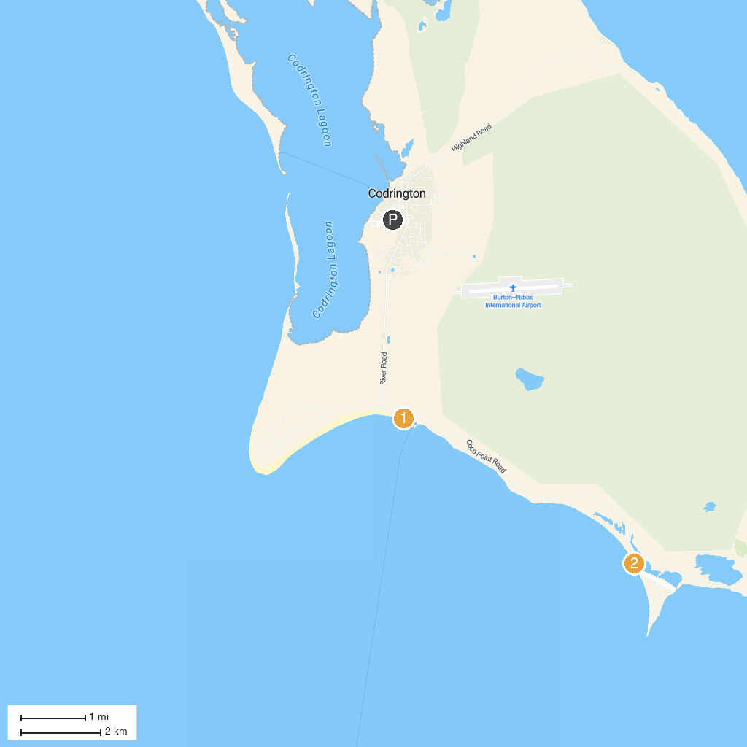
MAP KEY
1. Pink Sand Beach | 2. Princess Diana Beach
P. Cruise port / terminal
Map © MapTiler © OpenStreetMap contributors · cruiseports.org

