Barcelona, Spain
Gaudí's surreal architecture, 2,000 years of Gothic lanes, a working fishing port, and Spain's best food scene — all within reach of a single port call. Know your terminal before you plan anything.
⚓ Docks (pier-side, no tendering) · 🕒 Typical call: 9–11 hrs · 💶 Euro (EUR) · 🗣️ Catalan / Spanish · English widely spoken
✍️ MY DAY IN PORT (FILL IN)
Ship / Date
In port | arrive ______ · all aboard ______
Booked excursion
Notes / meeting point
GETTING ASHORE
- Docking: Adossat or Barcelona quay — use your assigned terminal and the current port terminal index
- To La Rambla: Blue Bus €3 from Moll Adossat (~10 min) · walk ~10 min from WTC South
- Best For: Gaudí architecture · Gothic Quarter · tapas · beach · Montserrat day trip
- Don't Miss: Sagrada Família — pre-book timed entry weeks ahead
GETTING AROUND
- 🚕 Taxi: €12–15 — Yellow-and-black official taxis queue at every terminal exit. A €4.50 pier surcharge is added to the meter — normal and
- 📱 Rideshare: ✅ Uber, Bolt, Cabify
- 🚌 Hop-on hop-off: ✅ Barcelona Bus Turístic / City Tour · from €33 / 24h
TOP THINGS TO DO
- Sagrada Família — Gaudí's century-in-the-making basilica is unlike anything on earth.
- Park Güell & Gaudí Modernisme Trail — Mosaic terraces, stone viaducts and panoramic city views — Gaudí's hillside park is a 45-minute metro ride from the port.
- Gothic Quarter & La Boqueria — Medieval lanes radiating from the Barcelona Cathedral to Plaça Reial — all within walking distance of the Blue Bus stop.
- El Born & Picasso Museum — Hipster Barcelona in a medieval frame: the Picasso Museum spans five Gothic palaces with 4,000+ works tracing the artist from…
- Montjuic — Castle, Cable Car & Miró — The hilltop fortress above the port offers the best views of your ship at dock and the city beyond.
BEST WALKS
- La Rambla to Gothic Quarter loop: ~3 km · 1.5–2 hrs · easy — Walk up La Rambla from the Columbus Monument, detour into La Boqueria market for fresh juice, then…
- El Born & Santa Maria del Mar: ~2 km · 1–1.5 hrs · easy — From the Gothic Quarter, follow Carrer del Born to reach El Born's indie boutiques and the stunning…
- Passeig de Gràcia Modernisme mile: ~2 km · 1–1.5 hrs · easy — Barcelona's grand boulevard lined with Gaudí's Casa Batlló and La Pedrera (Casa Milà), plus Puig i…
WEATHER · DAYLIGHT · MONEY
Month | High °F | Low °F | Rainy days
May | 70 | 57 | 7
Jul | 83 | 70 | 5
Sep | 77 | 65 | 11
Daylight: May 6:32AM–9:03PM · Jul 6:31AM–9:23PM · Sep 7:32AM–8:00PM
ESSENTIAL TRAVEL QUALIFICATIONS
One-zone TMB single €2.90; T-Casual €13.00 / 10 journeys, single-person and not shareable. T-Dia €12.00 / 24 hours, 1 zone from first validation (checked 3 October 2026); verify ticket/route rules.
cruiseports.org/barcelona · Confirm terminal & all-aboard time with your ship

Barcelona, Spain — Port Map
Red = walkable sights · Amber = excursions farther out · P = cruise terminal
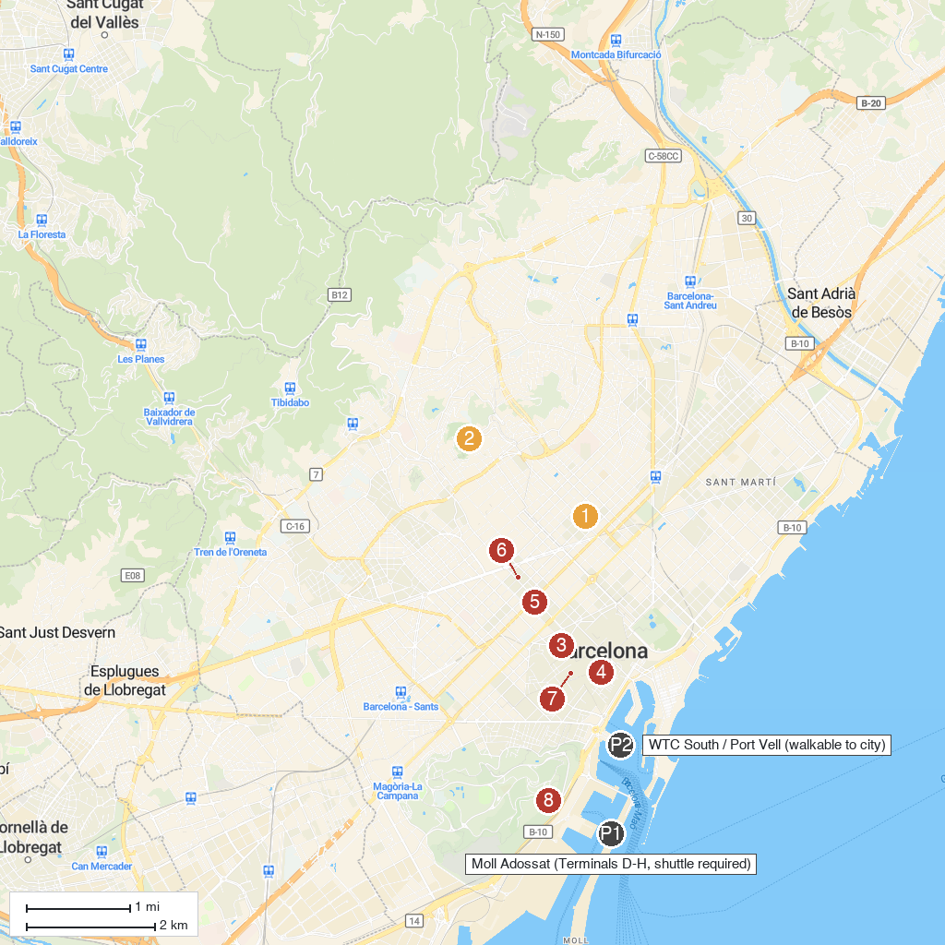
MAP KEY
1. Basílica de la Sagrada Família | 5. Casa Batlló
2. Park Güell | 6. La Pedrera
3. La Rambla | 7. Mercat de la Boqueria
4. Barri Gòtic | 8. Montjuïc
P. Cruise port / terminal
Map © MapTiler © OpenStreetMap contributors · cruiseports.org

