Barentsburg, Svalbard, Norway
A frozen Soviet time capsule on the edge of the world. Barentsburg is an active Russian mining settlement where Lenin still gazes over Grønfjorden and polar bears roam the outskirts.
⚓ Tender port (Zodiac or tour boat) · 🕒 Typical call: 3-5 hrs · 💵 Norwegian Krone (NOK); cards widely accepted · 🗣️ Russian / Norwegian (English understood at tourist spots)
✍️ MY DAY IN PORT (FILL IN)
Ship / Date
In port | arrive ______ · all aboard ______
Booked excursion
Notes / meeting point
GETTING ASHORE
- Docking: Tender only — Zodiacs or small tour boats to quay; 250 steps up to town
- Walk to centre: 5 min uphill from the quay; town is compact and walkable
- Best For: Soviet history, Arctic wildlife, and genuinely off-beat experiences
- Don't Miss: Guided coal mine tour underground in Mine #3 and the Lenin bust in the main square
GETTING AROUND
- 📱 Rideshare: ❌ not available
TOP THINGS TO DO
- Guided Coal Mine Tour (Mine #3) — The world's only active coal mine open to tourists.
- Soviet Town Walk & Pomor Museum — Stroll past Soviet-era murals, the iconic Lenin bust overlooking the fjord, and the small wooden Russian Orthodox chapel built…
- Zodiac Wildlife & Esmark Glacier Cruise — Most excursion boats detour via Esmarkbreen glacier and scan for walrus, beluga whales, and minke whales on the fjord.
- Red Bear Brewery Tasting — Red Bear was the first brewery on Svalbard, opened in 2012.
- Husky Centre Visit — Meet the sled dogs at Barentsburg's husky centre.
BEST WALKS
- Main Square Loop: 1 km · 45 min · Easy — From the quay steps, head up to the main square to see the Lenin statue and the 'Miru Mir' red star.
WEATHER · DAYLIGHT · MONEY
Month | High °F | Low °F | Rainy days
May | 30 | 25 | 9
Jul | 47 | 42 | 9
Sep | 38 | 33 | 12
Daylight: Sep 5:46AM–8:05PM
cruiseports.org/barentsburg · Confirm terminal & all-aboard time with your ship

Barentsburg, Svalbard, Norway — Port Map
Red = walkable sights · Amber = excursions farther out · P = cruise terminal
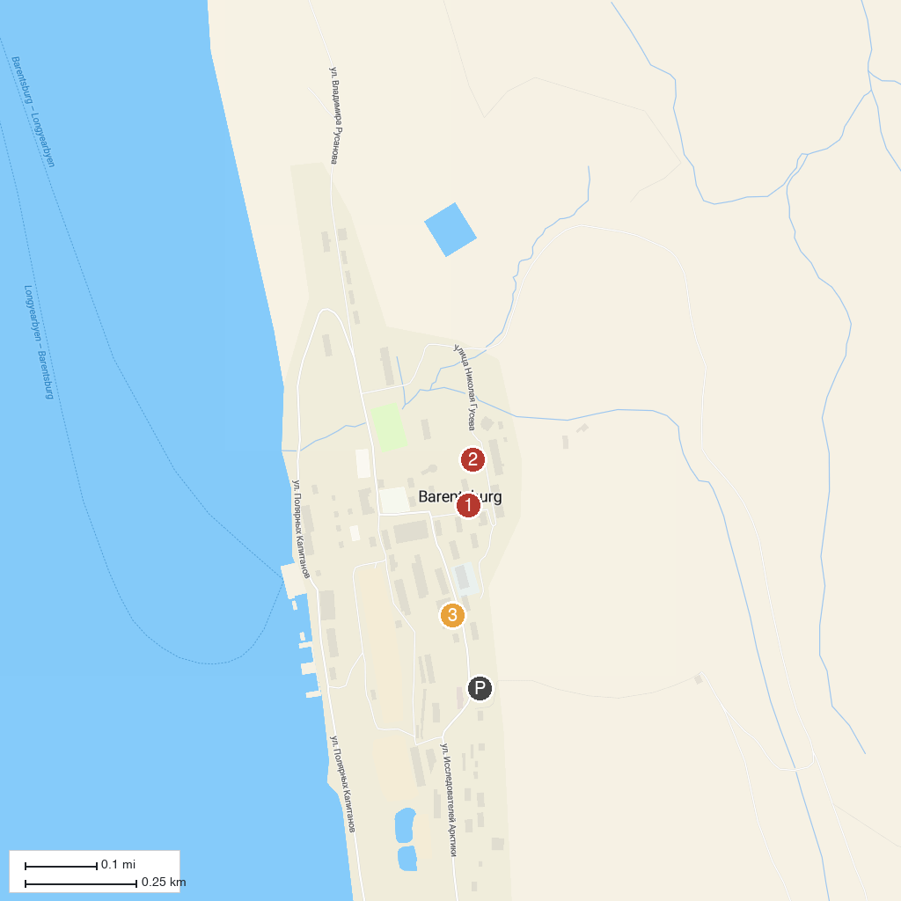
MAP KEY
1. Lenin Statue, Barentsburg | 3. Barentsburg Coal Mine
2. Barentsburg Pomor Museum
P. Cruise port / terminal
Map © MapTiler © OpenStreetMap contributors · cruiseports.org

