Båtsfjord, Finnmark, Norway
One of Norway's most productive fishing harbors, Båtsfjord sits on the wild Varanger Peninsula where seabird cliffs shelter thousands of puffins and gannets, king crabs roam the cold seabed, and the midnight sun paints the tundra gold.
⚓ Pier (central quay) · 🕒 Typical call: 5–8 hrs · 💵 Norwegian Krone (NOK) · 🗣️ Norwegian · 🐦 World-class birdwatching
✍️ MY DAY IN PORT (FILL IN)
Ship / Date
In port | arrive ______ · all aboard ______
Booked excursion
Notes / meeting point
GETTING ASHORE
- Docking: Ships berth at the central quay — village center is a 5-min walk
- Best For: Birdwatching, king crab safaris, Arctic hiking, fishing heritage
- Don't Miss: RIB boat tour to Syltefjordstauran bird cliffs (one of Norway's largest)
- Season Note: Most cruise calls May–Aug; Midnight Sun from late May; Northern Lights in winter
GETTING AROUND
- 🚕 Taxi: 170–190 NOK (~$16–18 USD) — Båtsfjord Taxisentral serves the town. The port is very close to the village center, so most fares are short. Pre-arrang
TOP THINGS TO DO
- Syltefjordstauran Bird Cliff RIB Tour — One of Norway's largest bird cliffs stretches 3 km along the coast and rises 200 m, hosting vast colonies of kittiwakes, gannets…
- King Crab Safari — Båtsfjord sits at the heart of Norway's Red King Crab grounds.
- Hamningberg Historic Fishing Village — A rare survivor of WWII — Hamningberg's 19th-century wooden buildings were left standing when the village escaped the wartime…
- Arctic Tundra Hike — Skrovnes & Veines — Short walks from the village reach the Skrovnes Lighthouse trail bird hide and the Veines Peninsula, where the ruins of a German…
- Harbour Walk & Fishing Industry — Stroll along the working harbour to see fish processing plants in action, local murals celebrating Båtsfjord's seafaring…
BEST WALKS
- Harbour & Church Stroll: 1–2 km · 30 min · Easy · Self-guided — Walk the harbour quay past working fish processing plants and colourful murals, then head up to…
- Skrovnes Lighthouse Trail: ~3 km return · 1 hr · Easy · Arctic tundra — An easy out-and-back walk on open tundra leading to the bird hide near Skrovnes.
WEATHER · DAYLIGHT · MONEY
Month | High °F | Low °F | Rainy days
May | 42 | 34 | 16
Jul | 58 | 49 | 13
Sep | 50 | 42 | 14
Daylight: Sep 5:12AM–6:37PM
cruiseports.org/batsfjord · Confirm terminal & all-aboard time with your ship

Båtsfjord, Finnmark, Norway — Port Map
Red = walkable sights · Amber = excursions farther out · P = cruise terminal
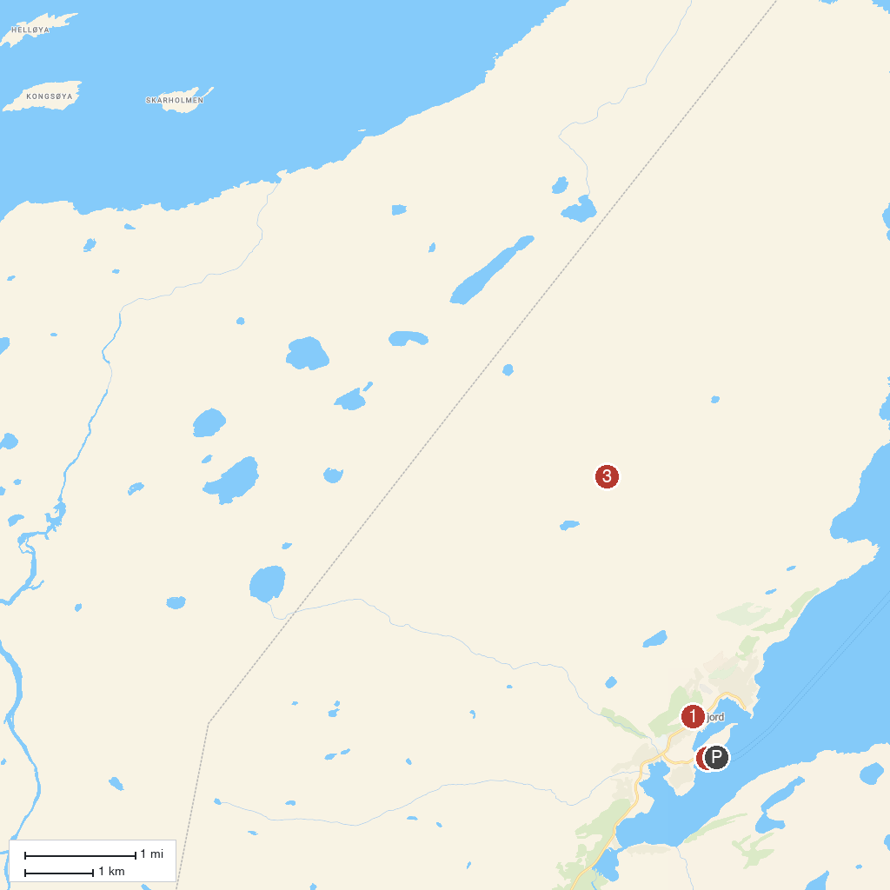
MAP KEY
1. Båtsfjord Kirke | 3. Makkaur Lighthouse
2. Båtsfjord Harbour
P. Cruise port / terminal
Map © MapTiler © OpenStreetMap contributors · cruiseports.org

