Batumi, Adjara, Georgia
Georgia's Black Sea showpiece blends Parisian-style boulevards with Soviet-era quirk, soaring modern architecture, and a hinterland of emerald canyons—all within easy reach of the pier.
⚓ Docked (Batumi Passenger Terminal) · 🕒 Typical call: 8–10 hrs · 💵 Georgian Lari (GEL) · 🗣️ Georgian / Russian · 🌊 Black Sea — Eastern Coast
✍️ MY DAY IN PORT (FILL IN)
Ship / Date
In port | arrive ______ · all aboard ______
Booked excursion
Notes / meeting point
GETTING ASHORE
- Docking: Batumi Passenger Terminal — ships dock alongside; city center is a ~15-min walk or 5-min taxi
- Walk to center: ~15 min on foot to Piazza Square; Boulevard starts immediately at port
- Best For: Scenic promenade strolls, Adjara canyon day trips, Georgian food & wine
- Don't Miss: Ajarian Khachapuri (boat-shaped cheese bread) and Martvili Canyon boat ride
GETTING AROUND
- 🚕 Taxi: 5–15 GEL (~$2–6 USD) — Readily available outside the port. Batumi's cruise terminal is centrally located, so most rides to city attractions are
- 📱 Rideshare: ✅ Bolt, Maxim, Yandex Taxi
TOP THINGS TO DO
- Martvili Canyon Boat Ride — Board small wooden boats to drift through a turquoise-green gorge carved by the Abasha River.
- Prometheus Cave & Underground Lake — One of the largest caves in the Caucasus, with dramatic stalactite chambers and an underground boat ride on a subterranean river.
- Batumi Boulevard & City Walk — Stroll the full 7 km seafront promenade past the Ali & Nino kinetic sculpture, the spiral Alphabet Tower, Piazza Square's clock…
- Gonio Apsaros Roman Fortress — A well-preserved Roman fortification just 15 km south of Batumi, dating to the 1st century AD.
- Adjara Food & Wine Village Tour — Head into the green Adjara hills for tastings of Georgian wine, Chacha (grape brandy), homemade cheese, and a spread of…
BEST WALKS
- The Boulevard End-to-End: 4–5 km · 1–1.5 hrs · Flat & paved — Walk north from the passenger terminal along Batumi Boulevard — past the Dancing Fountains, Europe…
- Old Town Backstreets: 1.5 km · 45 min · Easy — Duck behind Piazza Square into Batumi's compact 19th-century quarter: narrow balconied streets, the…
WEATHER · DAYLIGHT · MONEY
Month | High °F | Low °F | Rainy days
May | 71 | 56 | 14
Jul | 78 | 69 | 18
Sep | 76 | 65 | 16
Daylight: May 5:54AM–8:26PM · Jul 5:52AM–8:45PM · Sep 6:53AM–7:22PM
cruiseports.org/batumi · Confirm terminal & all-aboard time with your ship

Batumi, Adjara, Georgia — Port Map
Red = walkable sights · Amber = excursions farther out · P = cruise terminal
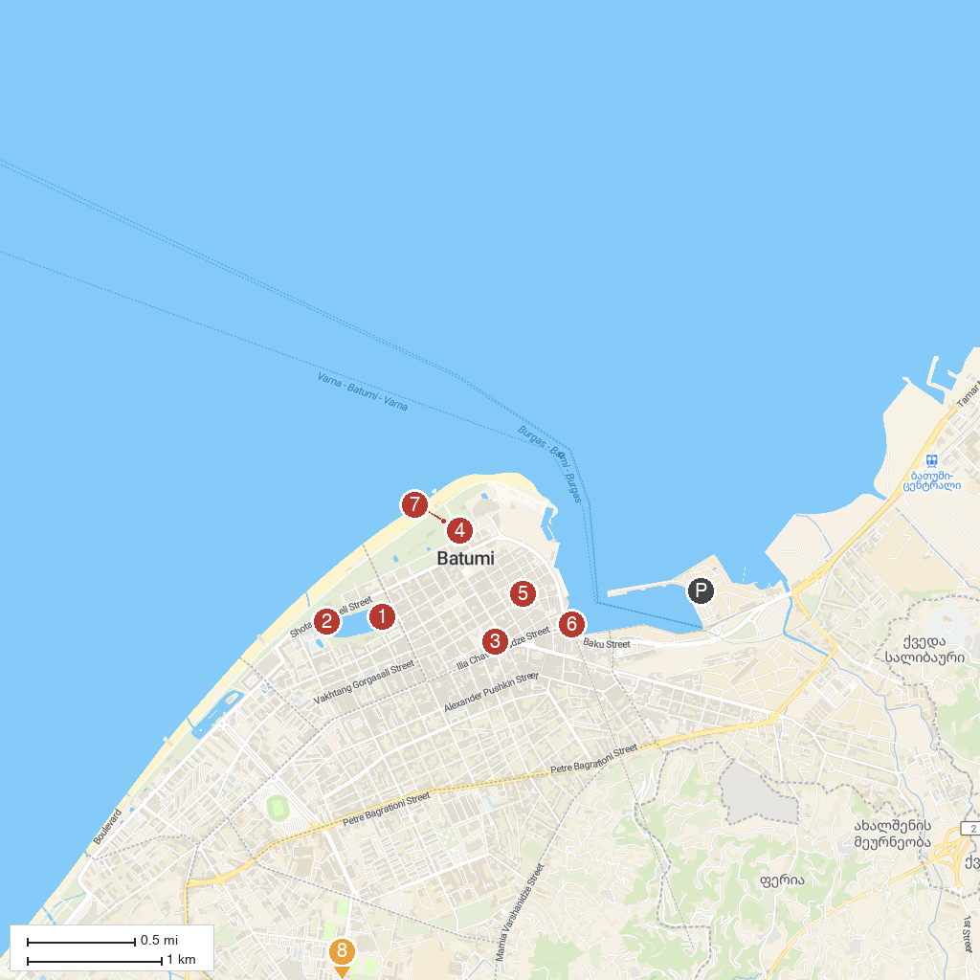
MAP KEY
1. Batumi Central Park | 5. Batumi Piazza Square
2. Batumi Dolphinarium | 6. Argo Cable Car
3. Holy Mother Virgin Nativity Cathedral | 7. Collonades
4. Batumi Boulevard | 8. Ethnographic Museum "Borjgalo"
P. Cruise port / terminal
Map © MapTiler © OpenStreetMap contributors · cruiseports.org

