Baubau, Southeast Sulawesi, Indonesia
Baubau guards the southern entrance to the Banda Sea with a Guinness-record fortress and a culture shaped by sultans, sea gypsies, and seafarers. Few cruise ports in Southeast Asia feel this genuinely off the beaten path.
⚓ Docked (Murhum Port) · 🕒 Typical call: 7-9 hrs · 💵 Indonesian Rupiah (IDR) · 🗣️ Indonesian / Butonese
✍️ MY DAY IN PORT (FILL IN)
Ship / Date
In port | arrive ______ · all aboard ______
Booked excursion
Notes / meeting point
GETTING ASHORE
- Docking: Murhum Port, ~2 km from city center; walk or short taxi
- Don't Miss: Benteng Keraton Buton — one of the world's largest fortresses
- Best For: History, local culture, off-the-beaten-path Indonesia
- Currency: Indonesian Rupiah; small USD/AUD acceptable at some stalls
GETTING AROUND
- 🚕 Taxi: ~50,000 IDR (~$3 USD) — Taxis wait at the port gate. Agree on a fare before departing; the city center is a short ride away.
- 📱 Rideshare: ✅ Grab, Maxim
TOP THINGS TO DO
- Benteng Keraton Buton Fortress — This 16th-century limestone hilltop citadel — recognized by Guinness World Records in 2006 as the largest fortress in the world…
- Pasar Wameo Market & Ikat Weavers — Baubau's traditional market near the waterfront buzzes with daily life.
- Nirwana Beach — About 9-10 km southwest of the city center (near Betoambari Airport), Nirwana Beach delivers clear water, white sand, and calm…
- Bajo Sea-Gypsy Village — The Bajo (Bajau) people have built their homes on stilts over the water for centuries.
- Sampolawa River Boat Trip — Head south for a boat journey up the Sampolawa River through lush mangrove and jungle scenery.
BEST WALKS
- Port to City Center & Market: 2 km | Easy | 25-30 min — A flat walk along the waterfront road from Murhum Port brings you to the city center and Pasar…
- Benteng Keraton Fortress Grounds: 1-2 km inside fortress | Moderate | 1-1.5 hrs — Once you've taxied up to the fortress, walk the perimeter walls and interior lanes past the Mesjid…
WEATHER · DAYLIGHT · MONEY
Month | High °F | Low °F | Rainy days
May | 85 | 77 | 23
Jul | 84 | 75 | 14
Sep | 87 | 74 | 7
Daylight: May 5:50AM–5:41PM · Jul 6:00AM–5:50PM · Sep 5:42AM–5:46PM
cruiseports.org/baubau · Confirm terminal & all-aboard time with your ship

Baubau, Southeast Sulawesi, Indonesia — Port Map
Red = walkable sights · Amber = excursions farther out · P = cruise terminal
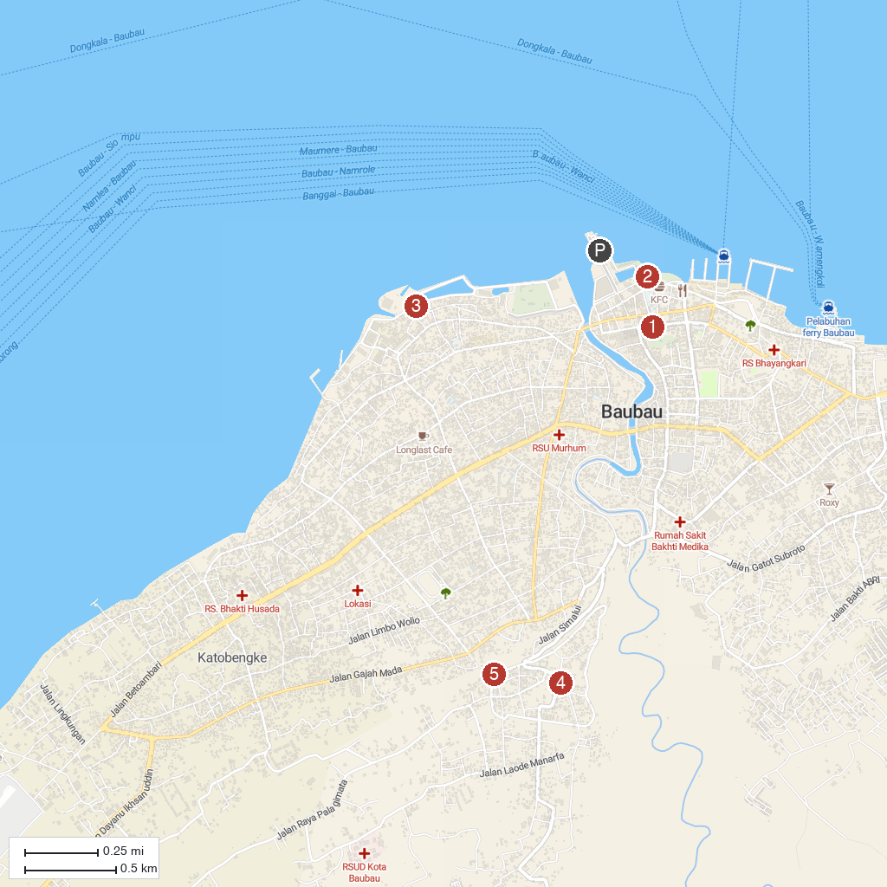
MAP KEY
1. Istana Malige | 4. Buton Sultanate Palace Fortress
2. Drakenstandbeeld van het Boeton Islamitische Sultanaat | 5. lawana gundu-gundu
3. BATU POARO
P. Cruise port / terminal
Map © MapTiler © OpenStreetMap contributors · cruiseports.org

