Beaufort, North Carolina, USA
One of America's oldest port towns, Beaufort charms small-ship cruisers with a walkable historic waterfront, wild Banker horses just across the channel, and the shipwreck legacy of Blackbeard lurking in every maritime museum corner.
⚓ Docked — Beaufort Town Docks · 🕒 Typical call: 7-9 hrs · 💵 USD · 🗣️ English · 🐴 Wild horses visible from dock
✍️ MY DAY IN PORT (FILL IN)
Ship / Date
In port | arrive ______ · all aboard ______
Booked excursion
Notes / meeting point
GETTING ASHORE
- Docking: Beaufort Town Docks, Front Street — small/mid-size ships only (up to ~250 ft); walk-off access to downtown
- Walk to center: Immediate — dock is on Front Street in the heart of the historic district
- Best For: Wild horse tours, maritime history, Cape Lookout ferry, kayaking, waterfront dining
- Don't Miss: Ferry to Shackleford Banks for wild Banker horses; NC Maritime Museum (Blackbeard artifacts)
GETTING AROUND
- 🚕 Taxi: Metered — Local options include Carteret Cab and Crystal Coast Cab. Useful if rideshare wait times are long; confirm rates by phon
- 📱 Rideshare: ✅ Uber, Lyft
TOP THINGS TO DO
- Wild Horse Ferry to Shackleford Banks — A short ferry ride across Back Sound lands you on Shackleford Banks, where a herd of free-roaming Banker horses has lived since…
- Cape Lookout National Seashore — Ferry to the undeveloped barrier island of Cape Lookout for pristine shelling beaches, the distinctive diamond-pattern Cape…
- Dolphin & Wild Horse Cruise — Narrated boat tours weave through Taylor Creek, the Rachel Carson Reserve, and Shackleford Banks in search of bottlenose dolphins…
- North Carolina Maritime Museum — One of the best free maritime museums on the East Coast, showcasing Blackbeard's flagship Queen Anne's Revenge artifacts…
- Beaufort Historic Site & Old Burying Ground — Walk through nine preserved 18th- and 19th-century structures including the 1732 Old Burying Ground — one of the oldest…
BEST WALKS
- Front Street Historic Waterfront Stroll: 0.5 mi · 20-30 min · Easy — The classic Beaufort walk: stroll Front Street from the Town Docks past the NC Maritime Museum…
- Historic District Loop: 1 mi · 40 min · Easy — Extend the Front Street walk inland to the Beaufort Historic Site, where nine preserved…
WEATHER · DAYLIGHT · MONEY
Month | High °F | Low °F | Rainy days
May | 82 | 67 | 11
Jul | 89 | 76 | 17
Sep | 84 | 71 | 14
Daylight: May 6:24AM–8:14PM · Jul 6:26AM–8:30PM · Sep 7:06AM–7:28PM
cruiseports.org/beaufort-nc · Confirm terminal & all-aboard time with your ship

Beaufort, North Carolina, USA — Port Map
Red = walkable sights · Amber = excursions farther out · P = cruise terminal
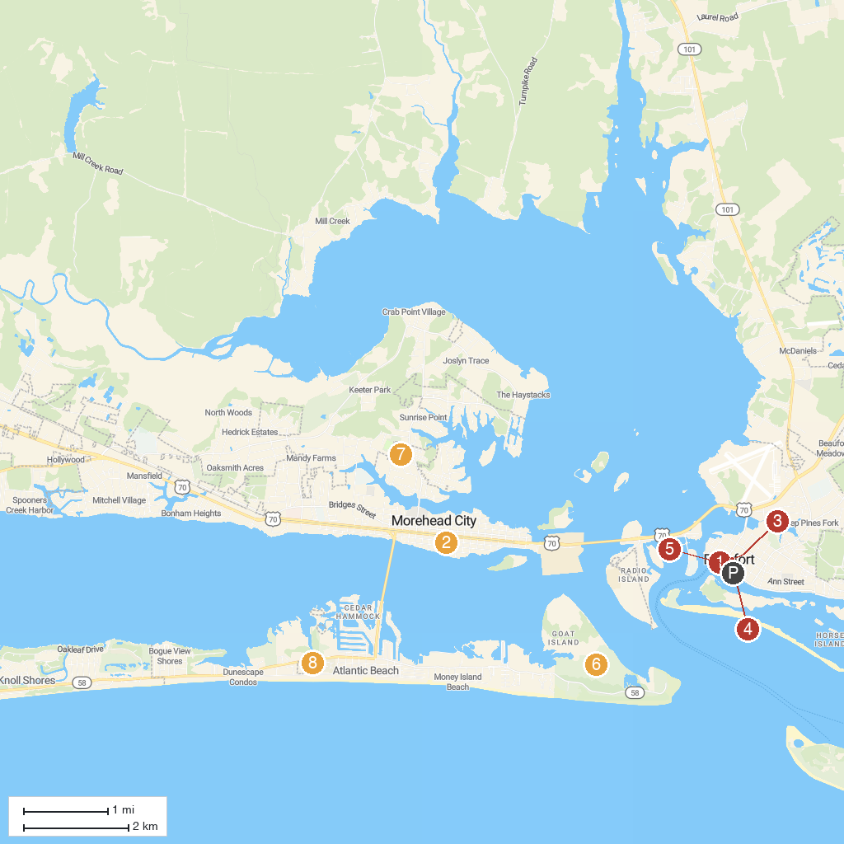
MAP KEY
1. North Carolina Maritime Museum in Beaufort | 5. Escape Lookout Games
2. Shevans Park | 6. Fort Macon State Park
3. Old Burying Ground | 7. Rotary Park
4. Island Express Ferry Service | 8. The Splash Pad
P. Cruise port / terminal
Map © MapTiler © OpenStreetMap contributors · cruiseports.org

