Beijing (via Tianjin), China
Cruise ships dock at Tianjin's modern Xingang terminal, gateway to one of history's great capitals — where the Great Wall meets imperial palaces and ancient alleyways.
⚓ Pier (docked) · 🕒 Typical call: 8–10 hrs (overnight recommended) · 💴 Currency: CNY (Chinese Yuan) · 🗣️ Language: Mandarin Chinese
✍️ MY DAY IN PORT (FILL IN)
Ship / Date
In port | arrive ______ · all aboard ______
Booked excursion
Notes / meeting point
GETTING ASHORE
- Docking: Tianjin International Cruise Home Port (Xingang) — 2 berths, up to 225,000 GT
- Distance to Beijing: ~150 km; taxi to Tanggu station (30–40 min), then high-speed train (~60 min) to Beijing South
- Best For: World-class history — Great Wall, Forbidden City, Temple of Heaven, Summer Palace
- Don't Miss: A pre-booked Mutianyu Great Wall section — less crowded than Badaling, with cable car option
GETTING AROUND
- 🚕 Taxi: CNY 150–180 (~USD 21–25) — Metered taxis from Tianjin International Cruise Home Port to Tianjin city center; roughly 60 km, about 1 hour. Have your
- 📱 Rideshare: ✅ DiDi
TOP THINGS TO DO
- Great Wall at Mutianyu — The most visitor-friendly restored section of the Wall, northeast of Beijing.
- Forbidden City & Tiananmen Square — Ming dynasty imperial palace — 980 buildings, 72 hectares, and 600 years of history.
- Hutong Walk & Rickshaw Tour — Weave through Beijing's ancient courtyard alleyways — Shichahai or Nanluoguxiang are the most atmospheric.
- Temple of Heaven — Where Ming and Qing emperors prayed for good harvests.
- Summer Palace — Imperial lakeside garden retreat — Kunming Lake, Long Corridor, and Longevity Hill.
BEST WALKS
- Beijing's Imperial Axis: 4–5 km | Easy | All-day | Central Beijing — Walk south to north along Beijing's ancient ceremonial spine: Tiananmen Square, through the…
- Shichahai Hutong Wander: 2–3 km | Easy | 1.5–2 hrs | Drum Tower area — Explore the lake-dotted hutong neighbourhood around Shichahai.
WEATHER · DAYLIGHT · MONEY
Month | High °F | Low °F | Rainy days
May | 81 | 59 | 5
Jul | 89 | 74 | 13
Sep | 80 | 64 | 5
Daylight: May 4:58AM–7:17PM · Jul 4:57AM–7:36PM · Sep 5:52AM–6:19PM
cruiseports.org/beijing · Confirm terminal & all-aboard time with your ship

Beijing (via Tianjin), China — Port Map
Red = walkable sights · Amber = excursions farther out · P = cruise terminal
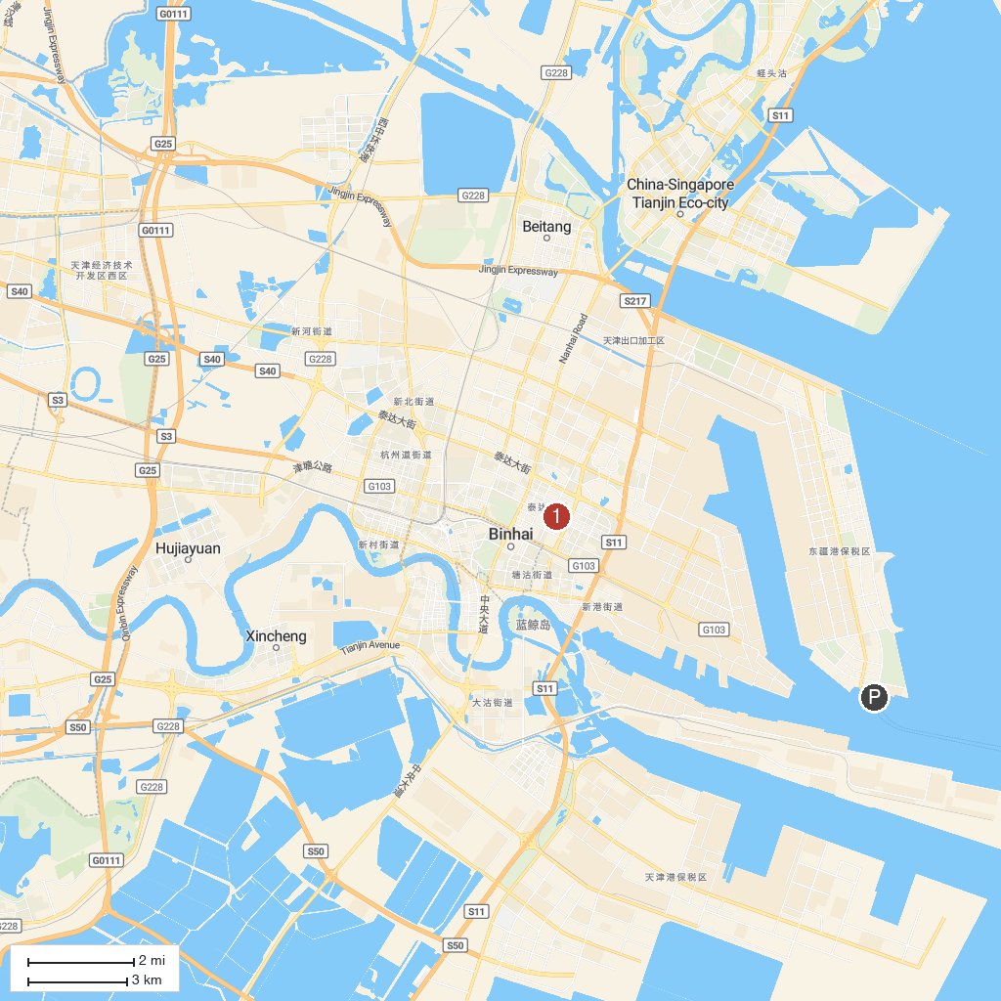
MAP KEY
1. Tianjin Ancient Culture Street | 3. National Maritime Museum, Binhai
2. Italian Style Town, Tianjin
P. Cruise port / terminal
Map © MapTiler © OpenStreetMap contributors · cruiseports.org

