Belawan, North Sumatra, Indonesia
Medan's gateway port opens the door to royal Malay palaces, the vast caldera of Lake Toba, and jungle treks to spot wild orangutans — but plan ahead, the city is a 45-minute drive away.
⚓ Docked (cruise terminal) · 🕒 Typical call: 8-10 hrs · 💵 Indonesian Rupiah (IDR) · 🗣️ Indonesian / Malay · 🌴 Tropical — expect heat and humidity
✍️ MY DAY IN PORT (FILL IN)
Ship / Date
In port | arrive ______ · all aboard ______
Booked excursion
Notes / meeting point
GETTING ASHORE
- Docking: Ships berth at Belawan International Cruise Terminal — no tendering required
- Distance to Medan: ~25 km; 45–60 min by taxi or tour bus (traffic can be heavy)
- Best For: Culture, history, wildlife (orangutans), and North Sumatran cuisine
- Don't Miss: Maimun Palace and the Great Mosque of Medan — both within 1 km of each other
GETTING AROUND
- 🚕 Taxi: IDR 100,000–200,000 (~$6–13 USD) — Taxis queue at the port for the 25–26 km ride to Medan city center (45–60 min). Agree on a fare before departing; driver
- 📱 Rideshare: ✅ Grab
TOP THINGS TO DO
- Medan City Highlights: Maimun Palace & Great Mosque — The 1888 Maimun Palace of the Sultans of Deli dazzles with Malay-Moorish architecture, and the ornate Great Mosque of Medan…
- Lake Toba & Samosir Island — The world's largest volcanic lake — formed by a supervolcanic eruption 74,000 years ago — sits in cool highlands 3 hours south of…
- Orangutan Trek at Bukit Lawang — The Bohorok River village of Bukit Lawang is the gateway to Gunung Leuser National Park, where semi-wild Sumatran orangutans…
- Tjong A Fie Mansion — Built in 1900 by a wealthy Chinese merchant, this beautifully preserved mansion in central Medan blends Chinese, Malay, and Art…
- Berastagi Highlands & Sipiso-Piso Waterfall — The cool hill town of Berastagi sits 1,300 m above sea level among active volcanoes.
BEST WALKS
- Medan Heritage Walk: Palaces, Mosque & Mansion: ~3 km · 1.5 hrs · Easy · Central Medan — Start at Maimun Palace, walk north to the Great Mosque of Medan, then east along Jalan Ahmad Yani…
- Kesawan Square Stroll: ~1 km · 30 min · Easy · Historic district — The old Kesawan district along Jalan Ahmad Yani retains colonial Dutch-era shophouses and the…
WEATHER · DAYLIGHT · MONEY
Month | High °F | Low °F | Rainy days
May | 86 | 76 | 28
Jul | 87 | 76 | 23
Sep | 86 | 75 | 27
Daylight: May 6:13AM–6:30PM · Jul 6:21AM–6:40PM · Sep 6:16AM–6:24PM
cruiseports.org/belawan-medan · Confirm terminal & all-aboard time with your ship

Belawan, North Sumatra, Indonesia — Port Map
Red = walkable sights · Amber = excursions farther out · P = cruise terminal
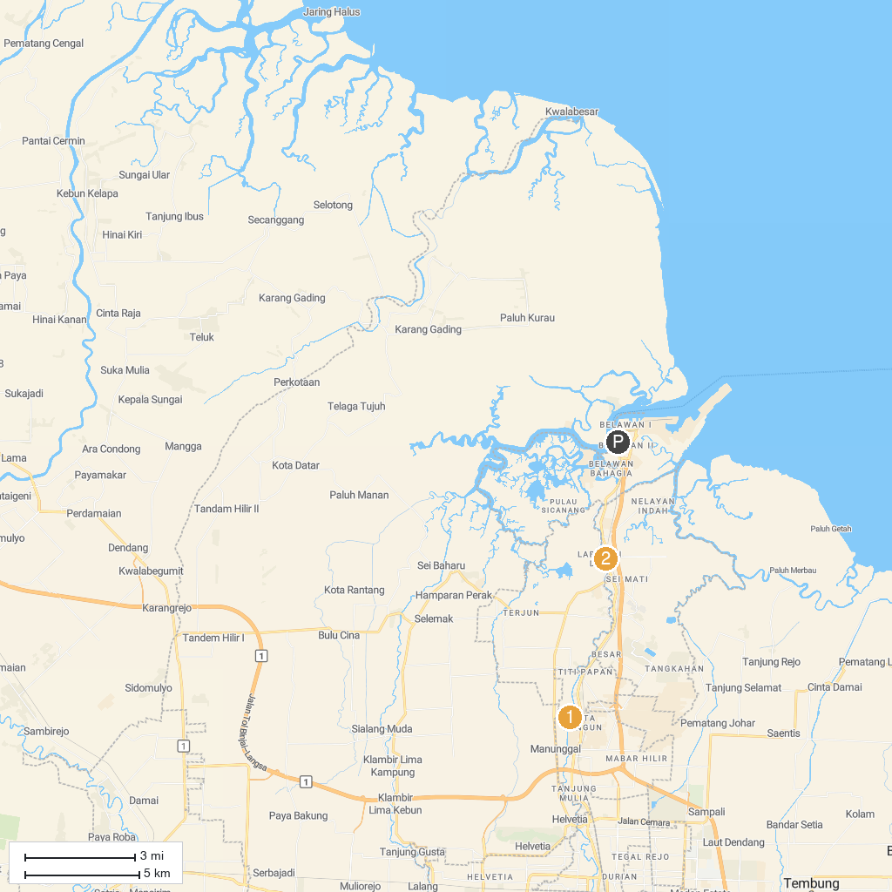
MAP KEY
1. Pubbarama Buddhist Centre (PBC) | 2. Al-Osmani Mosque
P. Cruise port / terminal
Map © MapTiler © OpenStreetMap contributors · cruiseports.org

