Belfast, Northern Ireland, UK
Where the Titanic was born and the Causeway Coast begins — Belfast pairs world-class museums with one of Europe's great scenic drives, all within easy reach of the cruise pier.
⚓ Docked (D1 terminal) · 🕒 Typical call: 8–10 hrs · 💷 GBP (pounds sterling) · 🗣️ English
✍️ MY DAY IN PORT (FILL IN)
Ship / Date
In port | arrive ______ · all aboard ______
Booked excursion
Notes / meeting point
GETTING ASHORE
- Docking: D1 Belfast Cruise Terminal — deepwater berth, opened 2019; no tender required
- Walk to center: ~2.5 km (1.5 mi) to City Hall; free shuttle often runs to city center
- Best For: Titanic history, Giant's Causeway day trip, Causeway Coastal Route scenery
- Don't Miss: Titanic Belfast museum — book tickets online before sailing
GETTING AROUND
- 🚕 Taxi: £10–£15 — Taxis from the cruise terminal to Belfast city centre cost around £10–£15. Value Cabs is a recommended local provider ac
- 📱 Rideshare: ✅ Uber, Bolt
- 🚌 Hop-on hop-off: ✅ Belfast City Sightseeing / City Tours Belfast
TOP THINGS TO DO
- Titanic Belfast Museum — Nine interactive galleries trace the Titanic from its construction in the very shipyard outside the window to the ocean floor.
- Giant's Causeway — A UNESCO World Heritage Site of 40,000 interlocking basalt columns formed by ancient volcanic activity.
- Causeway Coastal Route & Highlights — The A2 coastal road between Belfast and the Causeway is one of Europe's great drives.
- Belfast City Walk: Cathedral Quarter & Murals — The Cathedral Quarter is Belfast's creative heart — Victorian pubs, street art, and St Anne's Cathedral.
- Ulster Museum — Free national museum in the Botanic Gardens with Irish art, natural history, and a mummy from ancient Egypt.
BEST WALKS
- City Center to Titanic Quarter: 3.5 km · 45 min · Easy · Flat — Follow the River Lagan north from the Albert Clock past the Waterfront Hall to the Titanic Quarter.
- Cathedral Quarter & City Hall Loop: 2.5 km · 30 min · Easy · Flat — A short loop from the city center taking in St Anne's Cathedral, the cobbled Hill Street, the Crown…
WEATHER · DAYLIGHT · MONEY
Month | High °F | Low °F | Rainy days
May | 58 | 46 | 14
Jul | 65 | 54 | 17
Sep | 61 | 51 | 13
Daylight: May 5:18AM–9:23PM · Jul 5:08AM–9:50PM · Sep 6:57AM–7:39PM
cruiseports.org/belfast · Confirm terminal & all-aboard time with your ship

Belfast, Northern Ireland, UK — Port Map
Red = walkable sights · Amber = excursions farther out · P = cruise terminal
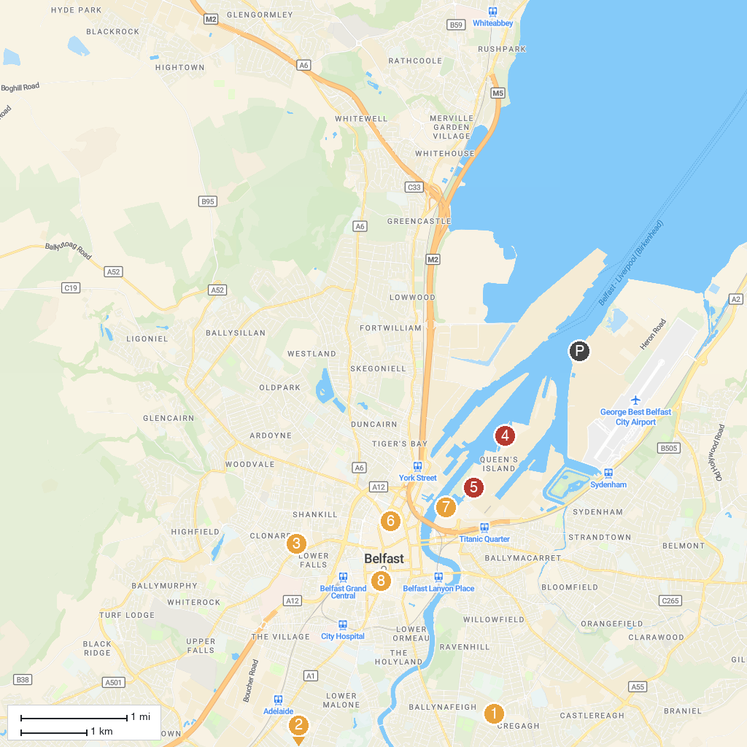
MAP KEY
1. Affidea Stadium | 5. Titanic Quarter Limited
2. Giant's Ring | 6. Belfast Cathedral, Church of Ireland Cathedral Church of St. Anne
3. Irish Republican History Museum | 7. W5
4. Titanic Distillery & Pump House | 8. Ulster Hall
P. Cruise port / terminal
Map © MapTiler © OpenStreetMap contributors · cruiseports.org

