Belleville-en-Beaujolais, Auvergne-Rhône-Alpes, France
Tucked along the Saône river at the heart of Beaujolais country, Belleville-en-Beaujolais is a compact market town that punches well above its weight — vineyards spill down the hills in every direction, and Europe's most celebrated Beaujolais Nouveau is pressed just minutes away.
⚓ Docked (river quay) · 🕒 Typical call: 6–8 hrs · 💶 Euro (€) · 🗣️ French
✍️ MY DAY IN PORT (FILL IN)
Ship / Date
In port | arrive ______ · all aboard ______
Booked excursion
Notes / meeting point
GETTING ASHORE
- Docking: River cruise ships tie up at the Halte fluviale de Belleville on the Saône; no tendering required.
- Walk to centre: Town centre is a 5–10 min walk from the river quay.
- Best For: Wine lovers, foodies, and cyclists exploring the Beaujolais route.
- Don't Miss: The Hameau Duboeuf wine park (a short drive away) and the 12th-century Église Notre-Dame de Belleville with its early rose window.
GETTING AROUND
- 🚕 Taxi: €10–€20 — Local taxis (RB Transport, Minigo) serve the port area. Fares within town are short and inexpensive; useful for reaching
- 📱 Rideshare: ✅ Uber
TOP THINGS TO DO
- Hameau Duboeuf — Wine Theme Park — Europe's first vine-and-wine theme park, created by Beaujolais legend Georges Duboeuf.
- Beaujolais Wine Estate Tastings — Visit domaines such as Château de Pizay or Maison P.
- Château de Montmelas — A working Beaujolais wine estate inside a dramatic neo-Gothic château with 10th-century origins (first recorded in 977).
- Beaujolais Greenway Cycling — A shaded cycling and walking trail built on a disused railway line winds through vineyards and villages.
- Beaujolais Wine Route Villages — Drive or tour the 140 km Route du Beaujolais through postcard-perfect hilltop villages — Oingt (one of France's most beautiful)…
BEST WALKS
- Quay to Town Centre Stroll: 1.5 km · 20 min · Easy — Walk from the river quay along the Saône promenade, turning into the town to reach the 12th-century…
- Vineyard Edge Walk: 3 km · 45 min · Easy — Head south from town on the D37 footpaths that border the first rows of Beaujolais vineyards.
WEATHER · DAYLIGHT · MONEY
Month | High °F | Low °F | Rainy days
May | 63 | 47 | 15
Jul | 75 | 58 | 10
Sep | 69 | 53 | 10
Daylight: May 6:08AM–9:06PM · Jul 6:04AM–9:28PM · Sep 7:19AM–7:51PM
cruiseports.org/belleville-en-beaujolais · Confirm terminal & all-aboard time with your ship

Belleville-en-Beaujolais, Auvergne-Rhône-Alpes, France — Port Map
Red = walkable sights · Amber = excursions farther out · P = cruise terminal
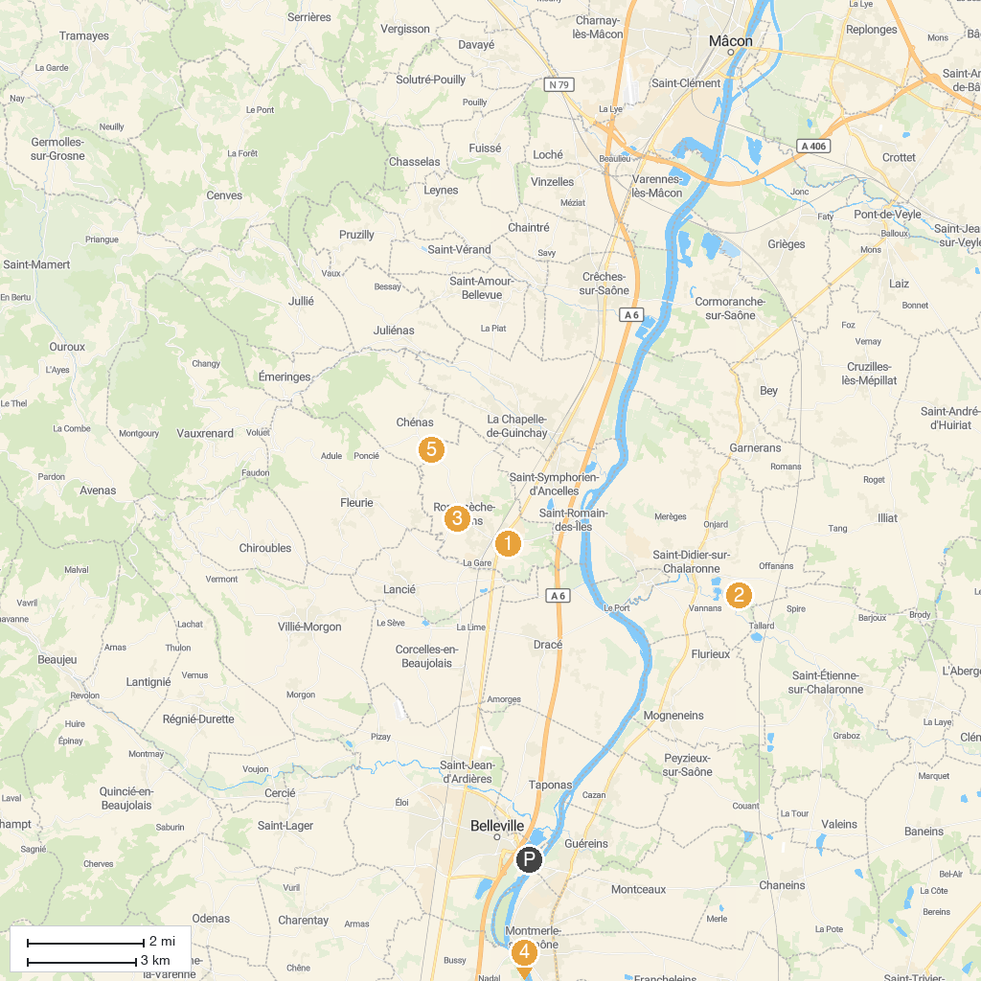
MAP KEY
1. Touroparc Zoo | 5. Château de Vaurenard
2. The Water Gardens | 6. Sanctuary of Ars (Basilica of Ars)
3. Musée Départemental du Compagnonnage | 7. Château de Fléchères
4. Museum Paul Dini | 8. Château du Moulin-à-Vent
P. Cruise port / terminal
Map © MapTiler © OpenStreetMap contributors · cruiseports.org

