Belleville-sur-Saône, Auvergne-Rhône-Alpes, France
The Saône's gateway to Beaujolais — where rolling vine-covered hills meet a quiet riverside town with a Romanesque abbey, weekly markets, and some of France's best-value wine country on your doorstep.
⚓ Docked (river quay) · 🕒 Typical call: 6-8 hrs · 💶 Euro (EUR) · 🗣️ French
✍️ MY DAY IN PORT (FILL IN)
Ship / Date
In port | arrive ______ · all aboard ______
Booked excursion
Notes / meeting point
GETTING ASHORE
- Docking: River quay (Halte fluviale de Belleville); ships dock alongside, gangway to path
- Walk to center: ~10 min (0.6 km) from quay to Place de l'Hôtel-de-Ville
- Best For: Wine lovers, cycling, relaxed sightseeing, French village atmosphere
- Don't Miss: Hameau Duboeuf wine experience in Romanèche-Thorins
GETTING AROUND
- 🚕 Taxi: ~8-15 EUR in-town, ~40-60 EUR to Lyon — Several local taxi and VTC companies operate 24/7, including RB Taxi VTC. Pre-booking is recommended at this smaller por
- 📱 Rideshare: ✅ Uber
TOP THINGS TO DO
- Hameau Duboeuf Wine Experience — The landmark wine theme park in Romanèche-Thorins (12 km north) covers the full arc of Beaujolais winemaking through immersive…
- Château de Corcelles-en-Beaujolais — A 15th-century château with drawbridge, Renaissance galleries, a donjon, and French gardens surrounded by producing vineyards.
- Oingt — Village Perché — One of France's most beautiful villages, this fortified hilltop settlement in the Beaujolais Pierres Dorées area offers…
- Vineyard Cycling — Rent bikes at or near the quay and pedal signed routes through the Beaujolais Villages appellation — gently rolling terrain…
- Roche de Solutré — A dramatic limestone escarpment (Grand Site de France) rising above Mâcon's vineyards.
BEST WALKS
- Town Centre Circuit: 1.5 km · 25 min · Flat — From the quay head to Place de l'Hôtel-de-Ville, then visit the Abbaye Notre-Dame de Belleville…
cruiseports.org/belleville-sur-saone · Confirm terminal & all-aboard time with your ship

Belleville-sur-Saône, Auvergne-Rhône-Alpes, France — Port Map
Red = walkable sights · Amber = excursions farther out · P = cruise terminal
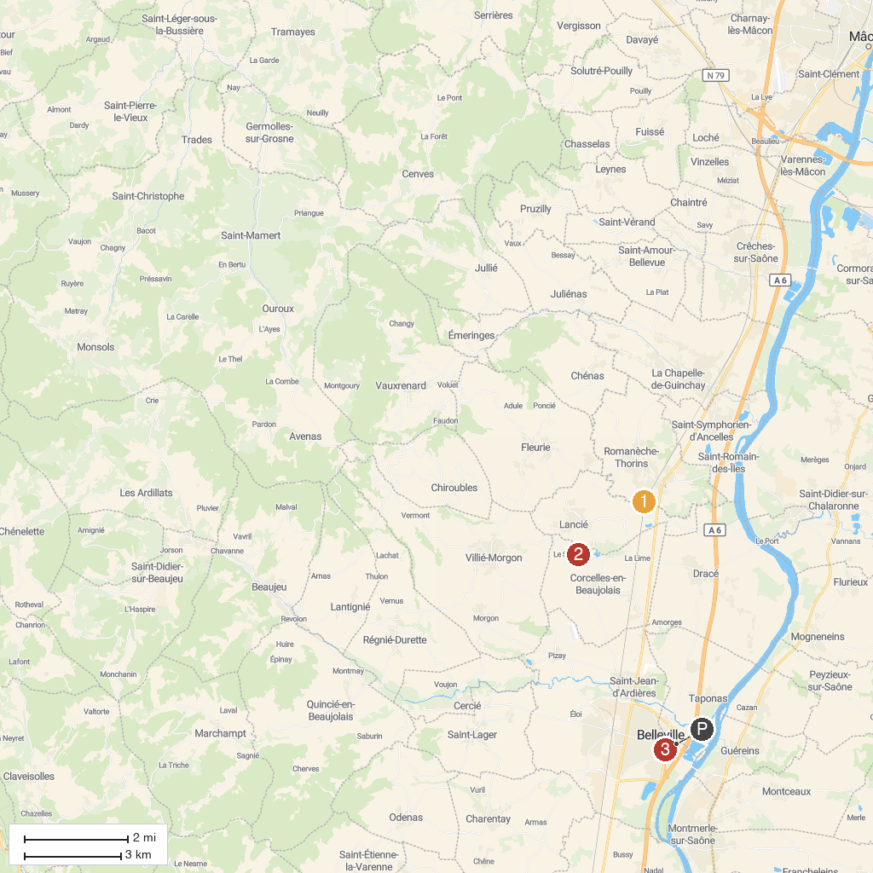
MAP KEY
1. Hameau Duboeuf | 4. Abbaye Notre-Dame de Belleville
2. Château de Corcelles-en-Beaujolais | 5. Roche de Solutré
3. Oingt
P. Cruise port / terminal
Map © MapTiler © OpenStreetMap contributors · cruiseports.org

