Ben Tre City, Mekong Delta, Vietnam
The 'Land of Coconuts' rewards slow travel — glide narrow canals by sampan, watch candy makers pull coconut toffee by hand, and taste fruit straight from the orchard in one of the Mekong Delta's least-touristy stops.
⚓ Tender (river landing) · 🕒 Typical call: 6-8 hrs · 💵 Vietnamese Dong (VND); USD accepted at tours · 🗣️ Vietnamese
✍️ MY DAY IN PORT (FILL IN)
Ship / Date
In port | arrive ______ · all aboard ______
Booked excursion
Notes / meeting point
GETTING ASHORE
- Docking: Tender to Ham Luong River wharf near town center
- Walk to center: 5 min from river landing to Ben Tre city streets
- Best For: Sampan canal rides, coconut candy workshops, fruit orchards
- Don't Miss: Sampan through shaded coconut canals to a candy-making cooperative
GETTING AROUND
- 🚕 Taxi: 20,000–50,000 VND — Motorbike taxis are the most common short-haul transport in Ben Tre. Agree on a fare before you ride; useful for reachin
- 📱 Rideshare: ✅ Grab
TOP THINGS TO DO
- Sampan Ride Through Coconut Canals — Board a hand-rowed sampan and glide through narrow, shade-covered canals flanked by towering coconut palms.
- Coconut Candy Workshop — Watch workers pull, cut, and wrap coconut toffee by hand at a family-run cooperative — a cottage industry Ben Tre has practiced…
- Fruit Orchard Visit — Tour a family orchard in the delta and sample whatever's in season — longan, rambutan, pomelo, jackfruit.
- Cycling the Delta Villages — Pedal quiet paths past rice fields, vegetable gardens, and rural homes between canal transfers.
- Con Phung (Phoenix) Islet — Take a short boat ride to this small islet on the Tien (My Tho) River and visit the quirky Coconut Monk monument — the site of a…
BEST WALKS
- Ben Tre Riverside Stroll: ~1.5 km · 20 min · Easy — Walk from Ham Luong Wharf along the riverfront promenade past local market stalls and the Ben Tre…
- Ben Tre Market Quarter: ~1 km · 15 min · Easy — Explore the streets around Ben Tre Market — pick up fresh coconut water, tropical fruit, and…
cruiseports.org/ben-tre-city · Confirm terminal & all-aboard time with your ship

Ben Tre City, Mekong Delta, Vietnam — Port Map
Red = walkable sights · Amber = excursions farther out · P = cruise terminal
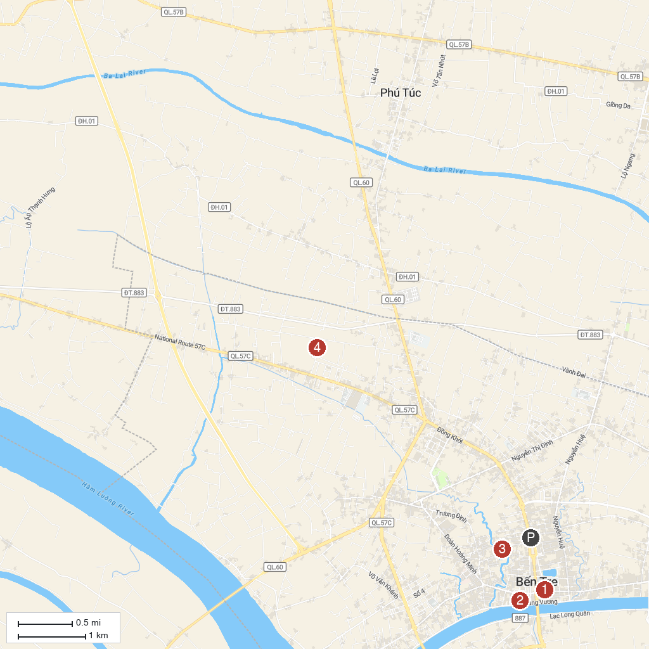
MAP KEY
1. Vien Minh Pagoda | 3. Ham Luong River
2. Ben Tre Museum | 4. Chau Thanh Coconut Candy Village
P. Cruise port / terminal
Map © MapTiler © OpenStreetMap contributors · cruiseports.org

