Beni Suef, Middle Egypt, Egypt
A quiet stop on longer Nile cruises, Beni Suef opens the door to Middle Egypt's overlooked wonders — including one of the oldest pyramids ever built and the ruins of an ancient capital that once rivalled Thebes.
⚓ Docked (Nile riverbank) · 🕒 Typical call: 4–6 hrs · 💵 Egyptian Pound (EGP) · 🗣️ Arabic
✍️ MY DAY IN PORT (FILL IN)
Ship / Date
In port | arrive ______ · all aboard ______
Booked excursion
Notes / meeting point
GETTING ASHORE
- Docking: Nile riverbank mooring; ships tie up near the city corniche
- Walk to centre: 5–10 min to Kornish el-Nile promenade
- Best For: Ancient pyramids, Coptic heritage, off-the-beaten-path Egypt
- Don't Miss: Meidum Pyramid — Egypt's transitional step-to-true pyramid
GETTING AROUND
- 🚕 Taxi: E£100–200 for short trips — Local taxis are available at the riverbank. Always negotiate the fare before departure — meters are rarely used. Expect
- 📱 Rideshare: ❌ not available
TOP THINGS TO DO
- Meidum Pyramid — Dating to the reign of Pharaoh Sneferu (~2600 BC), the Meidum Pyramid is Egypt's earliest attempt at a true pyramid — a dramatic…
- Heracleopolis Magna (Ihnasya el-Medina) — Once the capital of Egypt during the First Intermediate Period, Heracleopolis Magna lies ~15 km west of Beni Suef.
- Beni Suef Museum — A compact but well-curated regional museum covering Pharaonic, Greco-Roman, Coptic, and Islamic artefacts from the governorate.
- Wadi Sannur Cave — A rarely visited limestone cave system (karst) in the Eastern Desert, about 70 km southeast of Beni Suef, known for its alabaster…
- Coptic Monasteries of Middle Egypt — The region around Beni Suef is rich in early Christian heritage.
BEST WALKS
- Kornish el-Nile Stroll: 1–2 km • Flat • 20–30 min — A pleasant walk along the Nile Corniche, Beni Suef's riverside promenade.
- City Centre & Market Walk: 1.5 km • Flat • 30–40 min — From the corniche, walk inland toward the city centre and Al-Gawhara Market.
WEATHER · DAYLIGHT · MONEY
Month | High °F | Low °F | Rainy days
May | 95 | 69 | 0
Jul | 101 | 76 | 0
Sep | 97 | 73 | 0
Daylight: May 6:04AM–7:40PM · Jul 6:07AM–7:55PM · Sep 6:40AM–7:00PM
cruiseports.org/beni-suef · Confirm terminal & all-aboard time with your ship

Beni Suef, Middle Egypt, Egypt — Port Map
Red = walkable sights · Amber = excursions farther out · P = cruise terminal
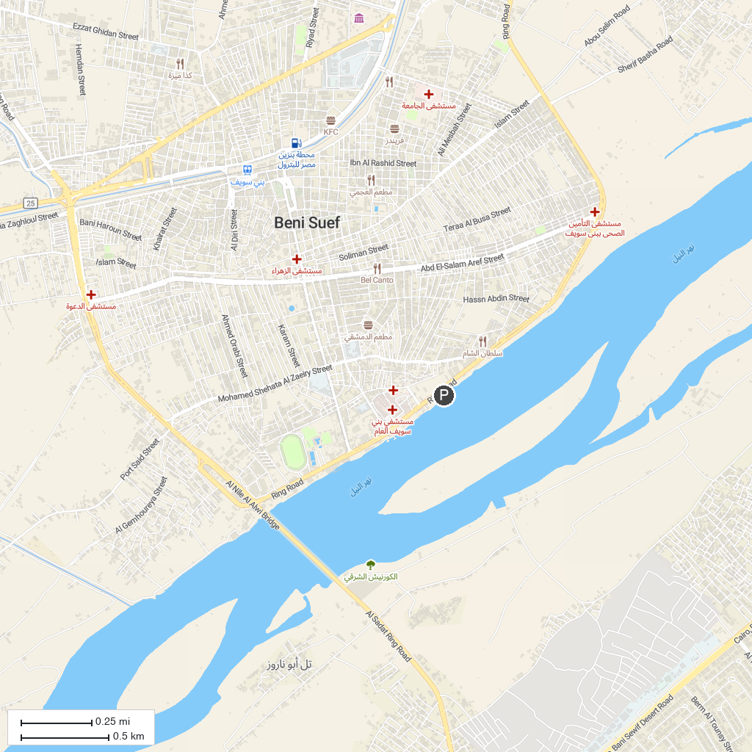
MAP KEY
1. جبل النور | 2. دمشقين
P. Cruise port / terminal
Map © MapTiler © OpenStreetMap contributors · cruiseports.org

