Beppu, Oita, Japan
Japan's undisputed hot spring capital pours more geothermal water than anywhere else in the country. From cobalt-blue 'Sea Hell' to blood-red mud pools, a day in Beppu is unlike anywhere else on Earth.
⚓ Docked (Ishigaki Wharf) · 🕒 Typical call: 8-10 hrs · 💴 Japanese Yen (JPY) · 🗣️ Japanese
✍️ MY DAY IN PORT (FILL IN)
Ship / Date
In port | arrive ______ · all aboard ______
Booked excursion
Notes / meeting point
GETTING ASHORE
- Docking: Ishigaki Wharf #3, Beppu International Tourist Port — large ships up to 140,000 GT dock here
- Walk to center: Port is ~4 km from Beppu Station; shuttle buses or taxis recommended (~10-15 min)
- Best For: The Jigoku Meguri 'Hell Tour', sand baths, and traditional onsen culture
- Don't Miss: Umi Jigoku (Sea Hell) in the Kannawa district and Chinoike Jigoku (Blood Pond Hell) in the Shibaseki district
GETTING AROUND
- 🚕 Taxi: ¥1,250–¥2,800 (~–) — Taxis queue at the cruise terminal. About ¥1,250 to Beppu Station; roughly ¥2,800 to the Kannawa Hells district. Groups
- 📱 Rideshare: ✅ Uber
TOP THINGS TO DO
- Jigoku Meguri — The Seven Hells Tour — Visit seven spectacular geothermal hot springs, each with a distinct color and character.
- Beppu Sand Bath at Shoningahama — Lie buried in naturally heated volcanic sand at Beppu Beach Sand Bath (Shoningahama).
- Kannawa Onsen Village & Jigoku-Mushi Steam Cooking — Wander the atmospheric Kannawa district where steam rises from gutters and street-side foot baths invite you to soak.
- Mount Tsurumi Ropeway — Ride the ropeway to the 1,375 m summit of Mount Tsurumi for panoramic views across Beppu Bay, the city, and the Kyushu mountains.
- Takasakiyama Natural Zoological Garden — Observe over 1,500 wild Japanese macaques at the foot of Mount Takasaki — a 10-minute bus ride from the city.
BEST WALKS
- Kannawa Onsen Street Walk: 1.5 km loop · Easy · 45 min — Stroll the atmospheric backstreets of Kannawa where steam vents from drainage grates and small…
- Beppu Station to Takegawara Onsen: 1 km · Easy · 20 min — A flat walk from JR Beppu Station through the old shopping arcade (Ekimae Ichibankan) to the…
WEATHER · DAYLIGHT · MONEY
Month | High °F | Low °F | Rainy days
May | 74 | 60 | 11
Jul | 85 | 75 | 20
Sep | 81 | 71 | 17
Daylight: May 5:14AM–7:06PM · Jul 5:15AM–7:24PM · Sep 5:57AM–6:20PM
cruiseports.org/beppu · Confirm terminal & all-aboard time with your ship

Beppu, Oita, Japan — Port Map
Red = walkable sights · Amber = excursions farther out · P = cruise terminal
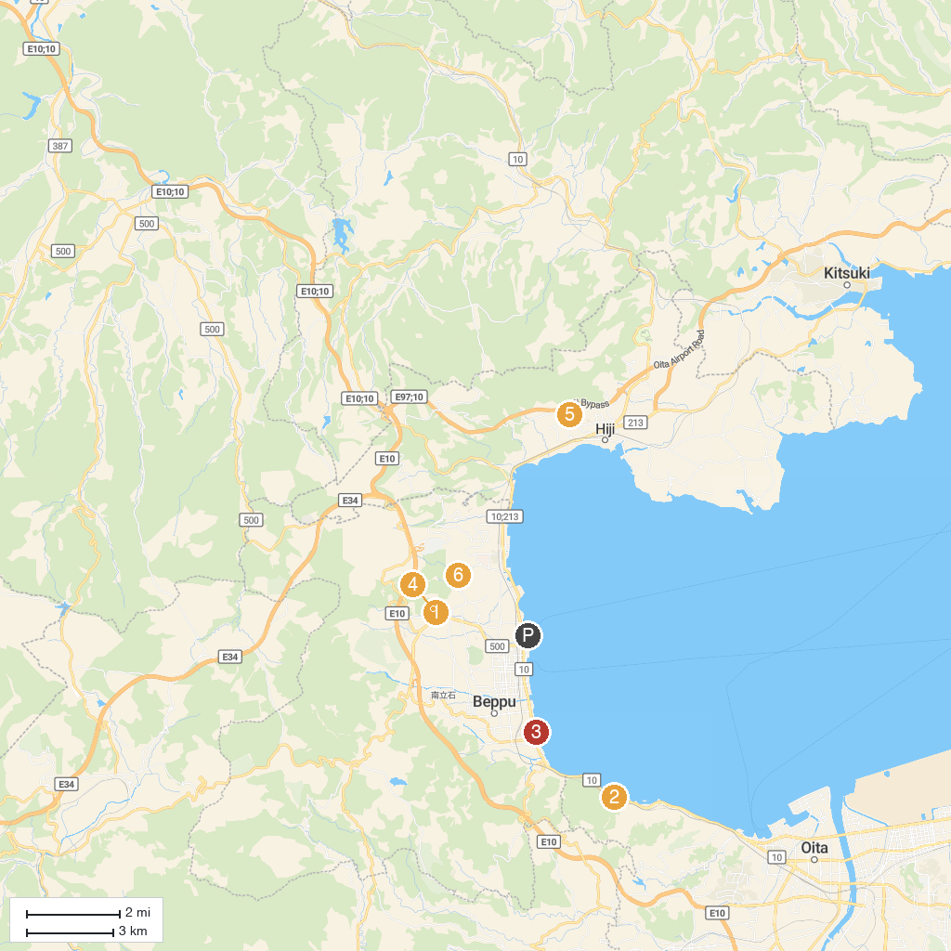
MAP KEY
1. Beppu Jigoku (Hells of Beppu) | 5. Kuroiwa Park
2. Oita Marine Palace Aquarium "Umitamago" | 6. Chinoike Jigoku
3. Kitahama Park | 7. Aso-Kuju National Park Sagiridai Overlook
4. Umi Jigoku | 8. Ikariyama Park
P. Cruise port / terminal
Map © MapTiler © OpenStreetMap contributors · cruiseports.org

