Bequia Island, St. Vincent and the Grenadines
The Grenadines' most beloved island keeps things small and real — sailboats crowd Admiralty Bay, fishermen mend nets on the jetty, and unhurried beaches are minutes from the tender dock.
⚓ Tender port (Admiralty Bay) · 🕒 Typical call: 6-8 hrs · 💵 Eastern Caribbean Dollar / USD accepted · 🗣️ English · 🏖️ Best for: beach, sailing, snorkeling
✍️ MY DAY IN PORT (FILL IN)
Ship / Date
In port | arrive ______ · all aboard ______
Booked excursion
Notes / meeting point
GETTING ASHORE
- Docking: Tender to Port Elizabeth jetty, Admiralty Bay
- Walk to center: On the jetty — town is right there
- Best For: Beaches, snorkeling, local Caribbean culture
- Don't Miss: Princess Margaret Beach & Old Hegg Turtle Sanctuary
GETTING AROUND
- 🚕 Taxi: US/hr (up to 4 people) — Open-backed taxis are the primary way to tour the island. Rates are fixed by the Bequia Tourism Association — pick up a
- 📱 Rideshare: ❌ not available
TOP THINGS TO DO
- Princess Margaret Beach — The island's most popular beach sits a 15-minute walk south along the Belmont Walkway from the jetty.
- Lower Bay — Just over the bluff from Princess Margaret Beach, Lower Bay has a slightly more local feel with beachside restaurants and gentle…
- Old Hegg Turtle Sanctuary — A community-run sanctuary on the northeast side of the island (Park Bay) that rehabilitates endangered hawksbill turtles for…
- Snorkeling at Industry Bay (Crescent Beach) — On the northeast coast, Industry Bay is a calm, reef-protected bay with excellent snorkeling and often deserted sands shaded by…
- Sargeant Brothers Model Boat Shop — Bequia's maritime tradition is alive at this workshop near the waterfront where craftsmen carve intricate scale models of sailing…
BEST WALKS
- Belmont Walkway to Princess Margaret Beach: 1.2 km · 15 min · Flat, paved — From the tender jetty, follow the Belmont Walkway south past colorful shops and restaurants with…
- Port Elizabeth Town Walk: 0.5 km loop · 20-30 min · Flat — A short wander from the jetty through Port Elizabeth's main street takes in the local market…
WEATHER · DAYLIGHT · MONEY
Month | High °F | Low °F | Rainy days
May | 70 | 58 | 6
Jul | 66 | 53 | 5
Sep | 67 | 56 | 7
Daylight: May 5:39AM–6:23PM · Jul 5:46AM–6:35PM · Sep 5:54AM–6:05PM
Representative sunrise/sunset — 2025, 15th of each month; local civil time including DST (America/St_Vincent). Source: Astral; not a forecast or climate average.
cruiseports.org/bequia-island · Confirm terminal & all-aboard time with your ship

Bequia Island, St. Vincent and the Grenadines — Port Map
Red = walkable sights · Amber = excursions farther out · P = cruise terminal
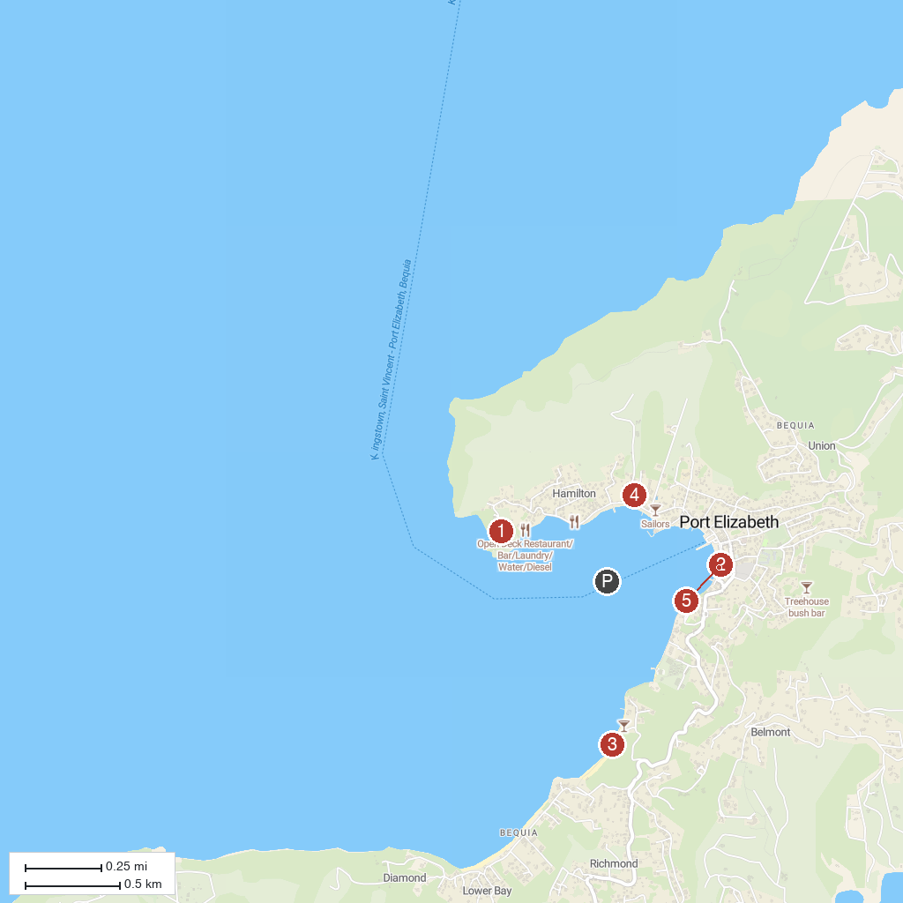
MAP KEY
1. Fort Hamilton | 4. Bequia Maritime Museum
2. Old Hegg Turtle Sanctuary | 5. Belmont Walkway
3. Princess Margaret Beach
P. Cruise port / terminal
Map © MapTiler © OpenStreetMap contributors · cruiseports.org

