Warnemünde (for Berlin), Mecklenburg-Vorpommern, Germany
Your cruise calls it Berlin, but your ship ties up in the Baltic resort of Warnemünde — 150 miles and 2.5 hours from the German capital. Commit to the full-day dash for the Wall, the Gate, and Museum Island, or keep it local with Rostock's Hanseatic squares and a sandy beach right off the pier.
⚓ Docked — Warnemünde Cruise Terminal · 🕒 Typical call: 10-12 hrs · 💶 Euro (EUR) · 🗣️ German
✍️ MY DAY IN PORT (FILL IN)
Ship / Date
In port | arrive ______ · all aboard ______
Booked excursion
Notes / meeting point
GETTING ASHORE
- Docking: Docked at Warnemünde Cruise Center, Rostock — no tender needed
- Distance to Berlin: ~150 miles (240 km); 2.5–3 hrs each way by train or coach
- Best For: Cold War history, WWII memorials, Hanseatic architecture, Baltic beaches
- Don't Miss: Brandenburg Gate and the Holocaust Memorial if you make it to Berlin; Alter Strom canal if you stay local
GETTING AROUND
- 🚕 Taxi: Meter — Local taxis (e.g. Taxi-Harry) available at the port for trips within Warnemünde and Rostock. Uber is also available in R
- 📱 Rideshare: ✅ Uber
TOP THINGS TO DO
- Berlin Cold War & WWII Highlights — Brandenburg Gate, Checkpoint Charlie, Berlin Wall Memorial, Holocaust Memorial, and the Reichstag — a full-day immersion in…
- Museum Island & Unter den Linden — Berlin's UNESCO-listed Museum Island clusters five world-class museums on a Spree island.
- Sachsenhausen Memorial Tour — The former Nazi concentration camp north of Berlin, now a sobering memorial and museum.
- Rostock Hanseatic City Walk — Skip the Berlin rush and explore Rostock's beautifully restored old town: New Market Square with the pink baroque Town Hall, St.
- Schwerin Palace Day Trip — The 'fairy-tale castle' set on an island in Schwerin Lake is one of Germany's most photogenic palaces.
BEST WALKS
- Warnemünde Waterfront Loop: 1.5 km · 30 min · Flat · Walk from pier — From the cruise terminal, head along the Alter Strom canal to the fishing harbour, then cross to…
- Rostock Old Town Walk: 2 km · 45 min · Easy · 15 min by S-Bahn from Warnemünde — From Rostock Hauptbahnhof, walk through the Steintor gateway into the old town, past the Kröpeliner…
WEATHER · DAYLIGHT · MONEY
Month | High °F | Low °F | Rainy days
May | 61 | 48 | 10
Jul | 71 | 59 | 15
Sep | 66 | 55 | 11
Daylight: May 5:08AM–9:09PM · Jul 4:58AM–9:36PM · Sep 6:45AM–7:27PM
cruiseports.org/berlin · Confirm terminal & all-aboard time with your ship

Warnemünde (for Berlin), Mecklenburg-Vorpommern, Germany — Port Map
Red = walkable sights · Amber = excursions farther out · P = cruise terminal
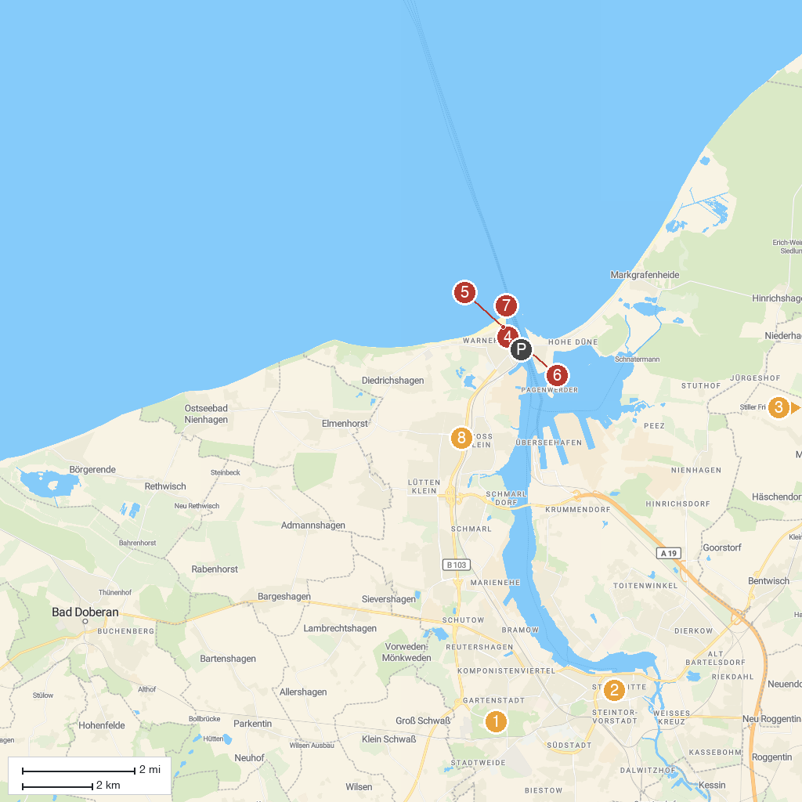
MAP KEY
1. Rostock Zoo | 5. Warnemünde lighthouse
2. Brunnen der Lebensfreude | 6. Hafenrundfahrt Warnemünde - Rostock - Fahrgastschifffahrt K. Schütt GmbH (Blaue Flotte)
3. Karl's Adventure Village Rövershagen | 7. Molenfeuer Westmole
4. Warnow-Personenschifffahrt OHG | 8. Sonnenblumenhaus
P. Cruise port / terminal
Map © MapTiler © OpenStreetMap contributors · cruiseports.org

