Bezdan, Vojvodina, Serbia
Where the Danube crosses into Serbia, Bezdan sits quietly on the left bank — a canal-laced village with a silk weaving tradition centuries old and wild wetlands stretching to the horizon. There's no cruise terminal here, just river, reeds, and real village life.
⚓ River dock (docked alongside) · 🕒 Typical call: 4–7 hrs · 💵 Serbian Dinar (RSD) · 🗣️ Serbian & Hungarian spoken
✍️ MY DAY IN PORT (FILL IN)
Ship / Date
In port | arrive ______ · all aboard ______
Booked excursion
Notes / meeting point
GETTING ASHORE
- Docking: Public river dock on the Danube bank; no dedicated cruise terminal
- Walk to center: 5 min from dock to village center
- Best For: Danube nature, heritage crafts, multicultural Vojvodina culture
- Don't Miss: Novitet-Dunav silk damask workshop and Chapel of Holy Trinity
GETTING AROUND
- 🚕 Taxi: 1,300–1,600 RSD (~€11–14) — Taxis wait at the port and can take you to Sombor, the nearest city, about 18–20 km away. The ride takes roughly 17 minu
TOP THINGS TO DO
- Novitet-Dunav Silk Damask Workshop — Visit Bezdan's most famous attraction — a working silk damask weaving workshop using 18 hand-powered wooden looms with a jacquard…
- Gornje Podunavlje UNESCO Biosphere Boat Ride — The Bačko Podunavlje biosphere reserve — nicknamed the 'European Amazon' — begins at Bezdan's doorstep.
- Chapel of Holy Trinity & Danube Locks — See one of Vojvodina's oldest preserved monuments — the Chapel of Holy Trinity, built by local people between 1710 and 1720.
- Bezdan Spa & Mineral Pools — Bezdan's thermal spa offers sodium-bicarbonate mineral water at around 32°C.
- Sombor City Tour — The regional capital (~18 km away) is sometimes called 'Little Vienna' for its tree-lined boulevards and elegant 18th-century…
BEST WALKS
- Village Canal Walk: ~2 km · 30–40 min · Flat · Easy — From the river dock, walk into the village center along the main street to reach the Chapel of Holy…
WEATHER · DAYLIGHT · MONEY
Month | High °F | Low °F | Rainy days
May | 71 | 53 | 12
Jul | 83 | 65 | 8
Sep | 74 | 57 | 8
Daylight: May 5:12AM–8:09PM · Jul 5:09AM–8:30PM · Sep 6:22AM–6:55PM
cruiseports.org/bezdan · Confirm terminal & all-aboard time with your ship

Bezdan, Vojvodina, Serbia — Port Map
Red = walkable sights · Amber = excursions farther out · P = cruise terminal
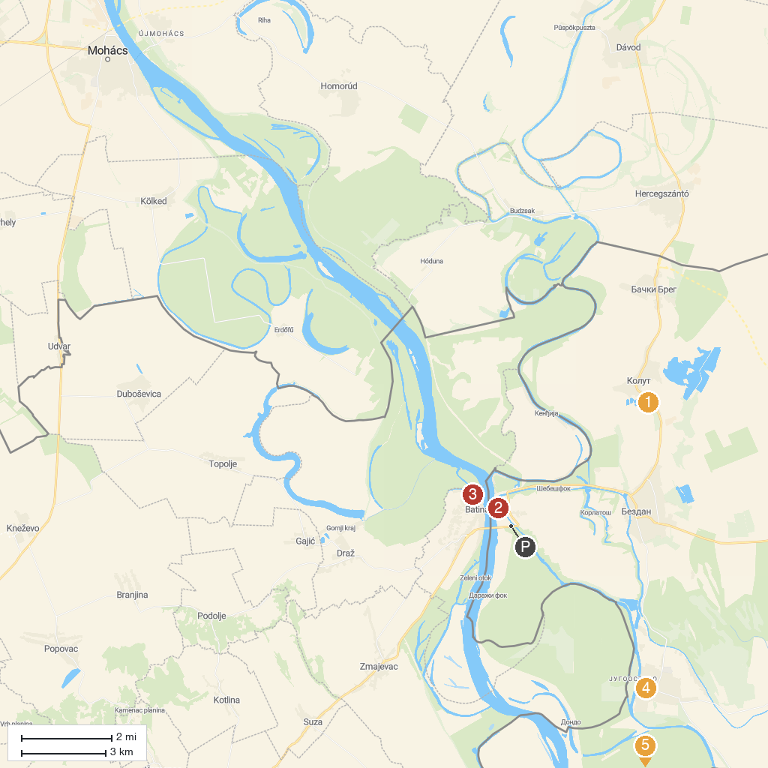
MAP KEY
1. Miki Zoo | 4. Etno Kuca Mali Bodrog
2. Batina Memorial House | 5. Gornje Podunavlje
3. Monument of Batina Battle ("Julka")
P. Cruise port / terminal
Map © MapTiler © OpenStreetMap contributors · cruiseports.org

