Bhamo, Kachin State, Myanmar
The Irrawaddy's northern terminus: a town where ancient Shan kingdoms, gilded pagodas, and Chinese trade routes converge on the riverbank.
⚓ River dock (gangway to bank) · 🕒 Typical call: 6–8 hrs · 💵 Myanmar Kyat (MMK); USD exchangeable · 🗣️ Burmese, Kachin
✍️ MY DAY IN PORT (FILL IN)
Ship / Date
In port | arrive ______ · all aboard ______
Booked excursion
Notes / meeting point
GETTING ASHORE
- Docking: Vessels tie alongside the riverbank or use a floating pontoon; no formal cruise terminal
- Walk to center: ~5 min stroll from the waterfront to the market and town center
- Best For: Pagoda history, Sampanago ruins, local market life, bamboo bridge
- Don't Miss: Sunset over the Irrawaddy from Bhamo Harbour
GETTING AROUND
TOP THINGS TO DO
- Sampanago Ruins — A few kilometers east of town lie the crumbling earthen walls of Sampanago, capital of an ancient Shan kingdom.
- Theindawgyi Pagoda — Roughly 4 miles from town, this revered pagoda is said to enshrine a Buddha tooth relic and features Thai-influenced…
- Bamboo Bridge at Wa Thatar Village — Villagers rebuild this remarkable ~470-metre bamboo bridge each year after the monsoon.
- Tain Pha Hill Bike Ride — Hire a bicycle in town and pedal out to Tain Pha Hill, a Buddhist hilltop complex with meditation halls, a stupa, and panoramic…
- Bhamo Morning Market — The riverside market is the beating heart of Bhamo, blending Burmese and Chinese trade goods, fresh produce, and street food.
BEST WALKS
- Bhamo Waterfront & Town Stroll: 1–2 km · Easy · 30–45 min — Start at the riverbank landing and walk north along the embankment, taking in fishing boats and…
WEATHER · DAYLIGHT · MONEY
Month | High °F | Low °F | Rainy days
May | 93 | 76 | 16
Jul | 88 | 77 | 30
Sep | 87 | 76 | 25
Daylight: May 5:18AM–6:36PM · Jul 5:22AM–6:51PM · Sep 5:47AM–6:04PM
cruiseports.org/bhamo · Confirm terminal & all-aboard time with your ship

Bhamo, Kachin State, Myanmar — Port Map
Red = walkable sights · Amber = excursions farther out · P = cruise terminal
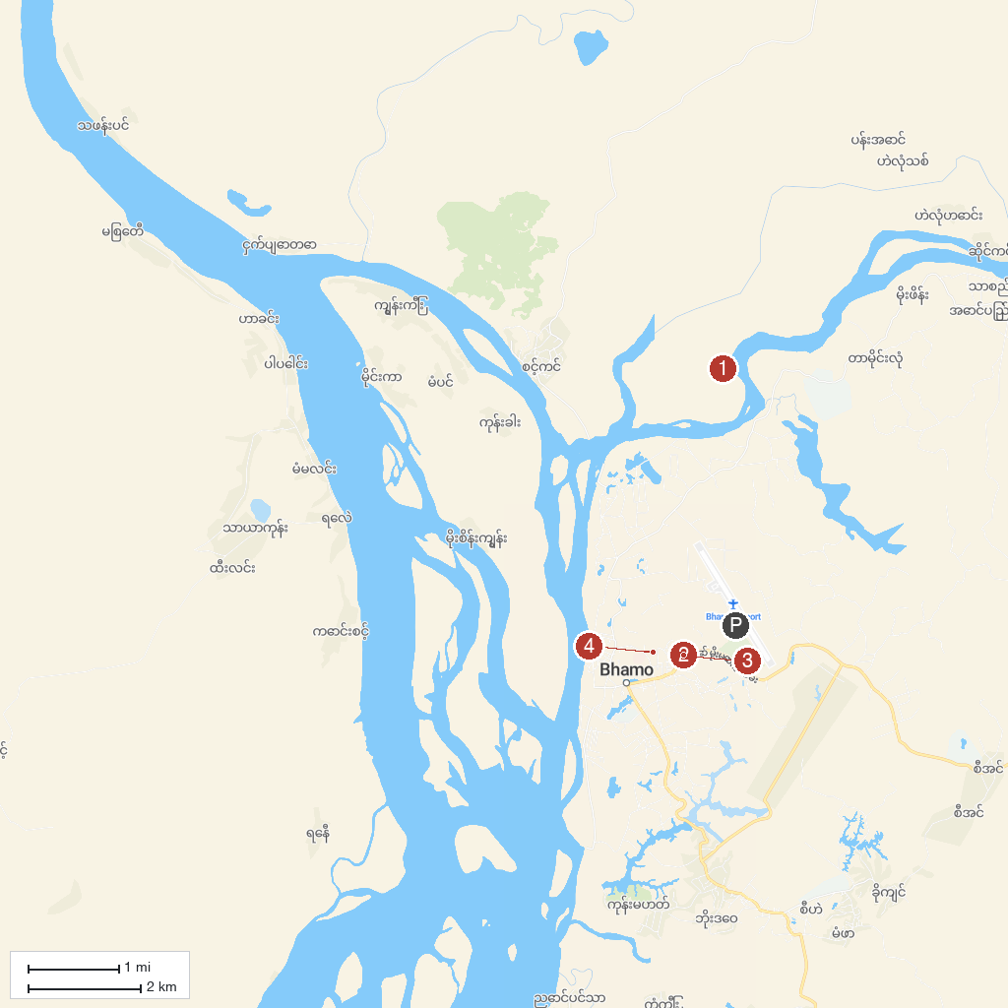
MAP KEY
1. Shwe Kyina Pagoda | 3. Sampanago Ruins
2. Bhamo Morning Market | 4. Irrawaddy River waterfront
P. Cruise port / terminal
Map © MapTiler © OpenStreetMap contributors · cruiseports.org

