Bitung, North Sulawesi, Indonesia
A working industrial port with remarkable rewards just beyond the gates — from the world's smallest primate in Tangkoko's rainforest to the critter-rich depths of Lembeh Strait.
⚓ Docked (commercial pier) · 🕒 Typical call: 8-10 hrs · 💵 Indonesian Rupiah (IDR) · 🗣️ Indonesian / Manado Malay · 🌿 Top wildlife & diving port
✍️ MY DAY IN PORT (FILL IN)
Ship / Date
In port | arrive ______ · all aboard ______
Booked excursion
Notes / meeting point
GETTING ASHORE
- Docking: Cruise ships dock at Samudera Bitung passenger terminal — no tendering required
- Walk to Center: Port area is industrial; taxis needed to reach Bitung city (~3 km) or any major attraction
- Best For: Wildlife trekking (Tangkoko), world-class muck diving (Lembeh Strait), volcano scenery
- Don't Miss: Spectral tarsiers at Tangkoko Nature Reserve — one of the world's rarest wildlife encounters
GETTING AROUND
- 🚕 Taxi: IDR 50,000–100,000 (~$3–$7 USD) — Taxis wait outside the port gates for the short ride into downtown Bitung. Meters are rarely used — negotiate the fare b
TOP THINGS TO DO
- Tangkoko Nature Reserve Trek — Trek through lowland rainforest at Tangkoko Batuangus Nature Reserve, home to the spectral tarsier — one of the world's smallest…
- Lembeh Strait Diving & Snorkeling — The Lembeh Strait — a narrow channel between Bitung and Lembeh Island — is the 'critter capital of the world' for muck diving.
- Mount Mahawu Crater Lake — Drive up the flanks of Mount Mahawu (an active volcano near Tomohon) for a short walk to its scenic crater lake.
- Waruga Megalithic Stone Graves — Visit the Waruga stone sarcophagi at Airmadidi village — ancient above-ground burial jars carved by the Minahasan people, some…
- Manado City & Tomohon Market — Head to Manado, the provincial capital, for the 19th-century Ban Hin Kiong Chinese temple (the oldest in eastern Indonesia)…
BEST WALKS
- Bitung Waterfront & City Center Stroll: 1-2 hrs | Easy | Flat — Take a taxi to central Bitung and walk along the waterfront promenade near Pelabuhan Bitung, past…
WEATHER · DAYLIGHT · MONEY
Month | High °F | Low °F | Rainy days
May | 85 | 78 | 28
Jul | 83 | 77 | 21
Sep | 85 | 77 | 15
Daylight: May 5:30AM–5:41PM · Jul 5:39AM–5:51PM · Sep 5:31AM–5:38PM
cruiseports.org/bitung · Confirm terminal & all-aboard time with your ship

Bitung, North Sulawesi, Indonesia — Port Map
Red = walkable sights · Amber = excursions farther out · P = cruise terminal
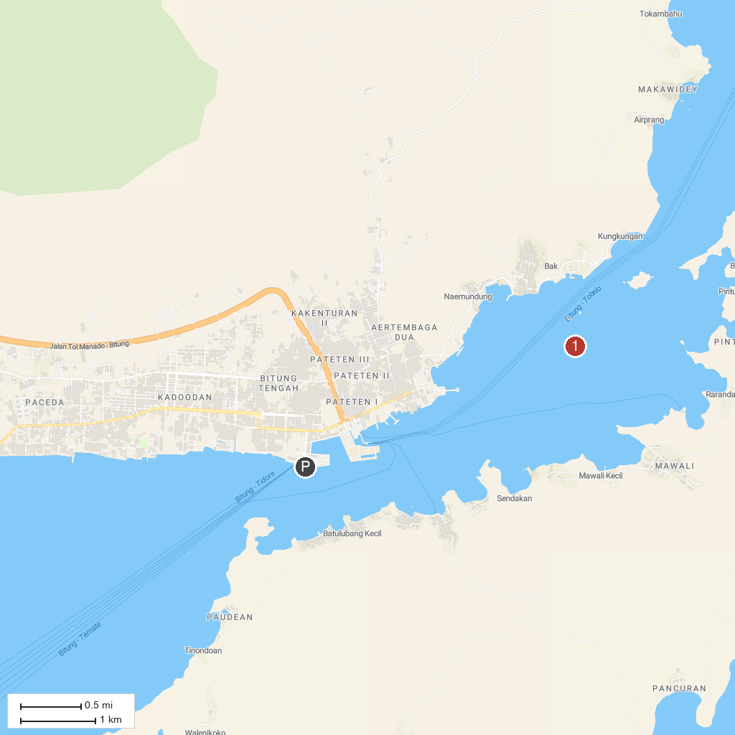
MAP KEY
1. Tangkoko Nature Reserve | 4. Lake Linow
2. Lembeh Strait | 5. Mount Klabat
3. Waruga Archeological Park
P. Cruise port / terminal
Map © MapTiler © OpenStreetMap contributors · cruiseports.org

