Bocas del Toro, Bocas del Toro Province, Panama
A scattered Caribbean archipelago where colorful wooden houses line the water, sloths hang in mangroves, and every excursion starts with a boat ride. Bocas del Toro rewards the spontaneous.
⚓ Tender port · 🕒 Typical call: 7-9 hrs · 💵 US Dollar (USD) · 🗣️ Spanish / English widely spoken · 🌴 Tropical — bring reef-safe sunscreen
✍️ MY DAY IN PORT (FILL IN)
Ship / Date
In port | arrive ______ · all aboard ______
Booked excursion
Notes / meeting point
GETTING ASHORE
- Docking: Tender — ships anchor offshore; tenders drop at Bocas Town municipal dock
- Walk to center: Immediate — Bocas Town is right at the tender dock
- Best For: Snorkeling, island hopping, wildlife spotting, beach days
- Don't Miss: Starfish Beach (Playa Estrella) and Hospital Point snorkeling
GETTING AROUND
- 🚕 Taxi: $2–$7 per trip — Water taxis are the primary way to travel between the islands of the archipelago. Fares are cheap and departures are fre
- 📱 Rideshare: ❌ not available
TOP THINGS TO DO
- Starfish Beach & Island Hop — Playa Estrella on Isla Colón is famous for its resident sea stars in the shallows.
- Snorkeling at Hospital Point & Cayo Coral — Hospital Point (off Isla Solarte) and Cayo Coral offer some of the best snorkeling in the archipelago — vibrant coral, tropical…
- Sloth Island & Dolphin Bay — Glide through mangrove channels to spot three-toed sloths hanging overhead, then head to Dolphin Bay for resident bottlenose…
- Cayos Zapatillas Day Trip — Two uninhabited cays inside Isla Bastimentos National Marine Park — white-sand beaches, sea turtles, and clear snorkeling waters.
- Bocas Town Walk & Local Lunch — The colorful waterfront town of Bocas (Isla Colón) is walkable in under an hour.
BEST WALKS
- Bocas Town Waterfront Stroll: ~1 km · 20-30 min · Flat & easy — From the tender dock, walk north along the main street (Calle 3) past colorful Caribbean buildings…
WEATHER · DAYLIGHT · MONEY
Month | High °F | Low °F | Rainy days
May | 83 | 76 | 28
Jul | 82 | 75 | 30
Sep | 83 | 76 | 28
Daylight: May 6:08AM–6:41PM · Jul 6:16AM–6:53PM · Sep 6:19AM–6:28PM
cruiseports.org/bocas-del-toro · Confirm terminal & all-aboard time with your ship

Bocas del Toro, Bocas del Toro Province, Panama — Port Map
Red = walkable sights · Amber = excursions farther out · P = cruise terminal
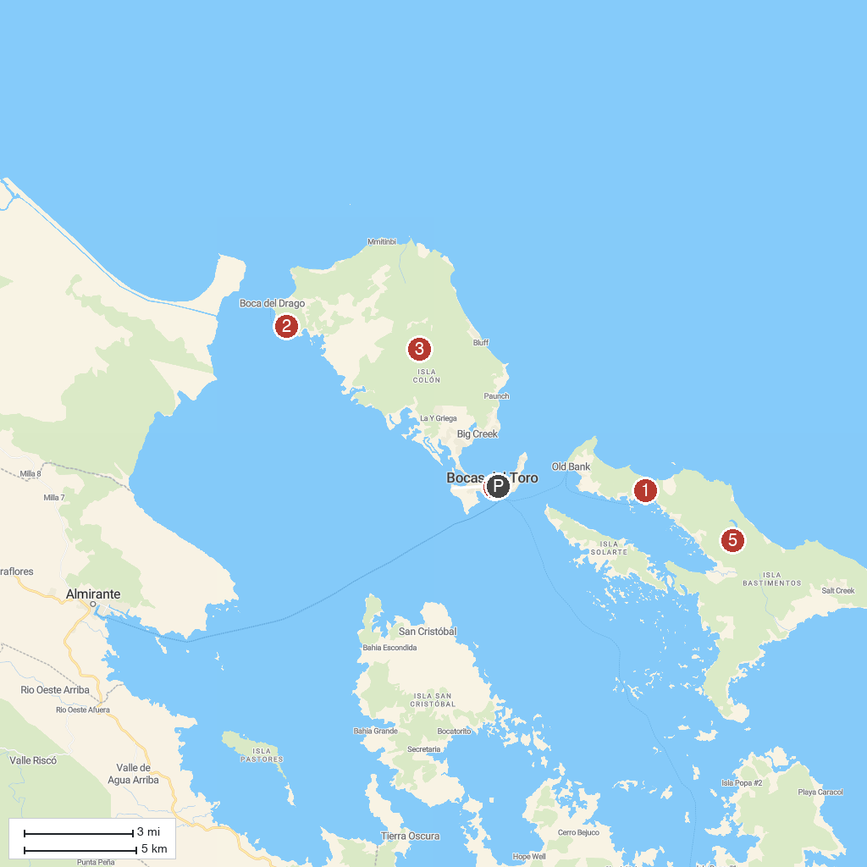
MAP KEY
1. Red Frog Beach | 4. Bocas del Toro Town
2. Starfish Beach | 5. Isla Bastimentos Marine National Park
3. La Gruta Bat Cave
P. Cruise port / terminal
Map © MapTiler © OpenStreetMap contributors · cruiseports.org

