Bom Bom Island, Príncipe, São Tomé and Príncipe
A tiny jungle-fringed islet dangling off northern Príncipe, Bom Bom rewards the few cruise ships that call here with deserted beaches, endemic birds, and waters full of colour.
⚓ Tender only (no pier) · 🕒 Typical call: 6-8 hrs · 💵 Dobra (STN) / USD/EUR accepted · 🗣️ Portuguese · 🌿 UNESCO Biosphere Reserve
✍️ MY DAY IN PORT (FILL IN)
Ship / Date
In port | arrive ______ · all aboard ______
Booked excursion
Notes / meeting point
GETTING ASHORE
- Docking: Anchor & tender — no cruise pier on Bom Bom or Príncipe
- Walk to centre: Bom Bom resort beach is the landing; Santo António town ~30-60 min by road
- Best For: Beach relaxation, snorkelling, rainforest hikes, birdwatching
- Don't Miss: Baía das Agulhas phonolite rock spires by boat
GETTING AROUND
- 🚕 Taxi: ~€40–60 — Private taxis can be arranged for the 30–60 min drive to Santo António, the island capital, along a laterite forest trac
TOP THINGS TO DO
- Rainforest Hike to Maria Correia Waterfall — A full-morning trek through primary rainforest to a jungle waterfall.
- Birdwatching Walk — Príncipe is home to several endemic bird species including the Príncipe thrush, sunbird, and scops owl.
- Boat Trip to Baía das Agulhas — A boat excursion along the coast to the Bay of Spires, where dramatic phonolite rock columns rise from the sea.
- Snorkelling off Bom Bom Beaches — The waters off the resort's two crescent beaches — Praia Bom Bom and neighbouring Praia Banana — offer excellent snorkelling with…
- Santo António Town Visit & Cocoa Plantation — The quiet capital of Príncipe offers colonial Portuguese architecture and a glimpse of everyday island life.
BEST WALKS
- Resort Islet Loop & Praia Bom Bom: Easy · 30–45 min · Beach walk — Follow the wooden walkway from the resort across to the small islet, then loop back along Praia Bom…
- Praia Banana: Easy · short walk/transfer · Secluded beach — One of Príncipe's most photographed beaches, a crescent of golden sand a short distance from the…
WEATHER · DAYLIGHT · MONEY
Month | High °F | Low °F | Rainy days
May | 86 | 74 | 15
Jul | 79 | 71 | 3
Sep | 82 | 72 | 6
Daylight: May 5:46AM–6:58PM · Jul 5:51AM–7:12PM · Sep 6:12AM–6:29PM
cruiseports.org/bom-bom-island · Confirm terminal & all-aboard time with your ship

Bom Bom Island, Príncipe, São Tomé and Príncipe — Port Map
Red = walkable sights · Amber = excursions farther out · P = cruise terminal
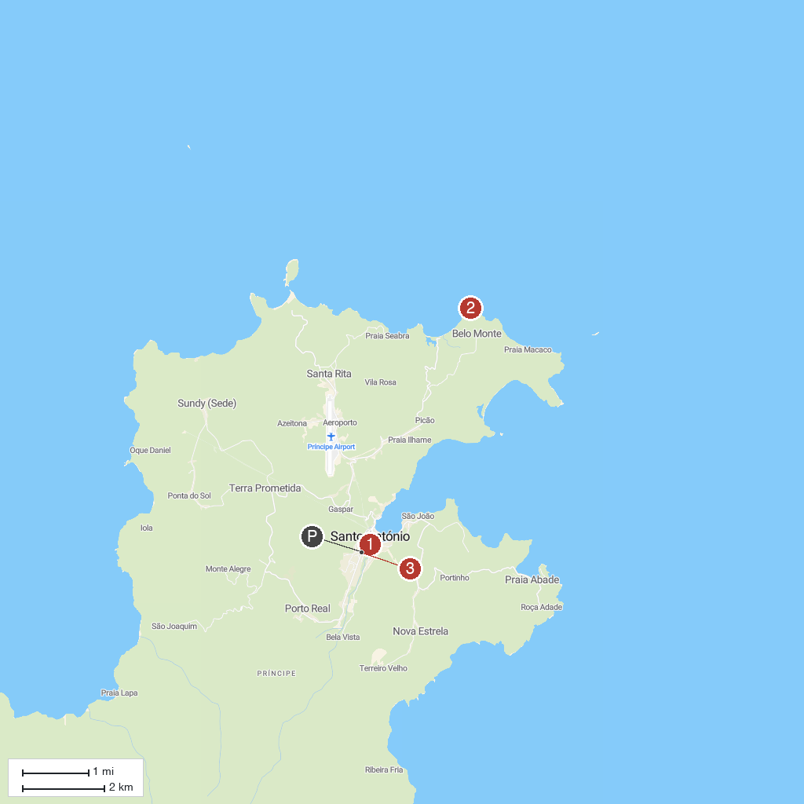
MAP KEY
1. Bom Bom Footbridge | 3. Santo Antonio
2. Praia Banana
P. Cruise port / terminal
Map © MapTiler © OpenStreetMap contributors · cruiseports.org

