Bonifacio, Corsica, France
Perched on soaring white cliffs above a fjord-like harbor, Bonifacio's ancient citadel and crystalline southern waters make it one of the Mediterranean's most arresting stops. The town is compact and walkable — but those cliffs demand good shoes.
⚓ Mostly tender (small ships may dock in marina) · 🕒 Typical call: 6–8 hrs · 💶 Currency: Euro (€) · 🗣️ Language: French / Corsican
✍️ MY DAY IN PORT (FILL IN)
Ship / Date
In port | arrive ______ · all aboard ______
Booked excursion
Notes / meeting point
GETTING ASHORE
- Docking: Large ships anchor and tender to Quai Sotta Portigliola in the marina; smaller yachts/expedition ships can berth in the marina directly
- Walk to citadel: 15–25 min steep climb from tender dock to the Old Town gate; tourist train available
- Best For: Clifftop history, boat tours, sea caves, Lavezzi Islands snorkeling
- Don't Miss: King of Aragon's Staircase (187 cliff-cut steps) and a boat tour of the sea caves
GETTING AROUND
- 🚕 Taxi: Short hops — Taxis wait near the marina for the citadel road or the airport. Agree the fare before you sit down.
- 📱 Rideshare: ❌ not available
TOP THINGS TO DO
- Cliffs & Sea Caves Boat Tour — The essential Bonifacio experience: circle the limestone cliffs by boat, drift through the Sdragonato sea cave (whose ceiling…
- Lavezzi Islands Snorkeling — A 30–40 minute boat ride brings you to the Lavezzi Islands nature reserve — granite islets, turquoise lagoons, and some of the…
- Bonifacio Citadel Walking Tour — Guided stroll through the medieval Haute Ville: Porte de Gênes, Sainte-Marie-Majeure church, Bastion de l'Etendard viewpoint, and…
- King of Aragon's Staircase — 187 steps carved directly into the cliff face descend from the Old Town to a rocky ledge above the sea.
- Day Trip to Sardinia — Ferries cross the Strait of Bonifacio to Santa Teresa Gallura in Sardinia in about 50 minutes.
BEST WALKS
- Marina to Citadel & Bastions Path: 1.5 km | 30–40 min | Moderate (steep climb) — From the tender dock at the marina, follow the road up to Porte de Gênes, the Old Town's main gate.
- Capo Pertusato Coastal Path: 3 km each way | 1.5–2 hrs | Easy–moderate — From Col Saint-Roch at the top of the old town, a well-marked coastal path follows the limestone…
WEATHER · DAYLIGHT · MONEY
Month | High °F | Low °F | Rainy days
May | 68 | 59 | 6
Jul | 84 | 72 | 1
Sep | 78 | 68 | 5
Daylight: May 6:04AM–8:35PM · Jul 6:03AM–8:55PM · Sep 7:04AM–7:32PM
cruiseports.org/bonifacio · Confirm terminal & all-aboard time with your ship

Bonifacio, Corsica, France — Port Map
Red = walkable sights · Amber = excursions farther out · P = cruise terminal
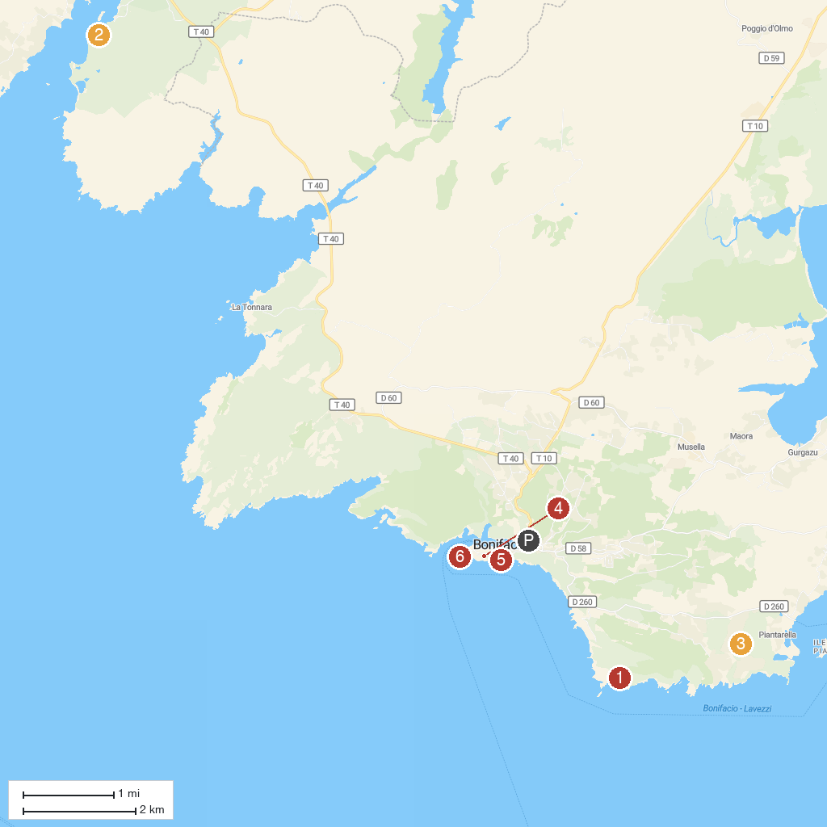
MAP KEY
1. Fanale di Pertusatu | 4. Ghjesgia San Dumenicu
2. Plage de Figari | 5. Falaises de Bonifacio
3. Golf de Spérone | 6. Cimiteriu Marinu di Bunifaziu
P. Cruise port / terminal
Map © MapTiler © OpenStreetMap contributors · cruiseports.org

