Boppard, Rhineland-Palatinate, Germany
Where the Rhine loops back on itself in a dramatic oxbow, creating the magical Vierseenblick illusion — Boppard is one of the valley's most rewarding half-day stops, with a walkable Old Town, a scenic chairlift, Roman ruins, and Riesling at every turn.
⚓ Docked — riverside promenade berth · 🕒 Typical call: 5–8 hrs · 💶 Currency: Euro (€) · 🗣️ Language: German · 🍷 UNESCO Rhine Gorge wine region
✍️ MY DAY IN PORT (FILL IN)
Ship / Date
In port | arrive ______ · all aboard ______
Booked excursion
Notes / meeting point
GETTING ASHORE
- Docking: Ships berth directly along the Rheinallee riverside promenade — step off and you're in town
- Walk to centre: Immediate — Old Town and promenade cafés begin at the gangway
- Best For: Scenic chairlift ride, Vierseenblick panorama, Rhine wine tasting, Roman history
- Don't Miss: Chairlift up to Gedeonseck and the Vierseenblick (Four Lakes View) optical illusion
GETTING AROUND
- 🚕 Taxi: €6–€12 — Licensed taxis are available at the pier and in town. Base fare is €4.20 plus €2.10/km — most in-town trips cost under €
TOP THINGS TO DO
- Chairlift to Vierseenblick (Four Lakes View) — Ride the Sesselbahn Boppard chairlift 232 m above the Rhine to the Gedeonseck viewpoint, then walk 5 minutes to the Vierseenblick…
- Roman Fort & Old Town Walk — Boppard was the Roman garrison of Bodobrica.
- Vineyard Hike — Bopparder Hamm — The Bopparder Hamm is the largest natural bend in the Rhine and one of Germany's most respected Riesling terroirs.
- Rhine Wine Tasting — Boppard's wine taverns (Straußwirtschaften) and estate cellars pour crisp Mittelrhein Riesling in a region that's been…
- Mittelrhein Klettersteig (Via Ferrata) — For fit and adventurous passengers, the Mittelrhein Klettersteig is a via ferrata route along slate rock faces above the…
BEST WALKS
- Riverside Promenade & Old Town Loop: 1.5 km · 30–45 min · Flat · Self-guided — From the cruise pier, walk north along the Rheinallee promenade past riverside cafés and wine-bar…
- Chairlift to Vierseenblick & Gedeonseck: 4 km round-trip at top · 1–1.5 hrs walking · Moderate at summit · Chairlift up — Take the Sesselbahn Boppard chairlift from Mühltal station to the mountain top, then walk 5 minutes…
WEATHER · DAYLIGHT · MONEY
Month | High °F | Low °F | Rainy days
May | 66 | 49 | 12
Jul | 77 | 60 | 11
Sep | 70 | 54 | 9
Daylight: May 5:42AM–9:09PM · Jul 5:36AM–9:34PM · Sep 7:05AM–7:42PM
cruiseports.org/boppard · Confirm terminal & all-aboard time with your ship

Boppard, Rhineland-Palatinate, Germany — Port Map
Red = walkable sights · Amber = excursions farther out · P = cruise terminal
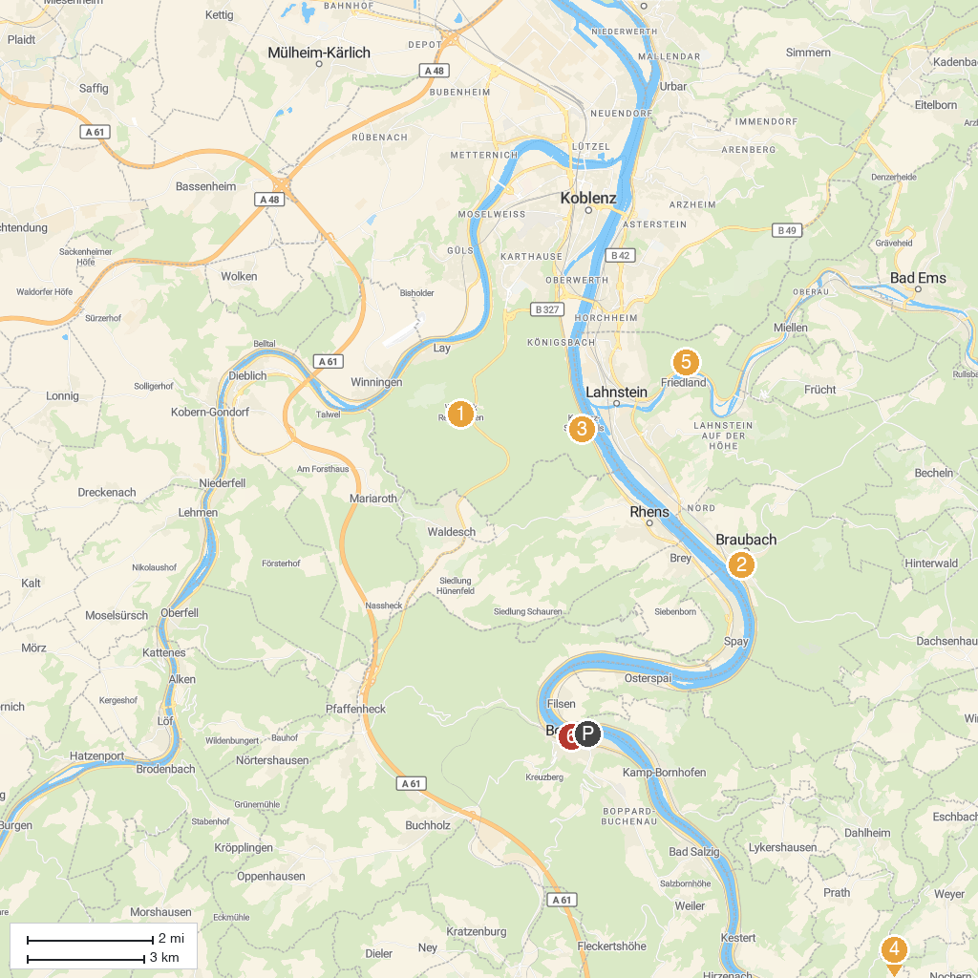
MAP KEY
1. Remstecken | 5. Rheinfels Castle
2. Marksburg | 6. Ruppertsklamm
3. Stolzenfels Castle | 7. Mittelrheinmuseum Koblenz
4. Deutsches Eck | 8. Karmeliterkirche
P. Cruise port / terminal
Map © MapTiler © OpenStreetMap contributors · cruiseports.org

