Bordeaux, Nouvelle-Aquitaine, France
France's wine capital sits right on the Garonne River — one of the few major cities where cruise ships dock steps from a UNESCO-listed historic center. Cobblestone quays, grand neoclassical facades, and the world's largest wine museum all within easy walking distance.
⚓ Docked (river quay) · 🕒 Typical call: 8-10 hrs · 💶 Euro (€) · 🗣️ French
✍️ MY DAY IN PORT (FILL IN)
Ship / Date
In port | arrive ______ · all aboard ______
Booked excursion
Notes / meeting point
GETTING ASHORE
- Docking: Ships berth at Quai des Chartrons or Bassens; the old city is a short walk or free shuttle from the quay
- Walk to center: 5-15 min on foot from Quai des Chartrons to Place de la Bourse and the Miroir d'Eau
- Best For: Wine lovers, architecture fans, and foodies — Bordeaux's UNESCO old town rivals any European city center
- Don't Miss: Miroir d'Eau (world's largest reflecting pool), Cité du Vin wine museum, and a glass of Bordeaux at a riverside café
GETTING AROUND
- 🚕 Taxi: €30–€50 (Bassens to city) — Metered taxis are readily available; fares from Bassens to the city center run €30–€50. Pre-booked private transfers sta
- 📱 Rideshare: ✅ Uber, Bolt
- 🚌 Hop-on hop-off: ✅ Bordeaux City Tours (Visiotour) · from 22
TOP THINGS TO DO
- UNESCO Old City Walking Tour — Bordeaux's entire historic centre is a UNESCO World Heritage Site.
- Cité du Vin — World-Class Wine Museum — The Cité du Vin is a stunning building by XTU Architects — its swirling, golden form evokes wine in motion and the eddies of the…
- Saint-Émilion Wine Village Day Trip — Just 40 km east, Saint-Émilion is a medieval village carved into limestone cliffs, surrounded by some of the world's most…
- Garonne Riverfront Cycle Ride — Rent a bike (multiple hire spots near Quai des Chartrons) and cruise the flat, car-free promenade along both banks of the Garonne.
- Médoc Wine Route Drive — Head north through the famous Médoc wine route — home to Château Margaux, Château Latour, and Pauillac's legendary estates.
BEST WALKS
- Quai des Chartrons to Miroir d'Eau: 1.5 km · 20 min · Flat — Walk south from the ship along the Garonne promenade.
- Old City Loop — Cathedrals, Markets & Grand Théâtre: 3.5 km · 1 hr · Flat cobblestones — From the Miroir d'Eau, head inland through the Rue Sainte-Catherine pedestrian shopping street (one…
WEATHER · DAYLIGHT · MONEY
Month | High °F | Low °F | Rainy days
May | 70 | 53 | 11
Jul | 81 | 63 | 7
Sep | 77 | 58 | 9
Daylight: May 6:33AM–9:24PM · Jul 6:30AM–9:45PM · Sep 7:41AM–8:12PM
cruiseports.org/bordeaux · Confirm terminal & all-aboard time with your ship

Bordeaux, Nouvelle-Aquitaine, France — Port Map
Red = walkable sights · Amber = excursions farther out · P = cruise terminal
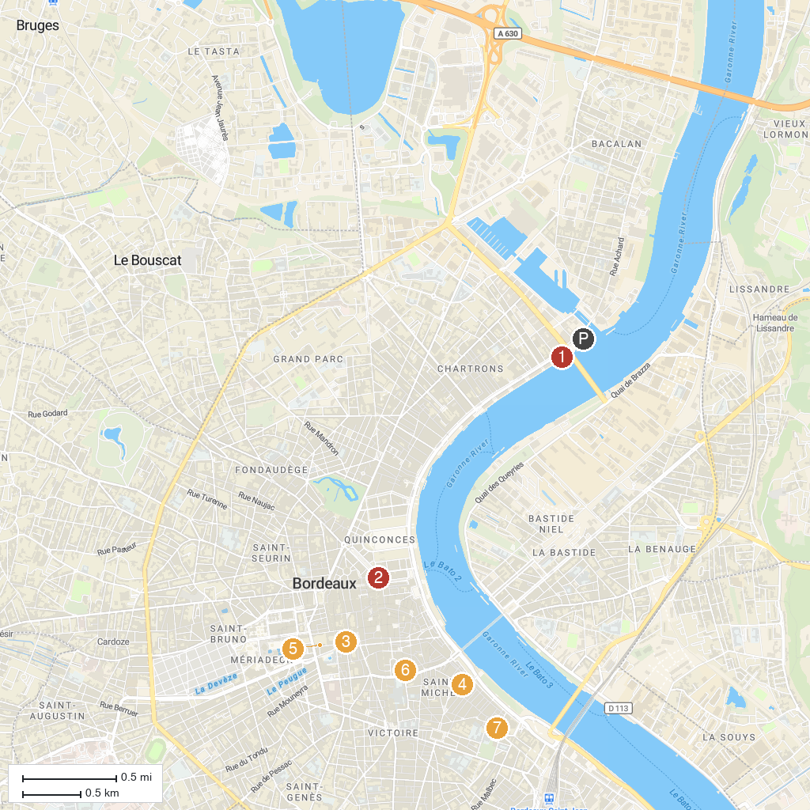
MAP KEY
1. Cap Sciences | 5. Bordeaux Museum of Fine Arts
2. Opéra National de Bordeaux - Grand-Théâtre | 6. Saint Eligius Church
3. Cathédrale Saint-André de Bordeaux | 7. Église Sainte-Croix de Bordeaux
4. Basilique Saint-Michel
P. Cruise port / terminal
Map © MapTiler © OpenStreetMap contributors · cruiseports.org

