Borkum Island, Lower Saxony, Germany
Germany's westernmost East Frisian island greets cruise visitors with windswept North Sea beaches, a UNESCO Wadden Sea, and a charming narrow-gauge railway trundling from the ferry harbor straight to town.
⚓ Docked at Borkum Reede pier · 🕒 Typical call: 6–8 hrs · 💶 Euro (EUR) · 🗣️ German
✍️ MY DAY IN PORT (FILL IN)
Ship / Date
In port | arrive ______ · all aboard ______
Booked excursion
Notes / meeting point
GETTING ASHORE
- Docking: Ships berth at Borkum Reede harbor — same pier used by the Emden/Eemshaven ferries
- Walk to center: ~15 min by Borkumer Kleinbahn narrow-gauge railway (7.5 km line); tickets sold at the pier
- Best For: Beach walks, Wadden Sea mudflat hikes, lighthouse views, seal watching
- Don't Miss: New Lighthouse (1879, 60 m, 308 steps) and a guided Wadden Sea mudflat walk
GETTING AROUND
- 🚕 Taxi: €6 base + €2.30/km (day rate) — Taxis are available at Georg-Schütte-Platz (the railway station) during the day. Call 04922 1001 to book. Nighttime rate
- 📱 Rideshare: ❌ not available
- 🚌 Hop-on hop-off: ✅ Borkumer Kleinbahn (Inselbusrundfahrt)
TOP THINGS TO DO
- Guided Wadden Sea Mudflat Walk — Step out onto the exposed seabed at low tide with a licensed Wadden Sea guide.
- New Lighthouse Climb — Borkum's working New Lighthouse (Neuer Leuchtturm, 1879) rises 60 metres above the island.
- Seal Watching at Borkumriff — Harbour seals and grey seals haul out on the Borkumriff sandbank off the island's north coast.
- Heimatmuseum Dykhus — Borkum's local history museum east of the Old Lighthouse covers five centuries of whaling, seafaring, and island life.
- Nordbad Beach & Strandkorb — Borkum's main North Beach boulevard (Nordbad) is lined with Strandkörbe — the iconic hooded wicker beach chairs of the German…
BEST WALKS
- Harbor to New Lighthouse & North Beach: 4 km one-way | Easy | ~1 hr — Ride or walk from Borkum Bahnhof west along Bismarckstraße to the New Lighthouse, then continue…
- Town & Old Lighthouse Loop: 2 km loop | Easy | ~45 mins — A compact stroll through Borkum town, past the Kurpark bandstand, east to the Old Lighthouse (Alter…
WEATHER · DAYLIGHT · MONEY
Month | High °F | Low °F | Rainy days
May | 55 | 51 | 11
Jul | 66 | 61 | 14
Sep | 64 | 59 | 12
Daylight: May 5:32AM–9:27PM · Jul 5:23AM–9:54PM · Sep 7:07AM–7:48PM
cruiseports.org/borkum-island · Confirm terminal & all-aboard time with your ship

Borkum Island, Lower Saxony, Germany — Port Map
Red = walkable sights · Amber = excursions farther out · P = cruise terminal
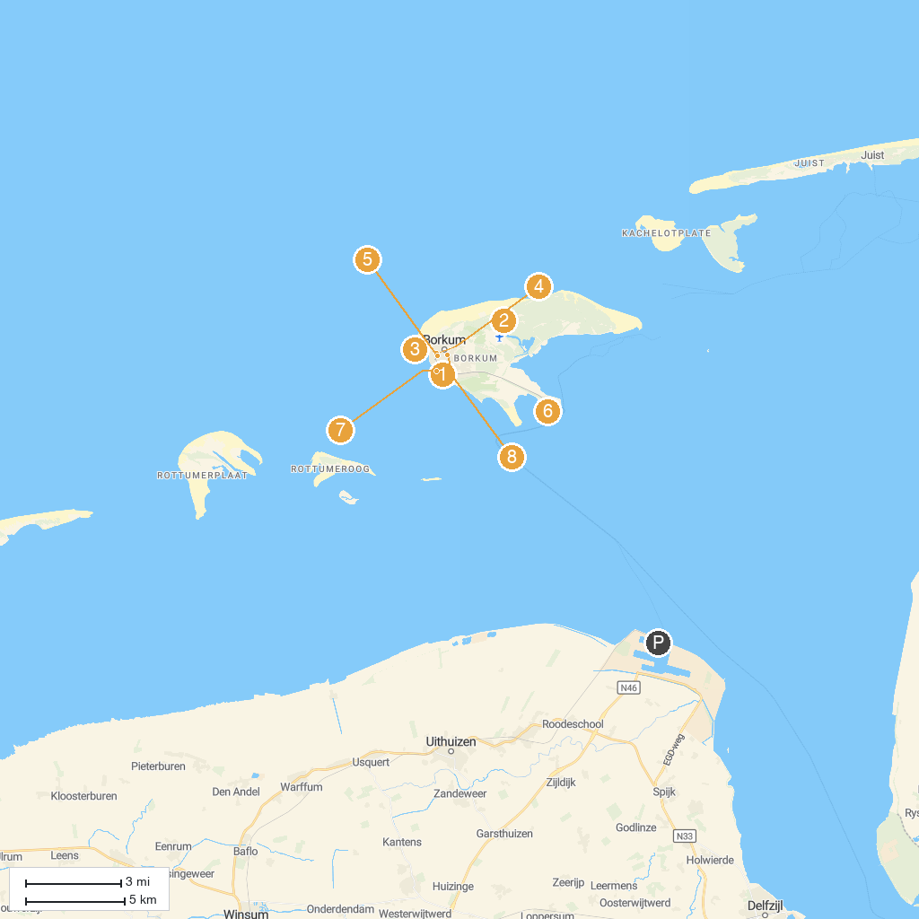
MAP KEY
1. Elektrischer Leuchtturm Borkum | 5. Borkumer Kleinbahn
2. Emmich-Denkmal | 6. Nationalpark-Schiff Feuerschiff Borkumriff
3. Seehundbank Borkum | 7. Nordsee Aquarium Borkum
4. New Lighthouse Borkum | 8. Alter Leuchtturm Borkum
P. Cruise port / terminal
Map © MapTiler © OpenStreetMap contributors · cruiseports.org

