Bosaro, Veneto, Italy
A tranquil Polesine river stop where flat farmland meets the wandering channels of the Po Delta — best explored by bike, at the pace of the waterway itself.
⚓ River mooring (small vessels) · 🕒 Typical call: 4–6 hrs · 💶 Euro (€) · 🗣️ Italian
✍️ MY DAY IN PORT (FILL IN)
Ship / Date
In port | arrive ______ · all aboard ______
Booked excursion
Notes / meeting point
GETTING ASHORE
- Docking: River berth on the Canalbianco canal; small barges and expedition-style vessels only
- Walk to centre: ~5 min from the canal quay to the town centre
- Best For: Cycling, Po Delta scenery, off-the-beaten-path river Italy
- Don't Miss: The Canalbianco riverside cycle path and the nearby Torre Morosini in Polesella
GETTING AROUND
- 🚕 Taxi: ~€15 — Rovigo city center is approximately 8 km from Bosaro. Local taxis can be arranged through your ship or at the dock; expe
TOP THINGS TO DO
- Po Delta Cycling Tour — Pedal along the Canalbianco and Po riverbanks through rice fields and wetlands.
- Torre Morosini & Villa Morosini, Polesella — A 22-metre crenellated tower — all that survives of the late-16th-century Villa Morosini, attributed to Vincenzo Scamozzi (of the…
- Rovigo City Half-Day — The provincial capital 8 km north has a proper piazza, the Pinacoteca dell'Accademia dei Concordi art gallery (with works by…
- Po Delta Boat Tour — From nearby Taglio di Po or Porto Tolle, small-boat tours wind through the Po Delta's labyrinthine channels and lagoon habitats…
BEST WALKS
- Bosaro Town Stroll: 30 min · Easy · ~1 km — A short loop through the town centre takes in the Church of San Sebastiano Martire, the historic…
- Canalbianco Towpath Ride: 1–2 hrs · Easy · 8–15 km · Bike — The flat towpath running along the Canalbianco is ideal for cyclists of all levels.
WEATHER · DAYLIGHT · MONEY
Month | High °F | Low °F | Rainy days
May | 73 | 56 | 13
Jul | 88 | 69 | 10
Sep | 78 | 61 | 9
Daylight: May 5:44AM–8:35PM · Jul 5:40AM–8:56PM · Sep 6:51AM–7:23PM
cruiseports.org/bosaro · Confirm terminal & all-aboard time with your ship

Bosaro, Veneto, Italy — Port Map
Red = walkable sights · Amber = excursions farther out · P = cruise terminal
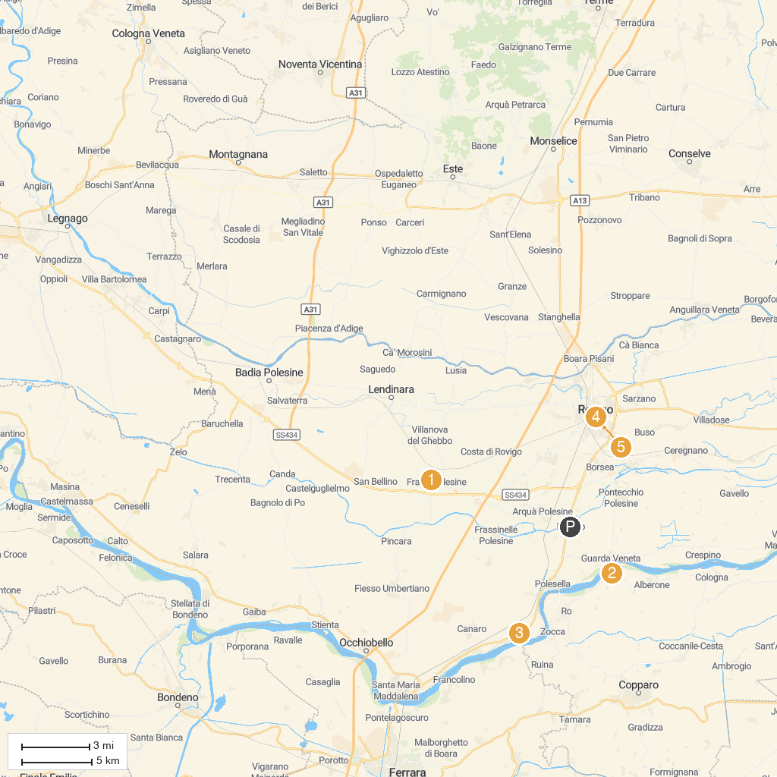
MAP KEY
1. Museo Archeologico Nazionale di Fratta Polesine | 4. Roncale Palace
2. Festa della Salama da Taglio | 5. Museo di Storia La Tratta
3. MUVIG: MUseo VIrtuale del Garofalo | 6. Museum of the Great Rivers
P. Cruise port / terminal
Map © MapTiler © OpenStreetMap contributors · cruiseports.org

