Boulogne-sur-Mer, Hauts-de-France, France
Where medieval ramparts crown France's largest fishing port — step off the ship and into cobbled streets, an extraordinary aquarium, and cliff-top views across the Channel to England.
⚓ Docked (Quai de l'Europe) · 🕒 Typical call: 8-10 hrs · 💶 Euro (€) · 🗣️ French
✍️ MY DAY IN PORT (FILL IN)
Ship / Date
In port | arrive ______ · all aboard ______
Booked excursion
Notes / meeting point
GETTING ASHORE
- Docking: Alongside at Quai de l'Europe; ~2 km from town center
- Walk to Center: ~25 min on foot; shuttle buses available from quay
- Best For: History, seafood, family (Nausicaá), coastal walks
- Don't Miss: Nausicaá Sea Centre, Haute Ville ramparts, Basilique Notre-Dame dome
GETTING AROUND
- 🚕 Taxi: €7–€10 — Short taxi ride to the city center; fares start around €2.30 plus ~€1.03–€1.30/km. Taxis available at the port.
- 📱 Rideshare: ✅ Uber
TOP THINGS TO DO
- Cap Blanc-Nez & Cap Gris-Nez — Two dramatic chalk headlands on the Opal Coast with sweeping views across the English Channel — on clear days you can see the…
- Nausicaá National Sea Centre — One of Europe's largest aquariums, with immersive exhibits covering the open ocean, tropical reefs, and polar seas.
- Haute Ville Ramparts & Basilique Notre-Dame — Walk the full circuit of 13th-century ramparts for panoramic views over the port and Channel, then step inside the Basilique with…
- Fish Market & Seafood Lunch — Boulogne is France's largest fishing port.
- Château-Musée & Belfry — The 13th-century castle houses eclectic collections from Egyptian antiquities to local fine art.
BEST WALKS
- Waterfront to Old Town Loop: 4-5 km · 1.5-2 hrs · Moderate (uphill to Haute Ville) — Walk the quays past the fish market, ascend to the Haute Ville ramparts, circle the full 1.5-km…
- Beach & Nausicaá Stroll: 2 km · 45 min · Easy (flat) — Head south along the promenade from the port to Boulogne's main sandy beach, passing Nausicaá on…
WEATHER · DAYLIGHT · MONEY
Month | High °F | Low °F | Rainy days
May | 60 | 49 | 11
Jul | 69 | 59 | 11
Sep | 66 | 56 | 11
Daylight: May 6:04AM–9:35PM · Jul 5:58AM–10:00PM · Sep 7:29AM–8:06PM
cruiseports.org/boulogne-sur-mer · Confirm terminal & all-aboard time with your ship

Boulogne-sur-Mer, Hauts-de-France, France — Port Map
Red = walkable sights · Amber = excursions farther out · P = cruise terminal
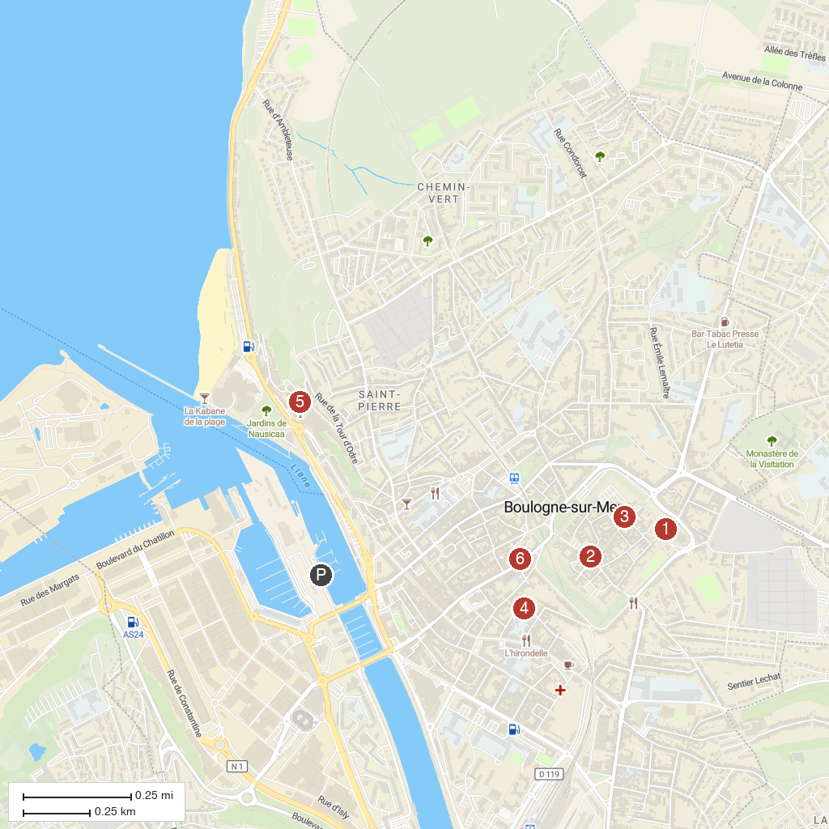
MAP KEY
1. Boulogne-sur-Mer Castle-Museum | 5. École-Musée de Boulogne-sur-Mer
2. Museum of the Atlantic Wall | 6. House of Beurière
3. Éphémère Garden | 7. Casa San Martín
4. Crypt of Our Lady Basilica
P. Cruise port / terminal
Map © MapTiler © OpenStreetMap contributors · cruiseports.org

