Brač Island, Dalmatia, Croatia
Croatia's largest Dalmatian island delivers the Adriatic at its most authentic — limestone villages, the iconic shape-shifting Zlatni Rat beach, and stonemasonry traditions unchanged for centuries. Cruise calls here are small-ship affairs, tendering into intimate harbors far from the crowds of Dubrovnik.
⚓ Tender port (anchor & tender to shore) · 🕒 Typical call: 6–8 hrs · 💶 Currency: Euro (€) · 🗣️ Language: Croatian · 🏖️ Best months: May–Jun, Sep
✍️ MY DAY IN PORT (FILL IN)
Ship / Date
In port | arrive ______ · all aboard ______
Booked excursion
Notes / meeting point
GETTING ASHORE
- Docking: Anchor-and-tender at Pučišća, Bol, or Sumartin; no large cruise pier on the island
- Walk to center: Tender drops you in the village center; all main attractions within 5–30 min walk
- Best For: Zlatni Rat beach, stonemasonry heritage, Vidova Gora views, Dalmatian food and wine
- Don't Miss: Zlatni Rat (Golden Horn) beach near Bol and the Pučišća Stonemasonry School
GETTING AROUND
- 🚕 Taxi: €15–€30 (Supetar town); €65–€85 (Supetar to Bol) — Local taxis meet the ferry/cruise dock at Supetar. Fixed-price agreements are common — confirm the fare before departure
- 📱 Rideshare: ❌ not available
TOP THINGS TO DO
- Zlatni Rat (Golden Horn) Beach — The most famous beach in Croatia — a long pebble tongue that juts into the sea and shifts direction with the wind.
- Vidova Gora Summit — At 778 m, Vidova Gora is the highest peak of any Adriatic island.
- Pučišća Stonemasonry School — Pučišća is built entirely from the island's prized white limestone and hosts a working stonemasonry school where students still…
- Blaca Hermitage — A remote 16th-century monastery and hermitage built into a cliff face in a desert canyon.
- Škrip Village & Olive Oil Museum — Škrip is the oldest continuously inhabited settlement on the island, with an Illyrian-era fort, Roman mausoleum, and a small…
BEST WALKS
- Bol Waterfront to Zlatni Rat: 2 km one-way · ~25 min · Easy paved promenade — From Bol's ferry/tender pier, follow the seafront promenade west through pine shade.
- Pučišća Harbour & Old Town: 1 km loop · ~30 min · Easy stone lanes — From the tender quay, stroll the U-shaped Pučišća bay, lined with stone houses and fishing boats.
WEATHER · DAYLIGHT · MONEY
Month | High °F | Low °F | Rainy days
May | 71 | 55 | 7
Jul | 84 | 66 | 4
Sep | 77 | 60 | 7
Daylight: May 5:29AM–8:10PM · Jul 5:27AM–8:31PM · Sep 6:33AM–7:03PM
Representative sunrise/sunset — 2025, 15th of each month; local civil time including DST (Europe/Zagreb). Source: Astral; not a forecast or climate average.
cruiseports.org/brac-island-croatia · Confirm terminal & all-aboard time with your ship

Brač Island, Dalmatia, Croatia — Port Map
Red = walkable sights · Amber = excursions farther out · P = cruise terminal
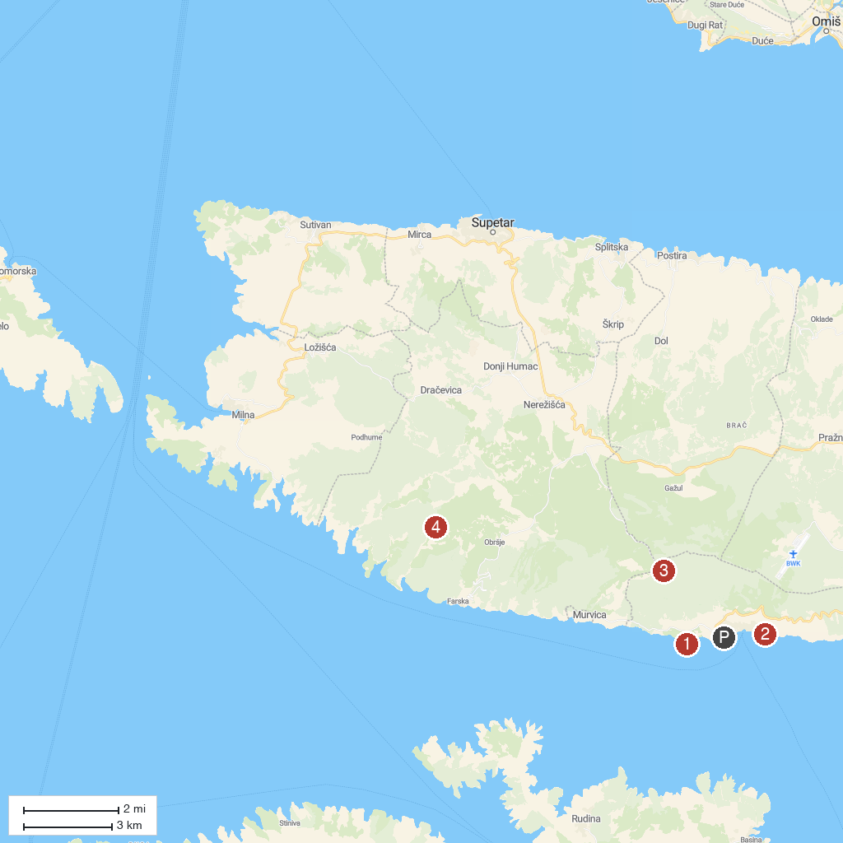
MAP KEY
1. Zlatni Rat Beach | 3. Vidova Gora
2. Dominican Monastery Bol | 4. Blaca Hermitage
P. Cruise port / terminal
Map © MapTiler © OpenStreetMap contributors · cruiseports.org

