Brăila, Muntenia, Romania
A river city of grand 19th-century squares and Baroque theatres, Brăila rises in a natural amphitheatre above the Danube — compact, walkable, and genuine.
⚓ Docked (river pontoon berths) · 🕒 Typical call: 6–8 hrs · 💵 Romanian Leu (RON) · 🗣️ Romanian
✍️ MY DAY IN PORT (FILL IN)
Ship / Date
In port | arrive ______ · all aboard ______
Booked excursion
Notes / meeting point
GETTING ASHORE
- Docking: River pontoon berths in the Old Port, left bank of the Danube
- Walk to center: ~20 min on foot or 5 min by taxi to Traian Square
- Best For: History, architecture, Danube scenery, offbeat Eastern Europe
- Don't Miss: Traian Square, Danube Esplanade, Maria Filotti Theatre
GETTING AROUND
- 🚕 Taxi: 10–20 RON (~€2–4) — Taxis are available at the port. Base fare ~2.5 RON plus ~2 RON/km; confirm price before departing. Short rides to cente
- 📱 Rideshare: ✅ Uber, Bolt
TOP THINGS TO DO
- Brăila Historic Centre Walk — The fan-shaped city descends toward the Danube in concentric arcs.
- Small Wetland of Brăila (Balta Mică a Brăilei) — A Natura 2000 and Ramsar-listed floodplain just outside the city, sometimes called the 'mini Danube Delta.' Boat trips weave…
- Brăila Museum 'Carol I' & Art Museum — The Brăila Museum occupies the former Hôtel Français, displaying prehistory through modern Romania.
- Lacu Sărat Saltwater Spa — A short tram ride from the city, this saltwater lake resort has been a health destination since the 19th century.
- Danube Delta Gateway (Tulcea) — On longer port calls, some excursions head to Tulcea (~90 km), the main gateway city for the UNESCO Danube Delta biosphere.
BEST WALKS
- Danube Esplanade to Traian Square: 1.2 km · 20 min · Easy — Follow the Esplanade promenade north from the port, passing the kinetic fountain and riverside…
- Historic Centre Circuit: 2.5 km · 45 min · Easy — From Traian Square, walk down Republic Street past merchant houses and cafes, detour to the Maria…
WEATHER · DAYLIGHT · MONEY
Month | High °F | Low °F | Rainy days
May | 72 | 54 | 10
Jul | 85 | 67 | 7
Sep | 77 | 58 | 4
Daylight: May 5:38AM–8:31PM · Jul 5:35AM–8:52PM · Sep 6:46AM–7:18PM
cruiseports.org/braila · Confirm terminal & all-aboard time with your ship

Brăila, Muntenia, Romania — Port Map
Red = walkable sights · Amber = excursions farther out · P = cruise terminal
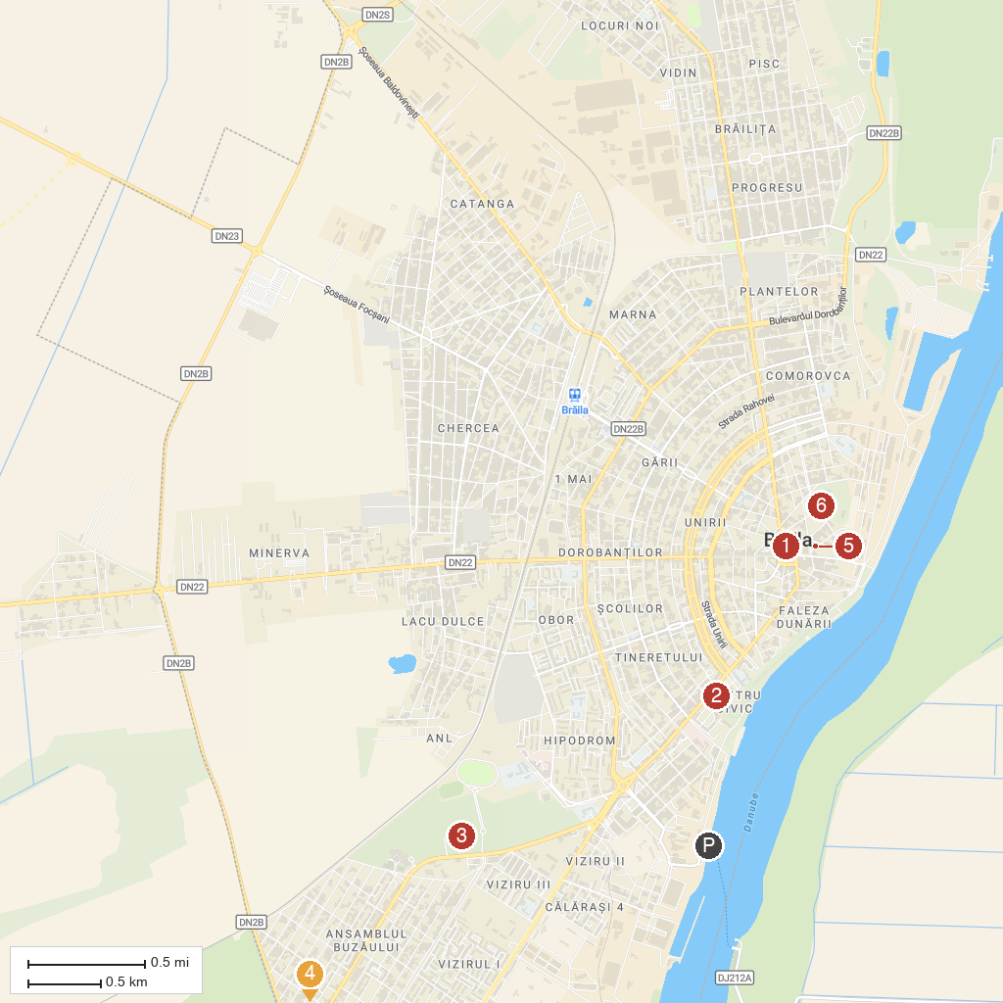
MAP KEY
1. "Carol I" Museum of Brăila | 4. Grădina Zoologică-Eco SA
2. The Kynetic Fountain | 5. "Nicăpetre" Cultural Center
3. Monument Park Brăila | 6. The Public Garden
P. Cruise port / terminal
Map © MapTiler © OpenStreetMap contributors · cruiseports.org

