Brandenburg an der Havel, Brandenburg, Germany
A city built on islands and bridged by history — Brandenburg an der Havel spreads across three medieval centres linked by waterways, with a Gothic cathedral dating to 1165 and Havel lakes stretching in every direction.
⚓ Docked (Salzhofufer berth) · 🕒 Typical call: 6-8 hrs · 💶 Euro (€) · 🗣️ German
✍️ MY DAY IN PORT (FILL IN)
Ship / Date
In port | arrive ______ · all aboard ______
Booked excursion
Notes / meeting point
GETTING ASHORE
- Docking: Alongside at Salzhofufer, right beside the Millennium Bridge
- Walk to centre: 3-min walk to Old Town; Cathedral Island ~20 min on foot
- Best For: Medieval architecture, Gothic churches, Havel river boat tours
- Don't Miss: Brandenburg Cathedral on Dominsel — founded 1165, the 'cradle of the Mark'
GETTING AROUND
- 🚕 Taxi: €9–€18 — Taxis use metered rates: €5 base fare plus €2.05–€2.60/km. Short hops within the city center (2–5 km) typically run €9–€
- 📱 Rideshare: ✅ Uber
TOP THINGS TO DO
- Brandenburg Cathedral & Dominsel — The Cathedral of St.
- State Museum of Archaeology (St. Paul's Monastery) — Housed inside the beautifully restored St.
- Havel River Boat Tour — Passenger boats depart from Salzhofufer for round trips on the Havel lakes — Breitlingsee and Beetzsee — passing reed banks, rare…
- Medieval Watchtowers & City Walls — Four watchtowers survive from Brandenburg's medieval fortifications — including the Plauer Torturm and Steintorturm.
- Slavic Village (Slawendorf) — Right beside the Salzhofufer berth, this reconstructed 11th-century Slavic settlement gives a vivid picture of life in the region…
BEST WALKS
- Three Historic Centres Walk: 4 km · ~1.5 hrs · Flat — Cross the Millennium Bridge from the berth into Neustadt, walk south to Altstadt, then cross to…
- Lakeside Cycle / Walk — Möserscher See: 5-8 km loop · 1.5-2 hrs · Flat path — Head west from the city centre to the shores of Möserscher See for flat waterside paths, open lake…
WEATHER · DAYLIGHT · MONEY
Month | High °F | Low °F | Rainy days
May | 66 | 49 | 10
Jul | 76 | 60 | 10
Sep | 69 | 54 | 8
Daylight: May 5:14AM–8:59PM · Jul 5:06AM–9:24PM · Sep 6:44AM–7:24PM
cruiseports.org/brandenburg-an-der-havel · Confirm terminal & all-aboard time with your ship

Brandenburg an der Havel, Brandenburg, Germany — Port Map
Red = walkable sights · Amber = excursions farther out · P = cruise terminal
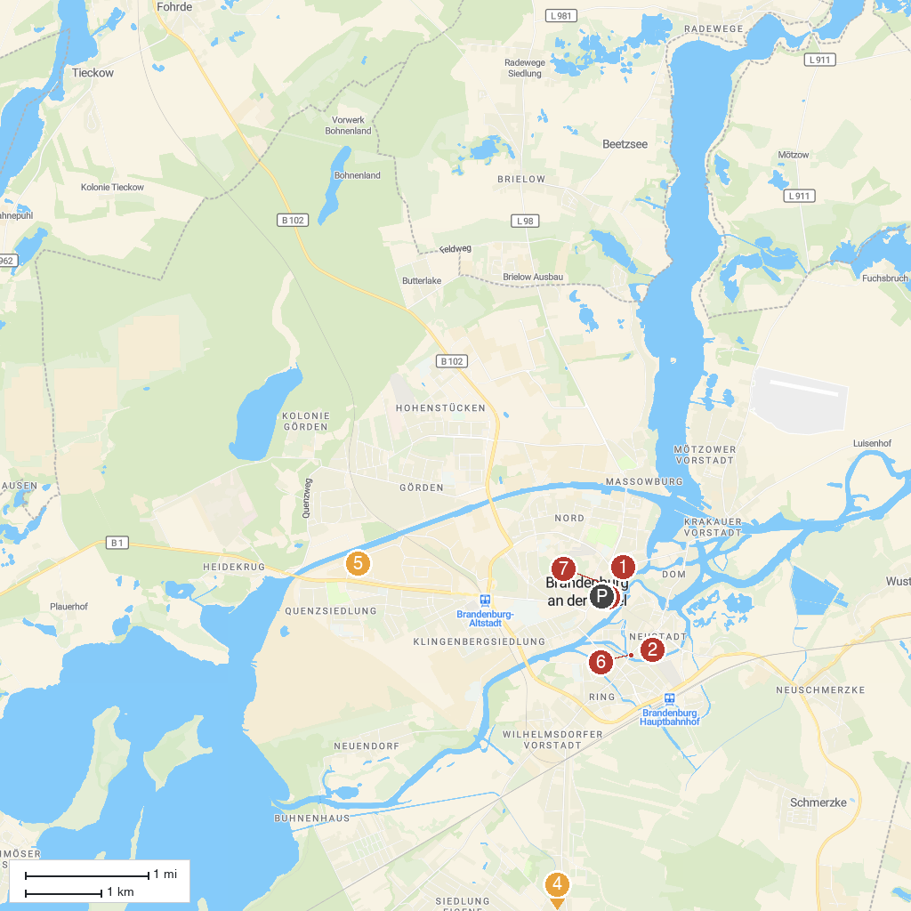
MAP KEY
1. St. Gotthardt | 5. Industrial Museum Brandenburg
2. Brandenburg State Archaeology Museum | 6. Steintorturm
3. Stadtmuseum im Frey-Haus | 7. Marktbrunnen und Waldmops (Erinnerung an Loriot)
4. Schulmuseum Reckahn
P. Cruise port / terminal
Map © MapTiler © OpenStreetMap contributors · cruiseports.org

