Brandenburg, Kentucky, USA
A quiet Kentucky river town where American history runs deep. From Lincoln's log-cabin birthplace to the legendary vaults of Fort Knox, Brandenburg is a shore-day that rewards curious travelers.
⚓ Docked (Riverfront Park pier) · 🕒 Typical call: 6-8 hrs · 💵 US Dollar · 🗣️ English
✍️ MY DAY IN PORT (FILL IN)
Ship / Date
In port | arrive ______ · all aboard ______
Booked excursion
Notes / meeting point
GETTING ASHORE
- Docking: Ships dock at Brandenburg Riverfront Park; gangway to shore, no tender
- Walk to town: Downtown Brandenburg is a short 5-min walk from the pier
- Best For: Lincoln history, Fort Knox bus tour, Ohio River scenery
- Don't Miss: Abraham Lincoln Birthplace NHP in Hodgenville (~50 min by bus)
GETTING AROUND
- 📱 Rideshare: ✅ Uber, Lyft
TOP THINGS TO DO
- Abraham Lincoln Birthplace — Visit the Abraham Lincoln Birthplace National Historical Park in Hodgenville (~50 min / 42 mi from Brandenburg).
- Fort Knox & Patton Museum — A rare chance to enter a working U.S.
- Buttermilk Falls Trail — A wide, paved trail (about 2.5 miles one-way, ~5 miles round trip) leading to a pretty waterfall fed by year-round hillside…
- Meade County History Museum — A small but rewarding local museum covering Civil War crossings (General John Hunt Morgan's 1863 Ohio crossing), the legend of…
- Jailhouse Pizza — Lunch in a genuine 19th-century jailhouse — now on the National Register of Historic Places.
BEST WALKS
- Riverfront to Downtown Stroll: ~1 mile | 20-30 min | Flat & easy — Walk along the Ohio River at Riverfront Park, then head up into the small downtown grid.
- Buttermilk Falls Walk: ~5 miles rt | 2-2.5 hrs | Paved — A pleasant out-and-back paved trail to the historic Buttermilk Falls (about 2.5 miles each way from…
WEATHER · DAYLIGHT · MONEY
Month | High °F | Low °F | Rainy days
May | 76 | 57 | 13
Jul | 87 | 70 | 12
Sep | 81 | 63 | 7
Daylight: May 6:34AM–8:48PM · Jul 6:34AM–9:06PM · Sep 7:26AM–7:51PM
cruiseports.org/brandenburg-ky · Confirm terminal & all-aboard time with your ship

Brandenburg, Kentucky, USA — Port Map
Red = walkable sights · Amber = excursions farther out · P = cruise terminal
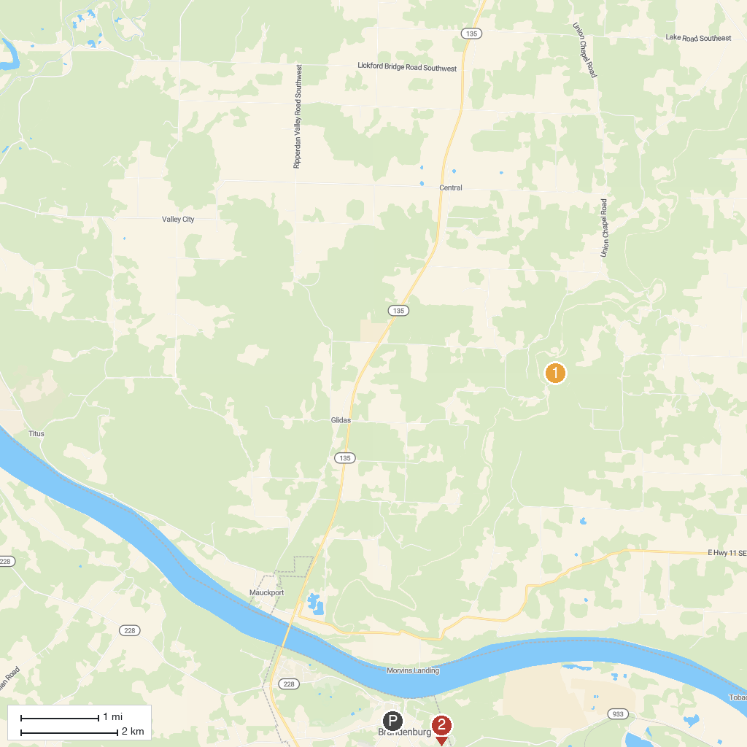
MAP KEY
1. Squire Boone Caverns | 3. Meade Olin Park
2. Otter Creek Outdoor Recreation Area
P. Cruise port / terminal
Map © MapTiler © OpenStreetMap contributors · cruiseports.org

