Bratislava, Slovakia
Compact, walkable, and loaded with Central European charm — Bratislava's hilltop castle and cobblestoned Old Town sit minutes from the Danube pier, making it one of the most accessible stops on any Danube river cruise.
⚓ Docked (river pier) · 🕒 Typical call: 6-8 hrs · 💶 Euro (€) · 🗣️ Slovak
✍️ MY DAY IN PORT (FILL IN)
Ship / Date
In port | arrive ______ · all aboard ______
Booked excursion
Notes / meeting point
GETTING ASHORE
- Docking: Passenger Port, Fajnorovo nábrežie — city-center riverfront
- Walk to Old Town: 5–10 min on foot from pier
- Best For: Compact Old Town, Bratislava Castle, riverside walks
- Don't Miss: The Blue Church (St. Elizabeth) and Cumil street statue
GETTING AROUND
- 🚕 Taxi: €5–10 — Metered taxis start around €3–5, then ~€0.80–1.20/km. Rides within the city center typically run €5–10. Use the meter or
- 📱 Rideshare: ✅ Uber, Bolt
- 🚌 Hop-on hop-off: ✅
TOP THINGS TO DO
- Old Town Walking Tour — Hit the essentials in two to three hours: Main Square, Roland's Fountain, Old Town Hall, St.
- Bratislava Castle — The city's defining silhouette rises above the Danube on a rocky hill.
- The Blue Church & Presidential Palace — St.
- Devin Castle & Danube Confluence — A striking medieval ruin ~12 km from the city at the confluence of the Danube and Morava rivers, on the former Iron Curtain border.
- Slovak Food & Beer Tasting — The Old Town's side streets hide wine bars pouring local Malokarpatská wine and pubs serving bryndza halušky (potato dumplings…
BEST WALKS
- Old Town Loop: 1.5–2 hrs · Easy · ~2.5 km — From the pier, walk north along the riverfront to Hviezdoslavovo Námestie, then into the Old Town…
- Castle Hill Climb: 2–3 hrs · Moderate · ~4 km round-trip — From Main Square, follow Zámocká Street uphill through the castle gate to the grounds and museum.
WEATHER · DAYLIGHT · MONEY
Month | High °F | Low °F | Rainy days
May | 68 | 51 | 12
Jul | 81 | 63 | 10
Sep | 71 | 55 | 9
Daylight: May 5:12AM–8:24PM · Jul 5:07AM–8:47PM · Sep 6:28AM–7:03PM
cruiseports.org/bratislava · Confirm terminal & all-aboard time with your ship

Bratislava, Slovakia — Port Map
Red = walkable sights · Amber = excursions farther out · P = cruise terminal
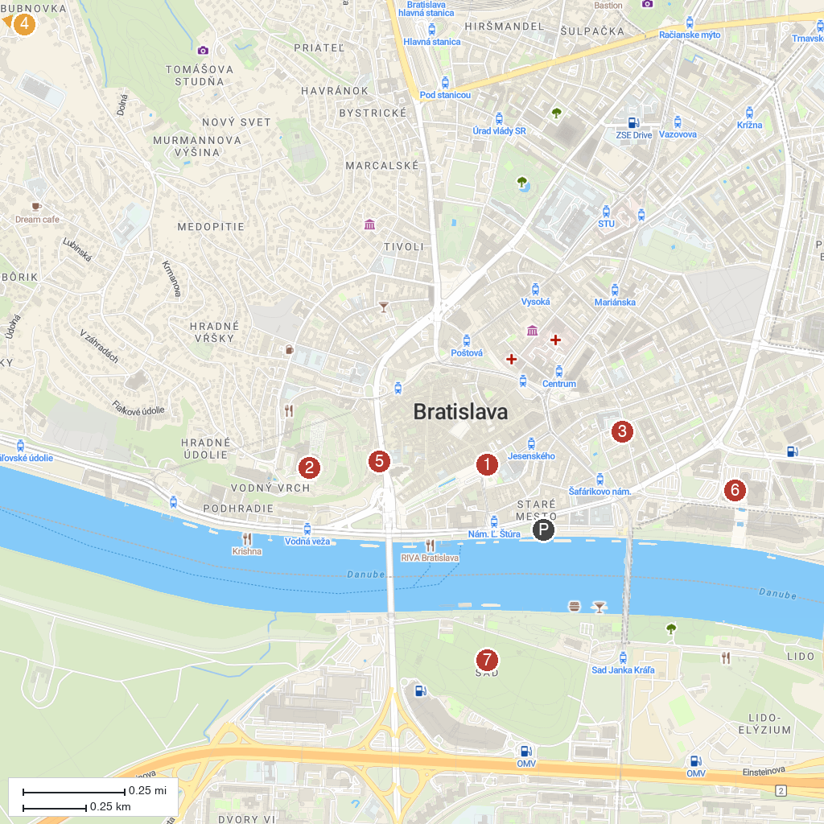
MAP KEY
1. Ganymede's Fountain | 5. Hrad Devín
2. Pajštún Castle | 6. House at the Good Shepherd, Exhibition of Clocks
3. Bratislava Castle | 7. Slovak National Theatre
4. The Blue Church - Church of St. Elizabeth | 8. Sad Janka Kráľa
P. Cruise port / terminal
Map © MapTiler © OpenStreetMap contributors · cruiseports.org

